

**Group Report**

*COMP1640 - Enterprise Web Software Development*

**Group Name :** Group 4 – TCH2403

**Member 1 :** Vuong Khanh Thanh –Greenwich ID

**Member 2 :** Đo Minh Tay –Greenwich ID

**Member 3 :** Nguyen Thi Thanh Mai–Greenwich ID

**Member 4 :** Nguyen Gia Khanh –Greenwich ID

**Member 5 :** Vu Hieu Minh –Greenwich ID

**Instructor :** MSc. Pham Duc Tho

**Table of Contents**

❖ 3

**1.** 4

**2.** **Error! Bookmark not defined.**

**3.** 8

**4.** 11

**5.** 46

**6.** 93

**7.** 95

**8.** 101

❖ 109

**Table of Figures**

**List of Tables**

Table 1 - Project Information 3

Table 2 - Group Information 3

# **General Information**

|  |  |  |  |
| --- | --- | --- | --- |
| Group name | Group 4 | | |
| Repository URL | [*https://github.com/vktmk123/demo-1640*](https://github.com/vktmk123/demo-1640) | | |
| Group Board URL |  | | |
| Web Hosting URL |  | | |
| Test accounts | *Role* | *Username* | *Password* |
| admin | thanh@gmail.com | 123456789 |
| manager | manager | 12345678 |
| coodinator |  | *12345678* |
| Screen cast URL | *YouTube link* | | |
| Backlog URL | *https://web1640.backlog.com/find/WEB1640_ENTERPRISE?projectId=129627&statusId=1&statusId=2&statusId=3&sort=UPDATED&order=false&simpleSearch=true&allOver=false&offset=0* | | |
| Test plan URL |  | | |
| Front-End Technology | *ReactJS, vercel* | | |
| Back-End Technology | *ReactrJS, rende.* | | |
| Database | *MongoD.* | | |

*Table 1 - Project Information*

|  |  |
| --- | --- |
| Full Name | Role |
| Nguyen Thi Thanh Mai | Report preparation, Scrum master |
| Vuong Khanh Thanh | Front-end Developer, Leader, Design Interface |
| Do Minh Tay | Back-end Developer, Database designer |
| Vu Hieu Minh | Design Interface, Frond-end |
| Nguyen Gia Khanh | Tester, Back-end |

*Table 2 – Member Role*

# **Introduction**

In this paper, the team will implement a web-secure, role-based system that allows students to submit articles to the annual journal of a major university. The system is divided into the following parts: Marketing Manager, Marketing Coordinator, Admin, Student, Guest.

The report details the project implementation and completion process with the following items:

* Requirements analysis: Analyze requirements of each function + non-function, project use case diagram and specification.
* Database: Standardized database structure including data security and data authentication.
* Design: Discuss system design including, Wireframe design, user interface design, flowcharts, activity diagrams and sequence diagrams.
* Implementation: Overview of specific methods (front-end, back-end, database), system architecture, description of features and highlighted/significant code snippets, and combined final web screenshots
* Testing: Test Overview, Plans, Scenarios, Cases, Logs, Test Evidence, and Review of Test Results.
* Methodology: This section also discusses user stories, product backlog, meeting minutes.
* Conclusion: Discuss what was done in this project, overall assessment of the web application, future improvements., ...

# **Requirement Analysis**

The project started on February 24, 2024, to complete the project it took us nearly 2 months, and we worked directly with the manager in charge. Fixed meeting every Saturday morning, and additional 2-3 meetings during the week to ensure project progress. The group consists of five members with different roles and functions. The system for collecting student contributions includes System Specifications: Manager (1 Manager for whole university), Coordinator (1 Coordinator for each faculty), Administrator (1 admin for whole university), Student, Gust.

* 1. Requirements of each function

|  |  |
| --- | --- |
| **Role** | **Requirements of each function** |
| Manger | Login/Logout |
| See the dashboard but edited |
| Download contributions in Zip format |
| See the number of contributions from each department |
| Contribution percentage of each department |
| Number of student collaborations per instructor |
| Admin | User management |
| Create accounts for Roles (marketing manager, marketing  coordinator, student) |
| Annual event management |
| View overview page |
| Student | Login/ Logout |
| Submit articles |
| Update their contribution |
| Must agree to Terms and Conditions |
| Comment and view all comments |
| View Home articles |
| View departments |
| View annual event |
| Receive email |
| Coordinator | Manage articles In department |
| Get email alerts when students submit something new. |
| Interact with pupils in their faculty |
| Select good contributions |
| Comment for contributions within 14 days |

* 1. Non-Functional Requirements

|  |  |
| --- | --- |
| **Number** | **Non-Functional Requirements** |
| 1 | Design a system with an eye-catching, easy-to-read interface |
| 2 | The system is not at fault |

* 1. User-case Diagram

**First, administrators** have full control over the system's inventory, update and close events times, create new accounts, limit login access, and before students submit assignments set approval criteria browser.

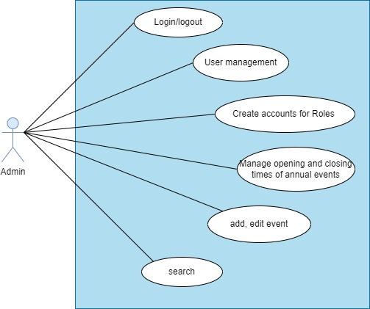

Figure 1: Use case Admin of system

**The coordinator** each department will have a department coordinator to manage the posting process of their department's students. Moderators will be notified when new articles are submitted by students; they only have access to contributions in the department they manage. Coordinators have 14 days to select the best contributions for publication, within 14 days they can communicate with students about edits to the contributions.

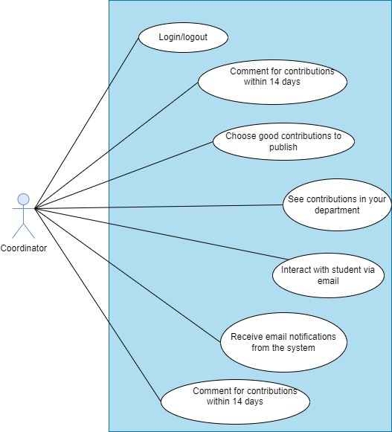

Figure 2: Use case Coordinator of system

**The manager**, who oversees the process, can view all contributions but cannot edit or delete them. All contributions can be downloaded as Zip files. Administrators can view the contribution percentage of each student in each department

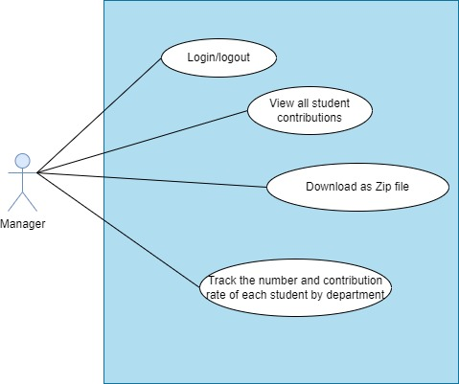

Figure 3: Use case Manager of system

# **Database**

**ERD**

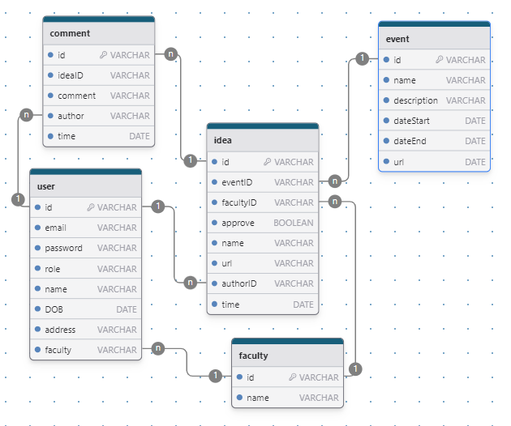

Figure 4 Database design

The image above is database design of our group we have 5 tables was used in this project such as user, Comment, ideas Faculty, Event. The following is relationship of table:

Faculty:

* A Faculty has many users and a user can only be in one Faculty
* Each facility will have many ideas and ideas will belong to only one faculty

Event:

* A event have many Ideas and one idea belong to one event

Idea:

* Each idea belong to a faculty, a event and a user
* Each have many idea
* Each user can create many idea
* Each idea have many comment

Comment:

* Each comment belong to a idea and a user create
* Each user can comment many time

User:

* A user in a faculty
* Each user can create many idea
* Each user can comment many time.

## **ERD Design**

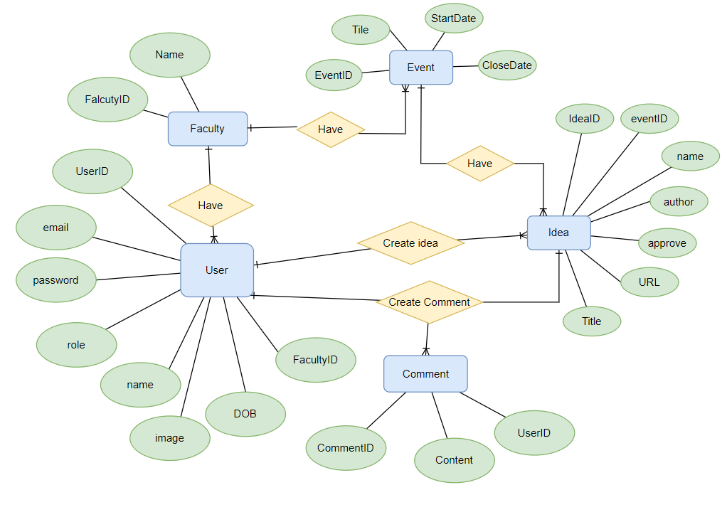

Figure 5 ERD diagram of database design

In the ERD design of the project build a web-based role-based system to collect ideas from students. We have five entities such as users, faculty , events, ideas, and comments. Each entity has properties that are considered characteristics or attributes. Key points and relationships between entities:

* faculty has many users, but users can only belong to one department.
* a faculty has many events, but events can only be deployed on one faculty
* One user can create many events and can contribute many comments
* A user can comment multiple times.
* One user can create many ideas.
* Each comment belongs to only one idea,
* An idea can have many comments
* An idea will only belong to one event, but an event can have many ideas

Our team opts for MongoDB as our database solution for several reasons. Firstly, it's a familiar choice among our team members, ensuring smoother integration and troubleshooting. Additionally, MongoDB's user-friendly interface and lack of a fixed schema streamline development, as we can define the schema within our code. Unlike traditional SQL databases, MongoDB doesn't require complex joins, simplifying queries. Moreover, its scalability and straightforward setup make it a convenient option for our project.

# **Design**

sitemap, wireframes, flowcharts, mockup (Figma), activity diagram, sequence diagrams

## Sitemap

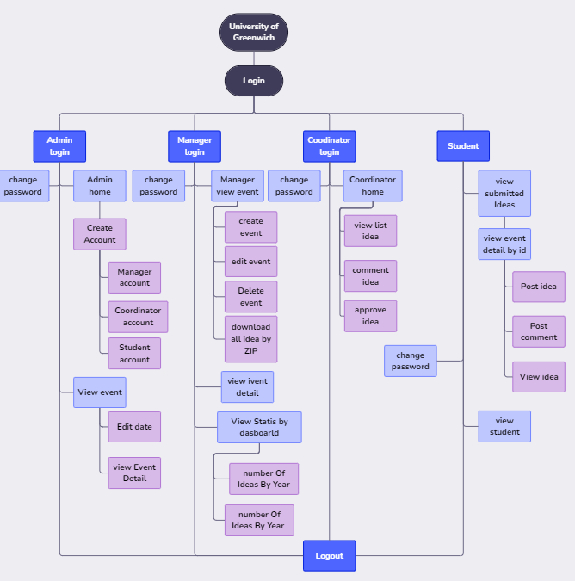

Figure 6 Sitemap

In this section, the sitemap. First is the Greenwich university website, then the Home page at Home will be the Login section to access the website. In this section there are 4 types of login:

admin login: in this section admin will be able to create accounts for (manager, coordinator and student). In addition, the admin also has a section to view all events and view all ideas

Manager login: index manager will have features like viewing all events, adding, editing, deleting events, downloading all ideas by zip file. View statistics by dashboard (number of ideas by year and number of contributors.)

Coordinator login: home page of

Coordinator has the following features, email notifications when students submit ideas, view ideas, comment on ideas and approve postings.

student login: student home page has the following features: (contribute ideas, edit ideas, view ideas and receive email notifications for individual ideas when there are new comments.

## 4.2 wireframes

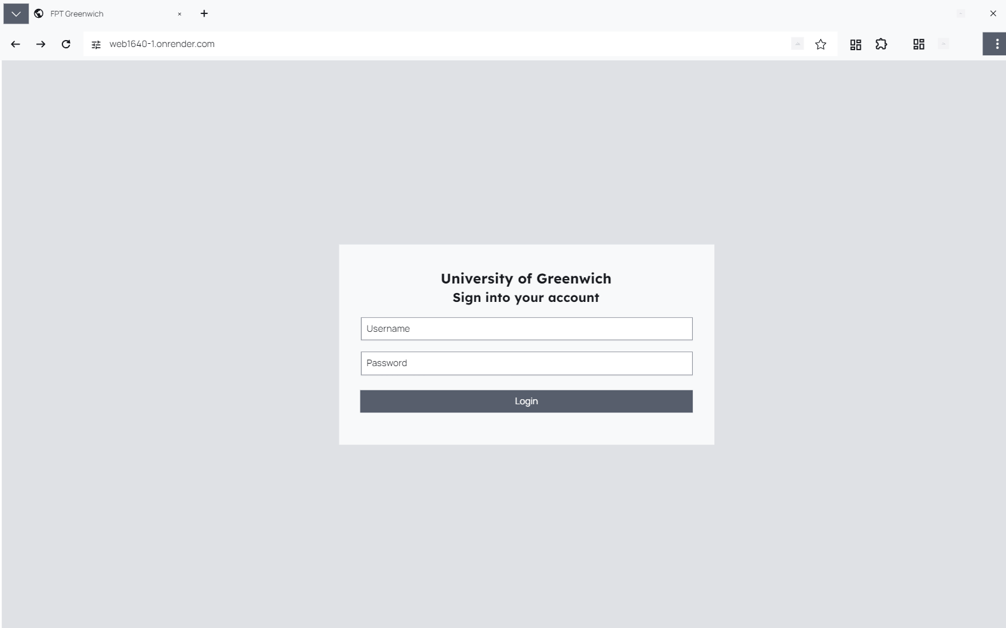

Figure 7 Login Page

This is the home page that when the user accesses, the login page will be displayed for the user

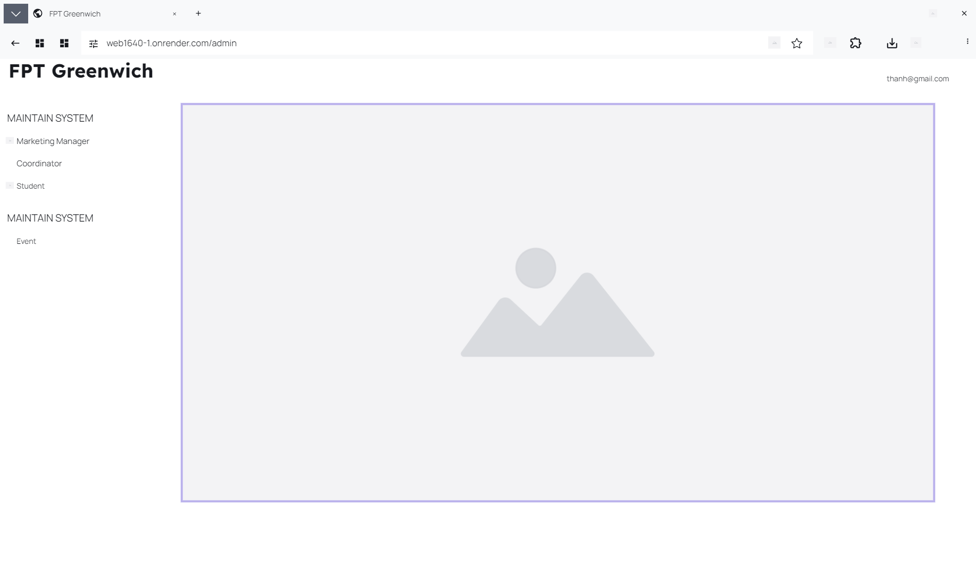

Figure 8 Admin Homepage

On the Admin page, managers, deans and students can be managed.

In the main system, the page manager can manage events such as student posts or comments from deans and students.

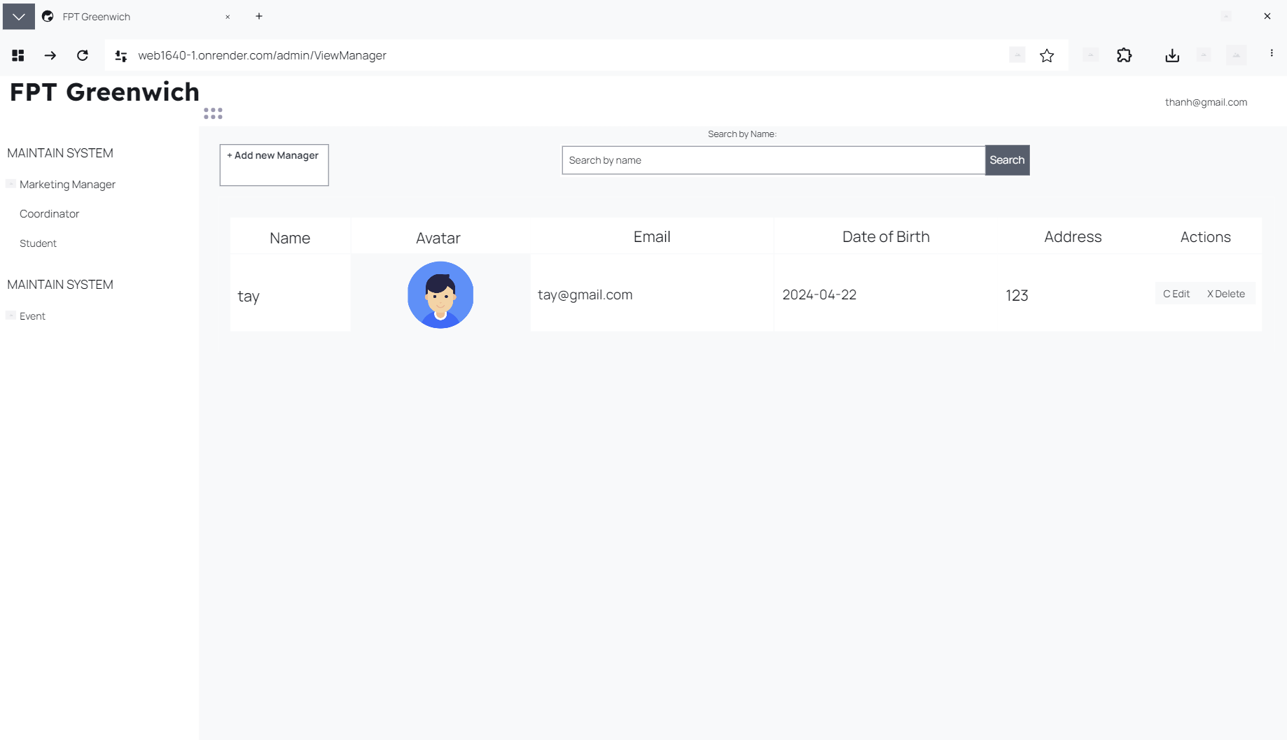

At Marketing Manager, a side page appears where you can see details about your name, photo, email, date of birth, address, and actions that can be edited or deleted. In this page, administrators can add people with admin access and search for admins by name.



After the manager uses the action to be able to edit, the page will be transferred to edit Manager so that the information of the admins managing the page can be edited.

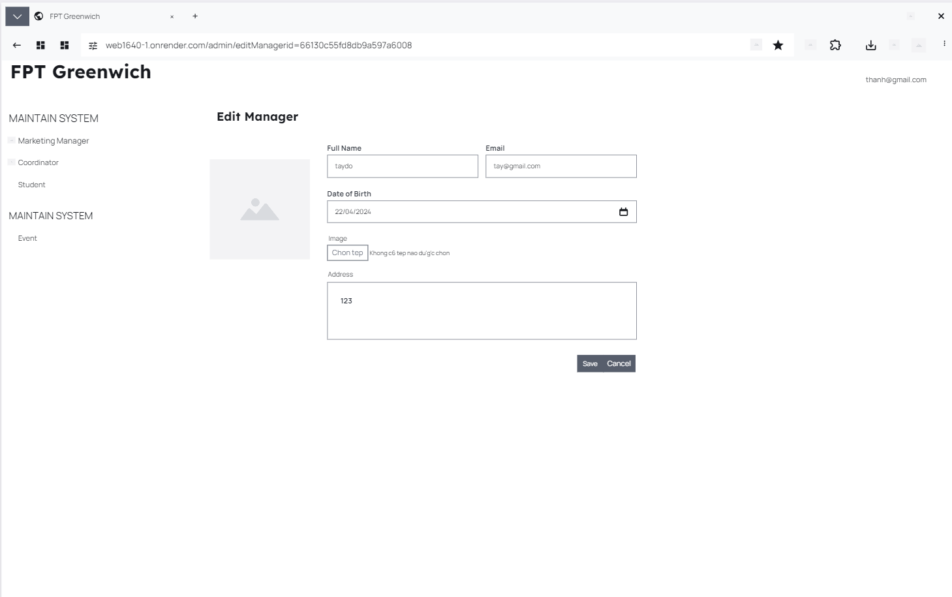

Here the manager can view the initial information in detail. If the manager can change the information, he or she can click Save to return to the original page to clearly see the manager's detailed information.

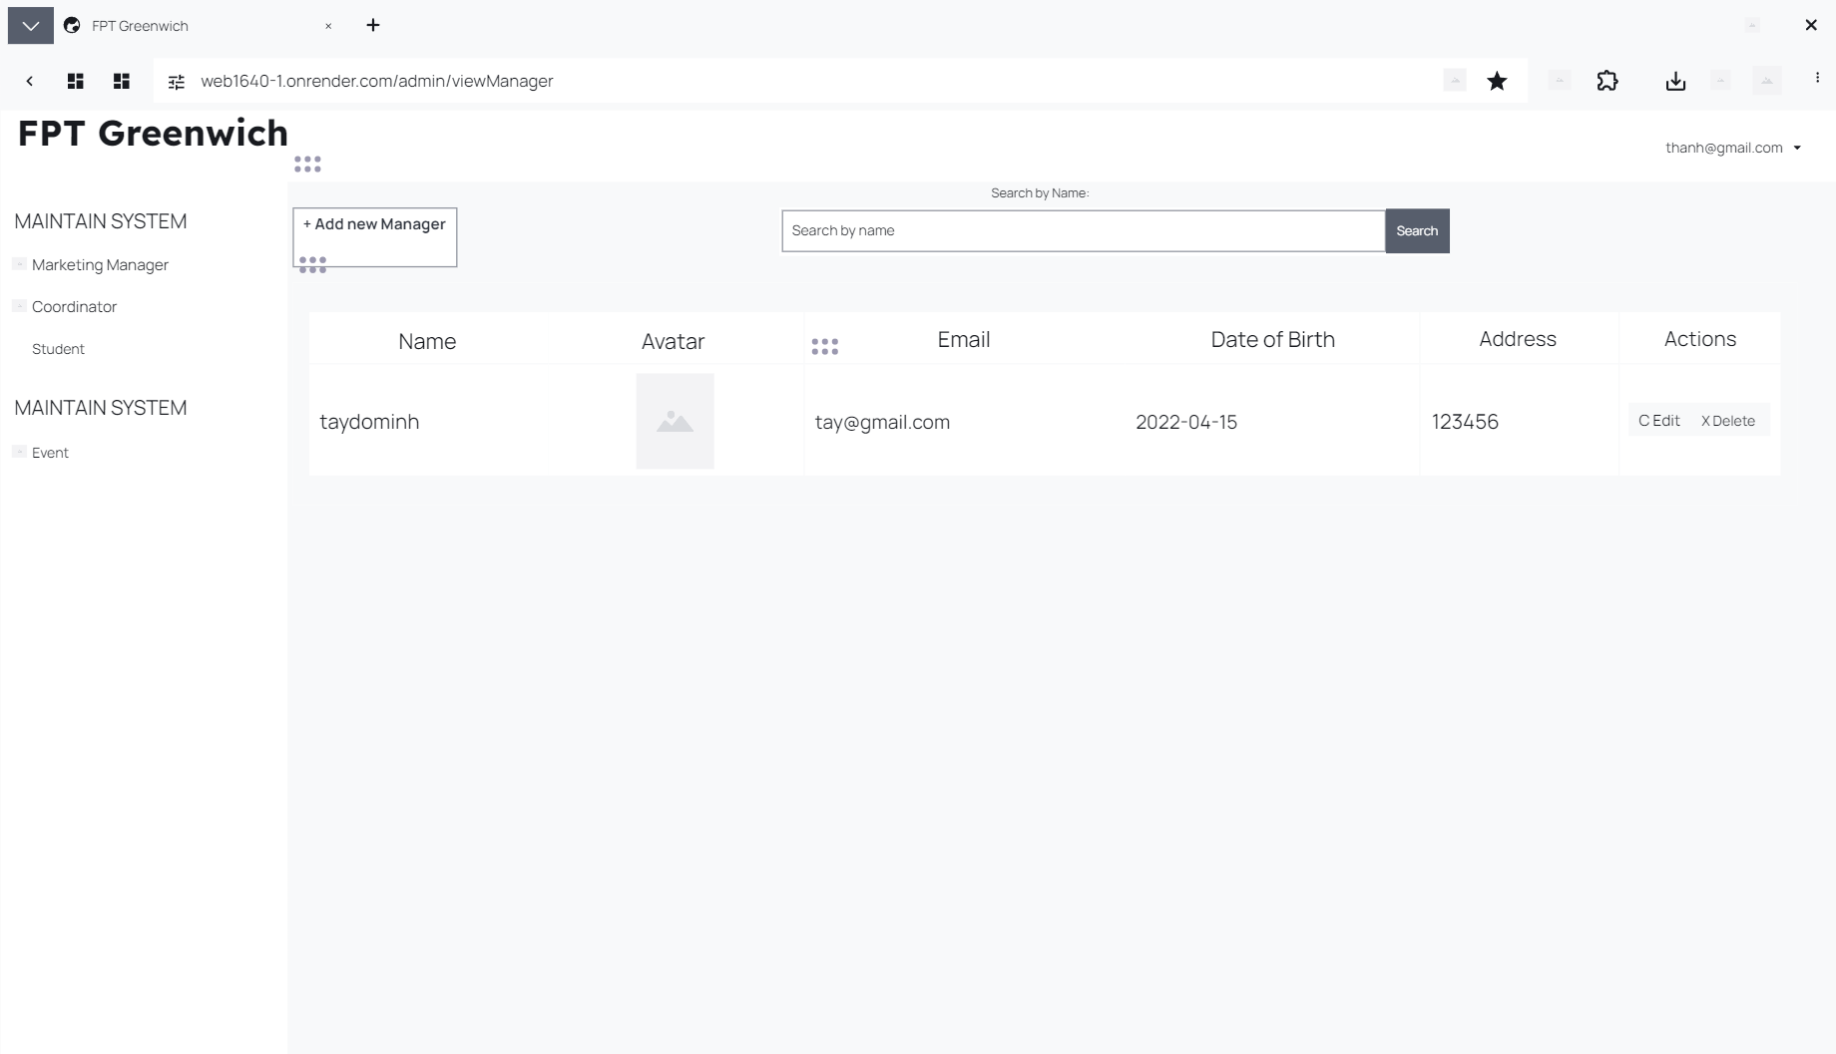

This page has been returned to the main management page to see the management section after being edited from name, date of birth, and address.

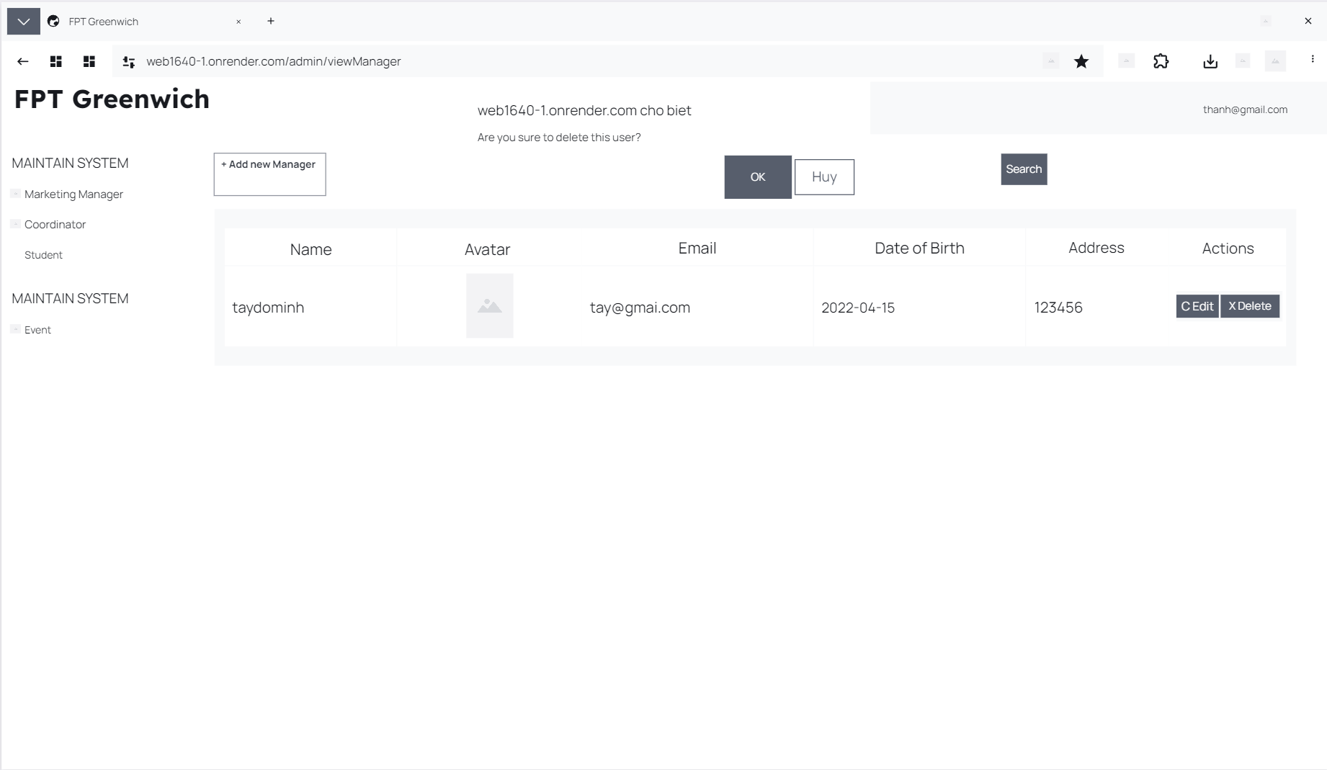

If the manager wants to delete the manager's information, after pressing the delete action, the message "you are sure you want to delete this user" will be displayed. After pressing delete, that information will no longer be displayed.

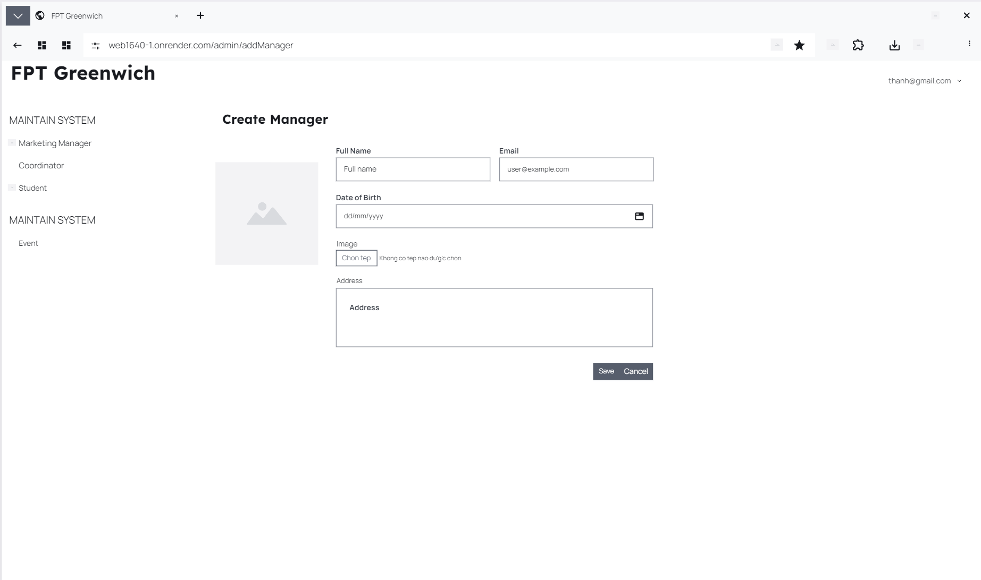

Figure 9 Add Manager

After adding information, the manager will be displayed on the main management page.

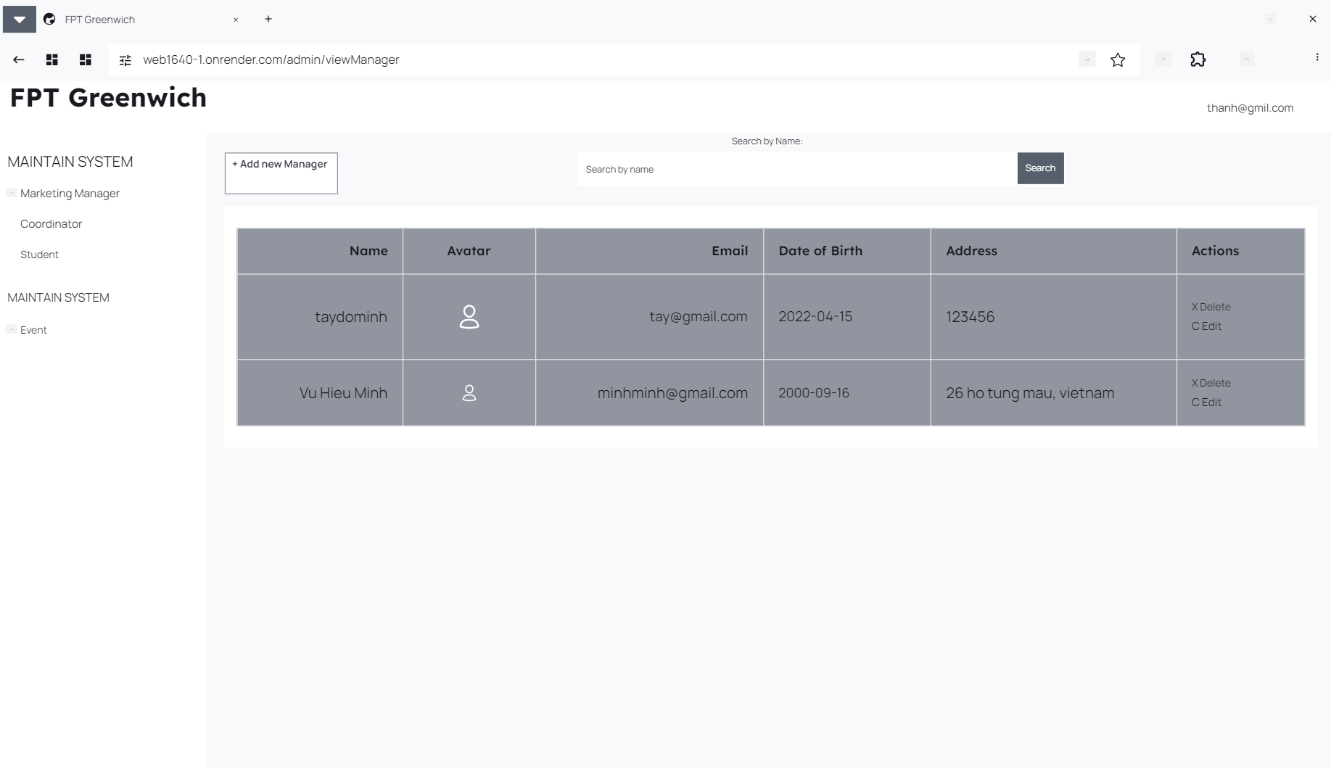

This is the information after being added to the page by the manager and displaying detailed information on the admin page.

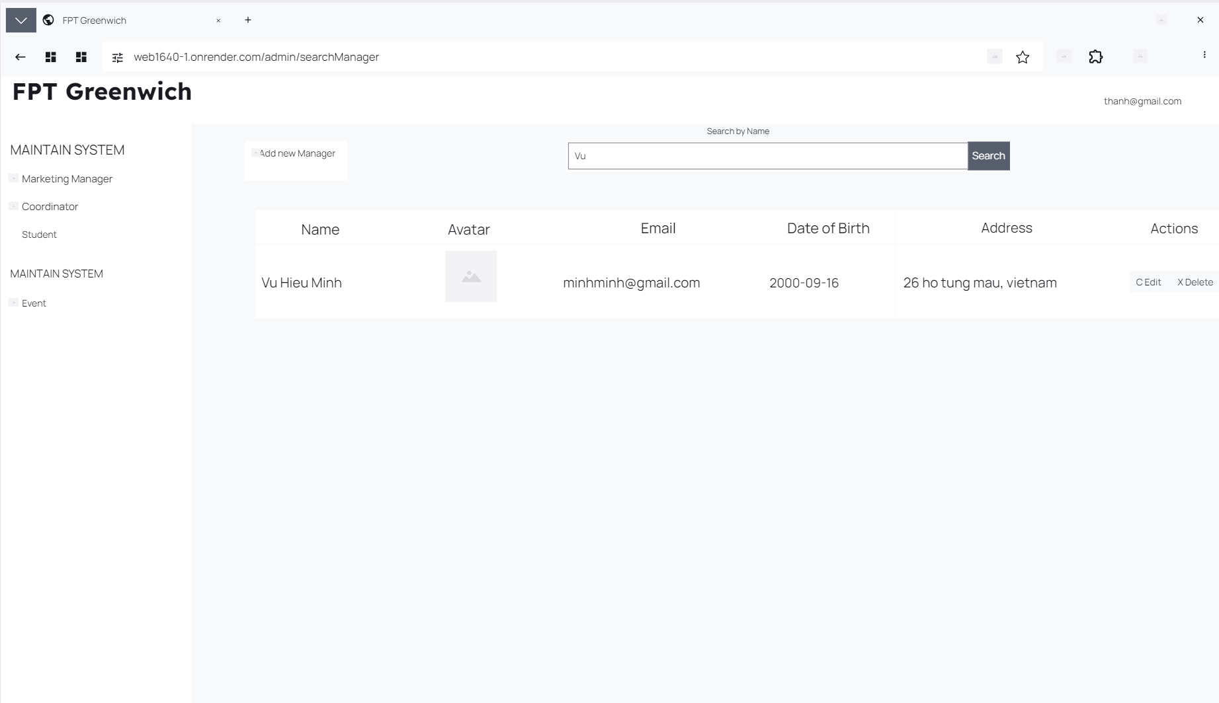

Managers can search for managers by name and after pressing the "Search" action.

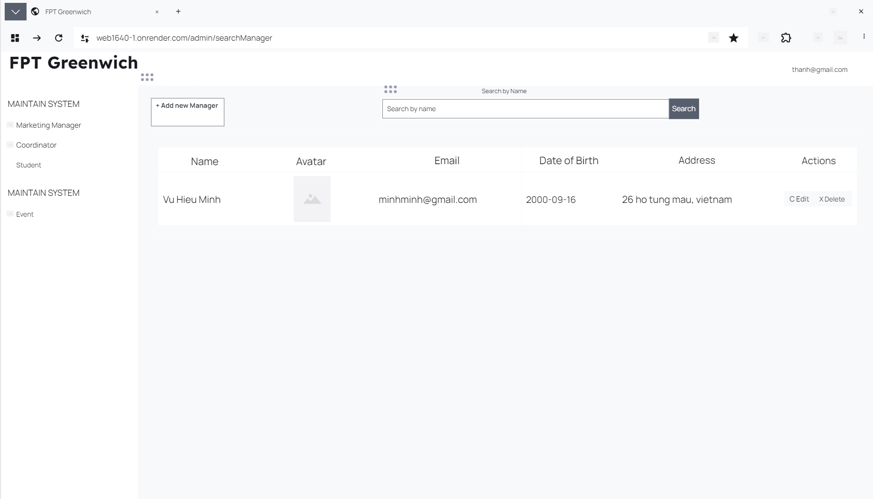

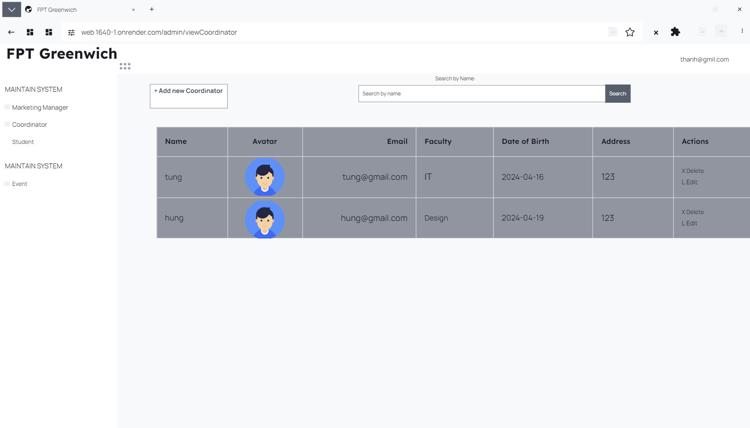

Figure 10 View Coordinator

On the administrator's page, the dean function can be accessed to edit information of deans, add deans, and search for deans' names.

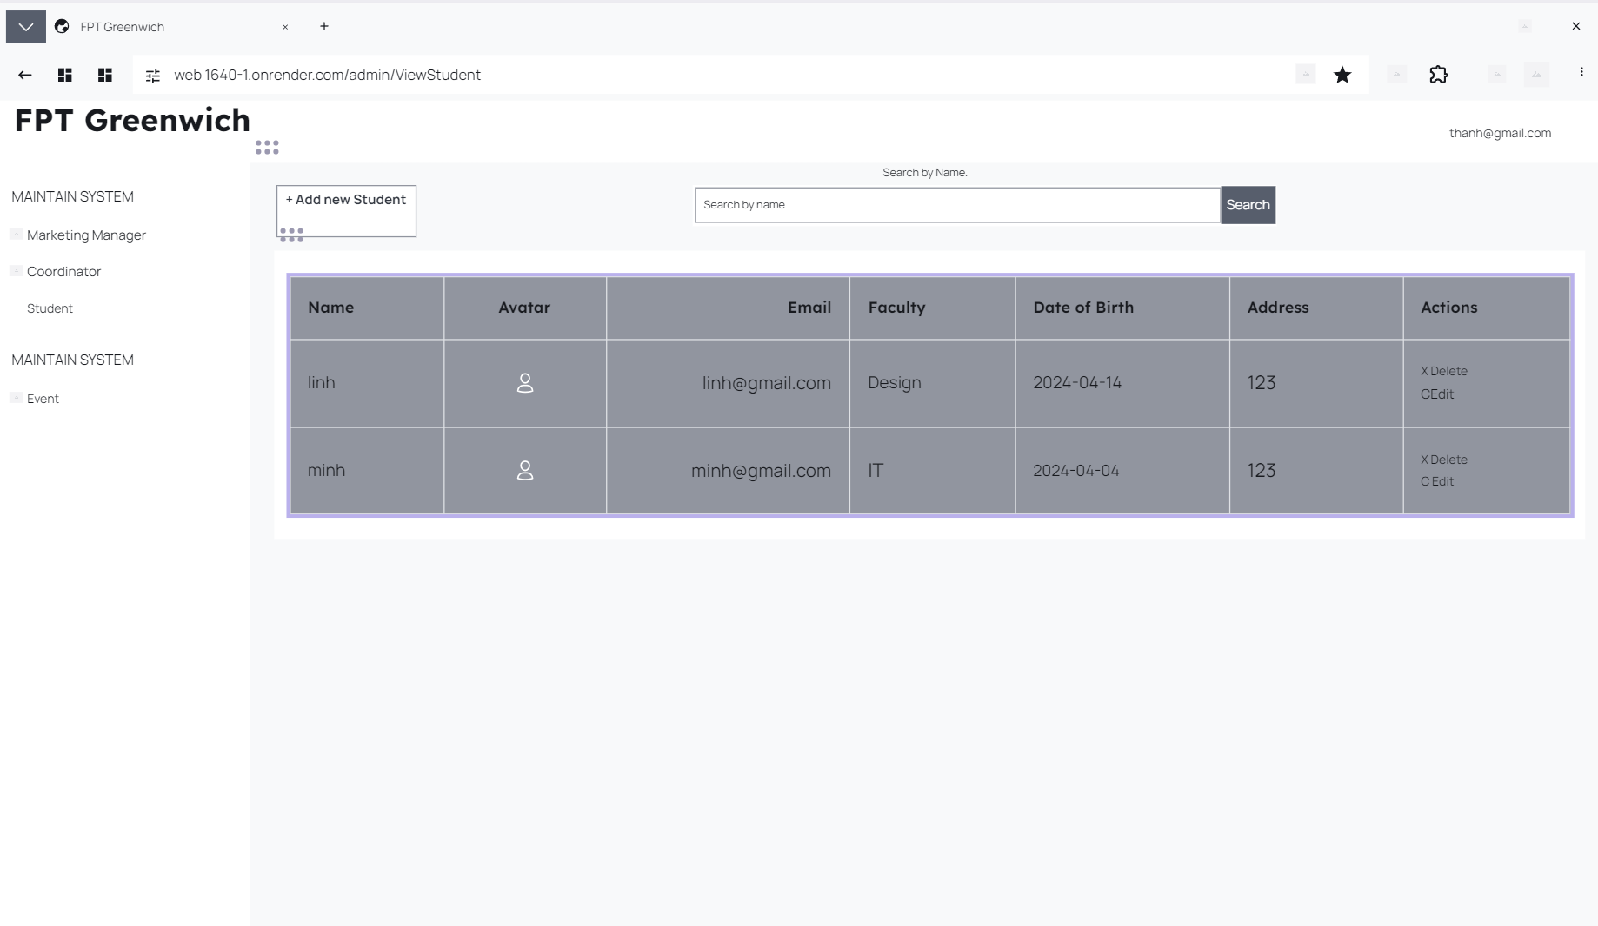

Figure 11 View Student

On this page, site administrators can also view student information and can add new students and search for student names.

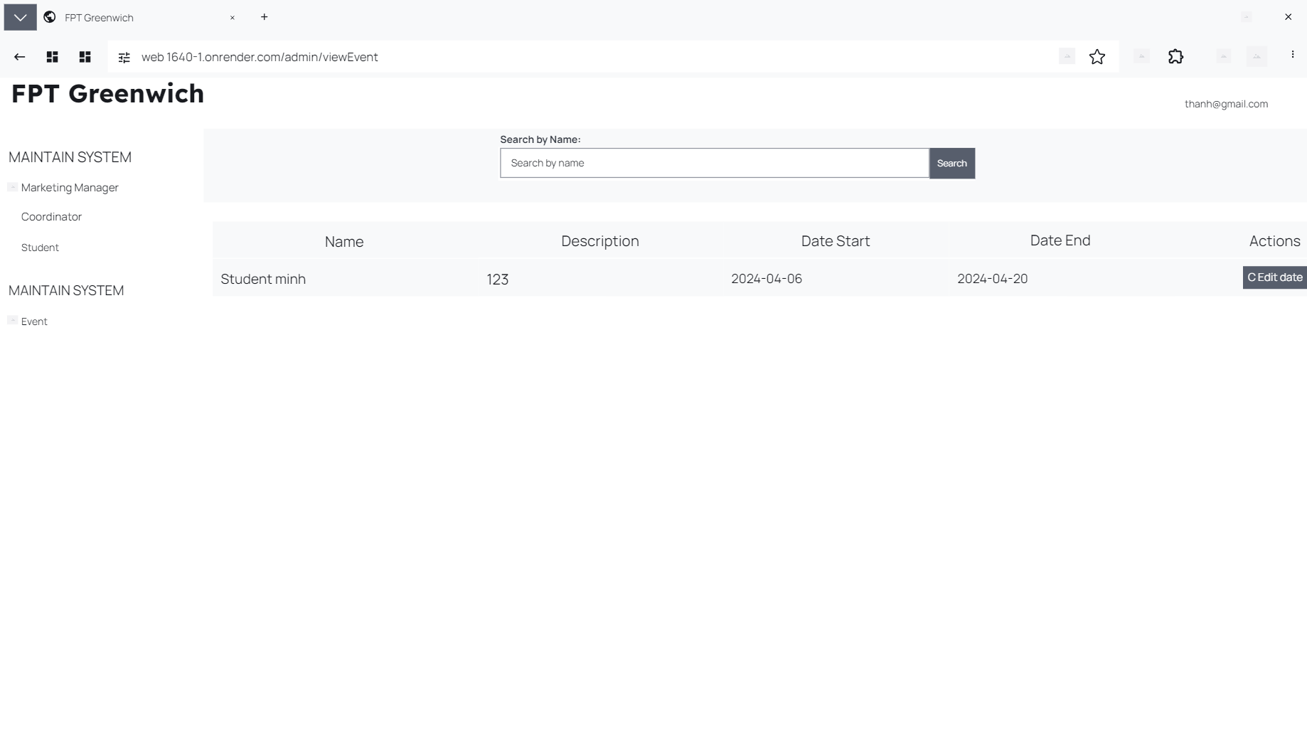

Events that administrators can control include information, descriptions, start and end dates, and the author can change the student's start date. Site administrators can view student and dean posts and comments but do not have access to make changes.

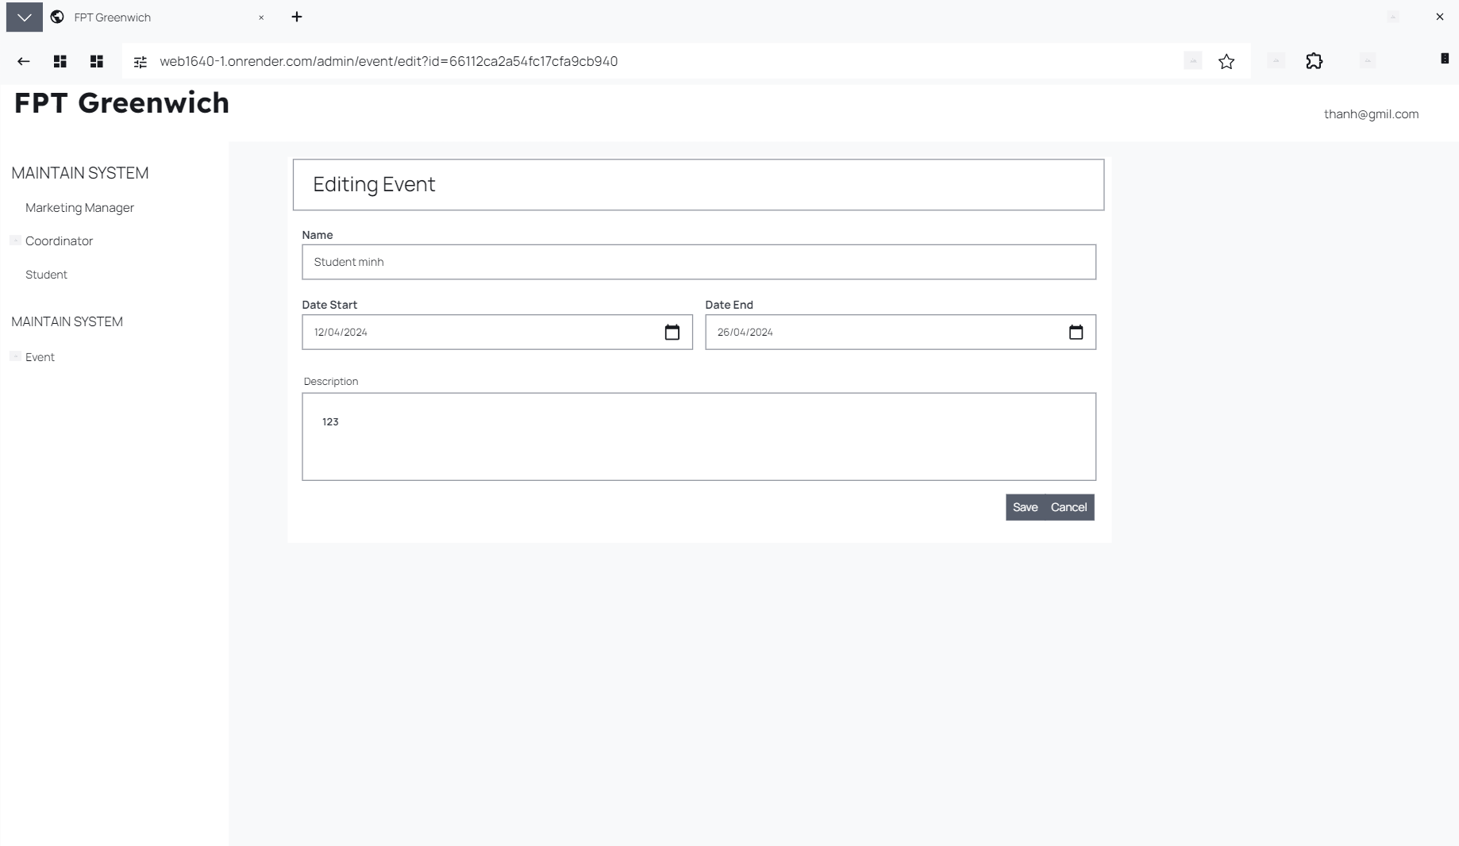

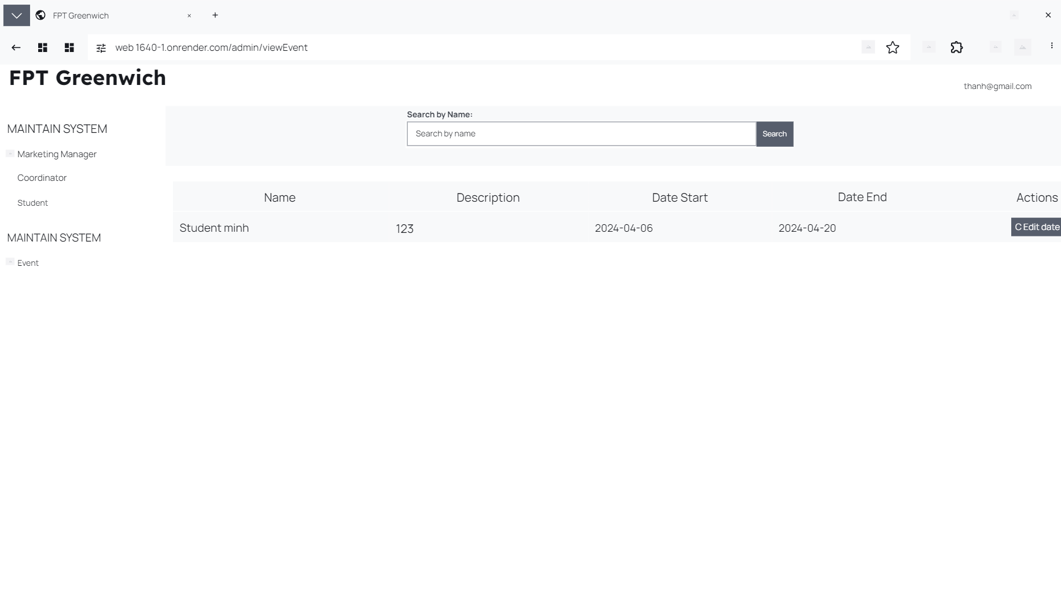

After managing the page, clicking on the student's name will be redirected to manage student posts and comments from students and deans.

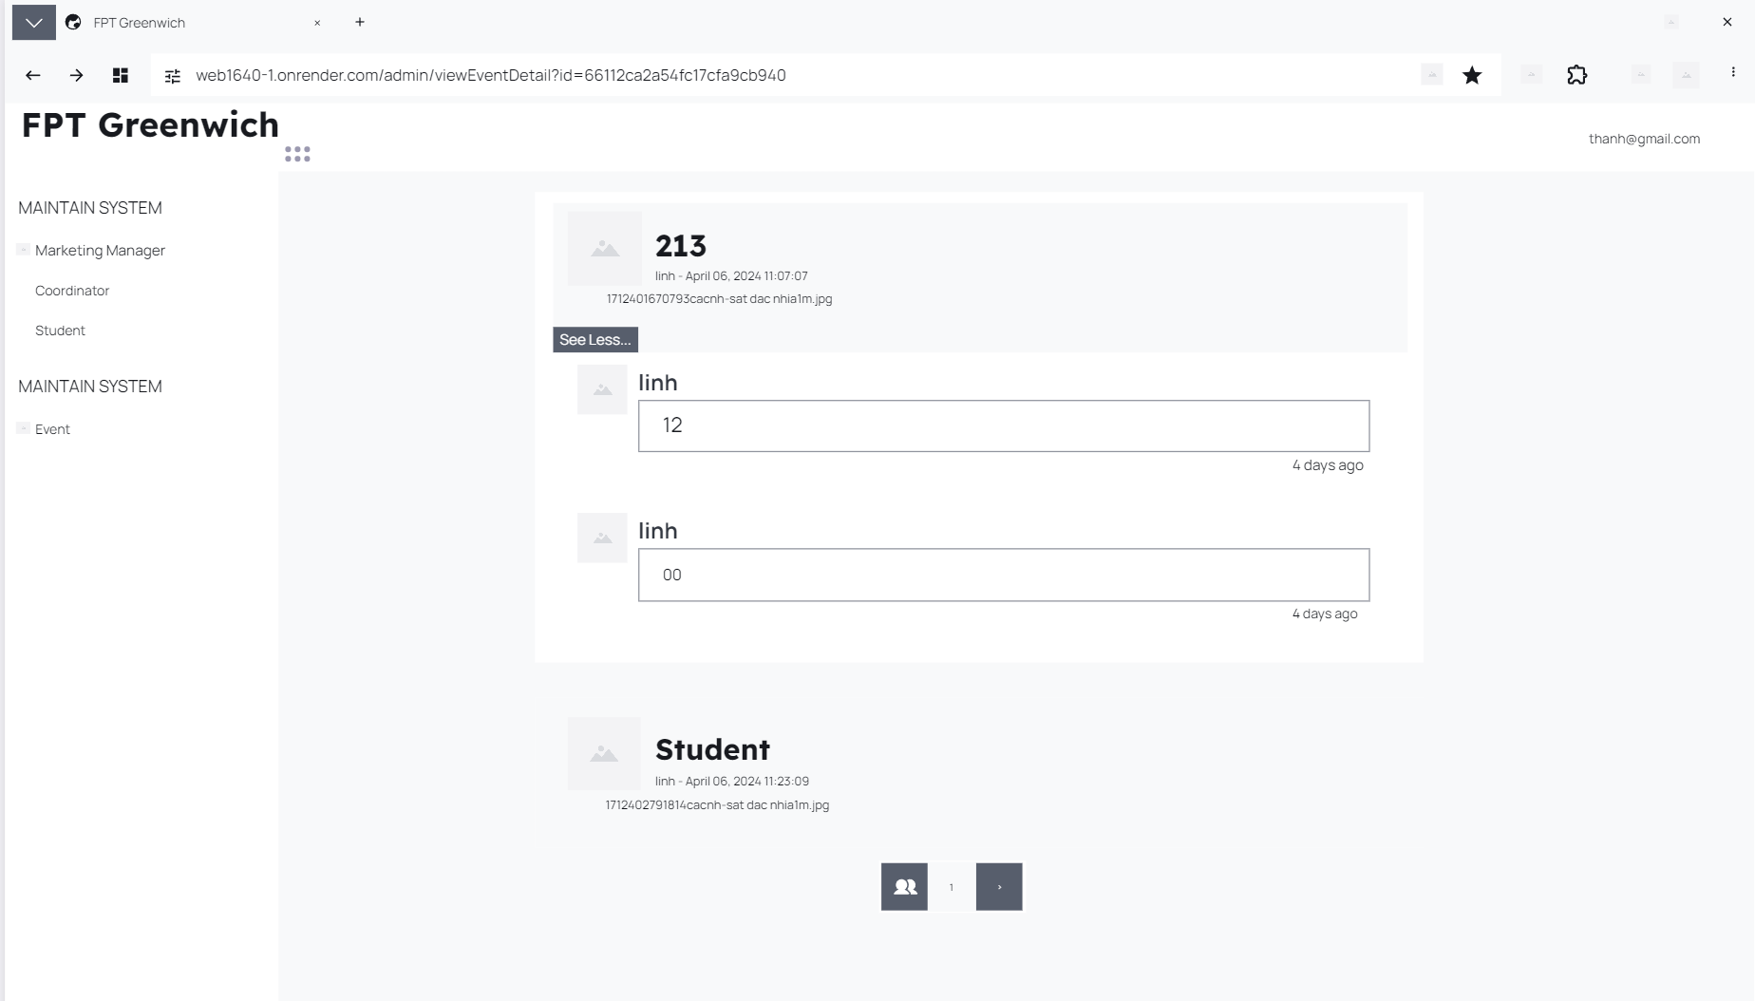

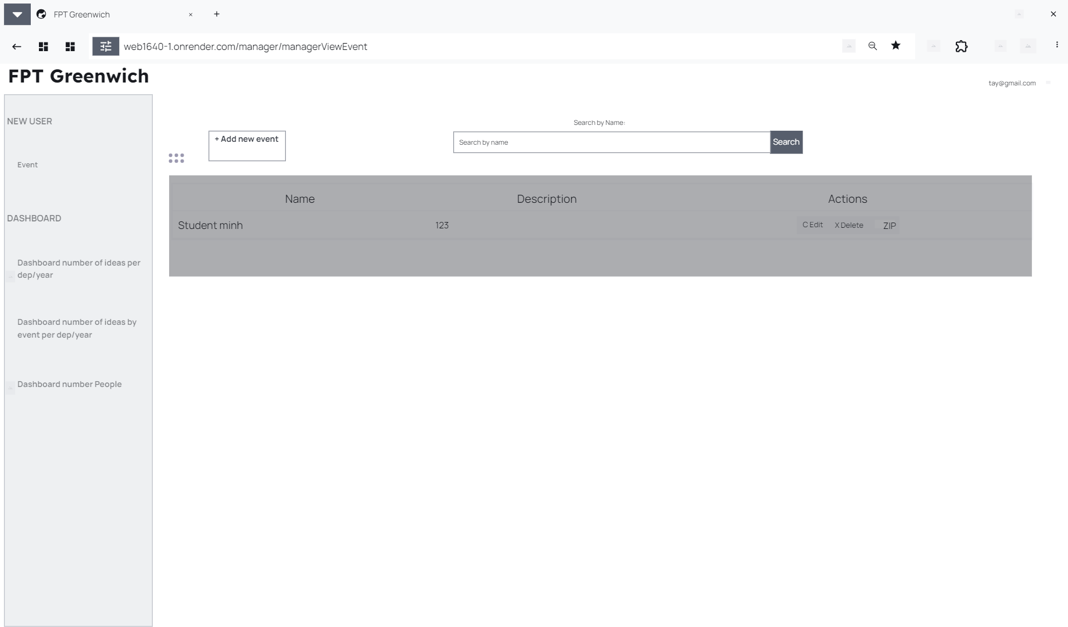

Figure 12 Manager View Event

This page is the main page of student management, administrators can view detailed information such as names, descriptions and actions for students such as editing, deleting, and downloading ZIP folders.

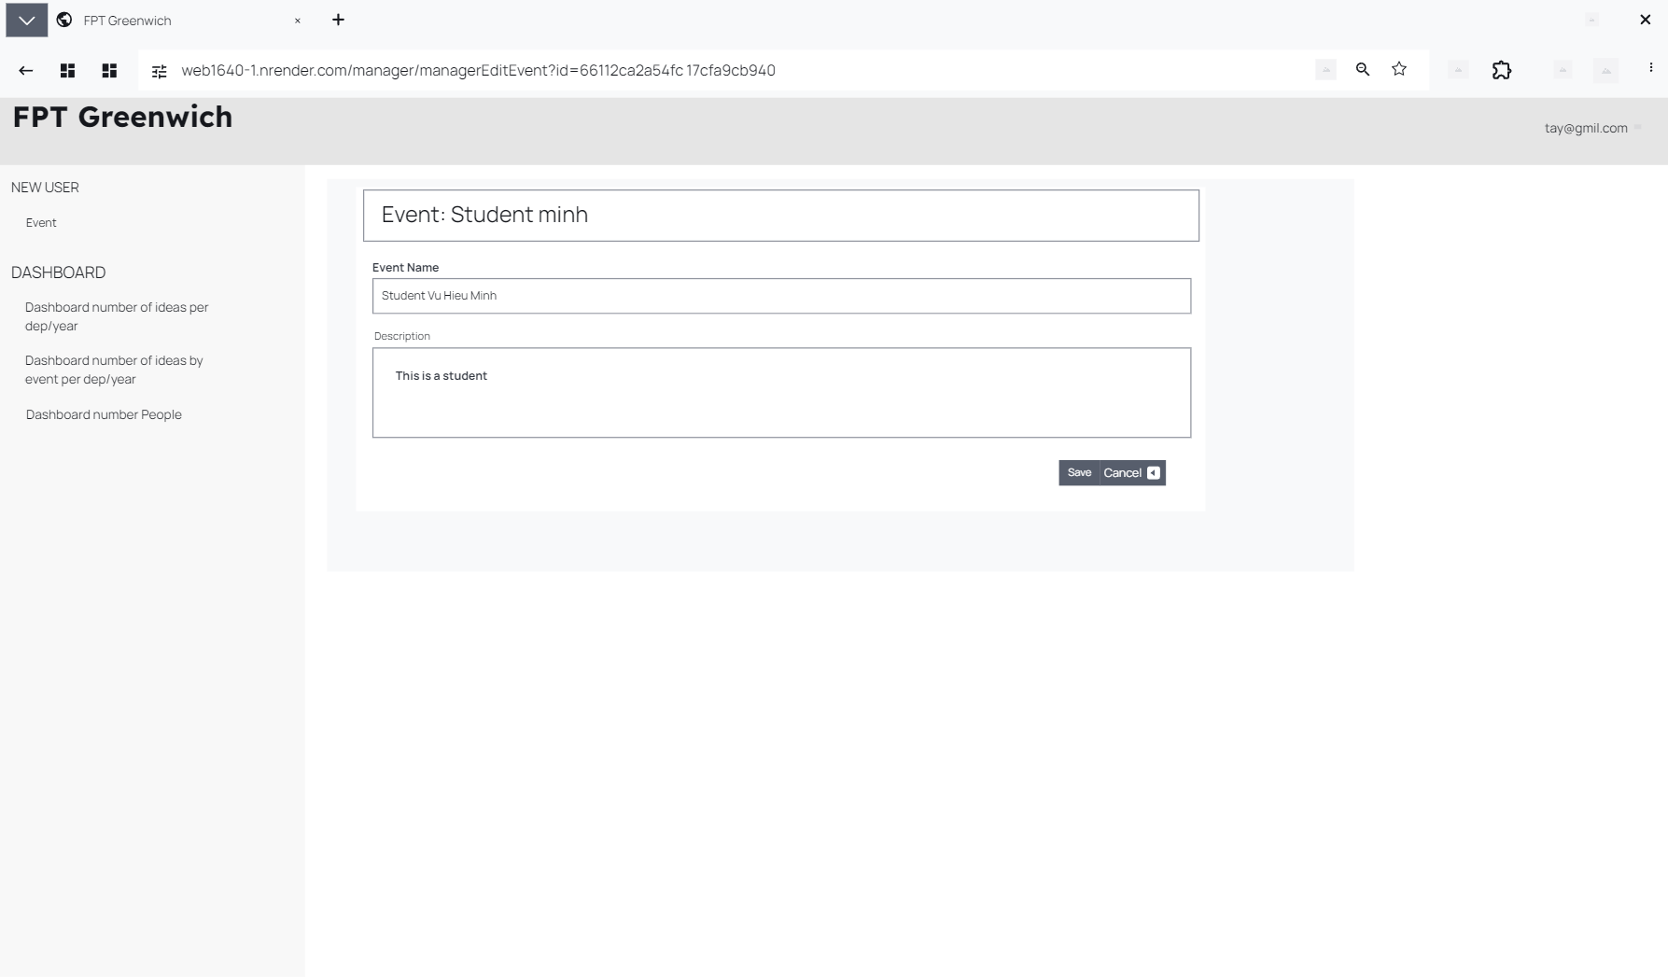

Figure 13 Edit Event

Administrators can change the student's name and description to be able to access and view student information.

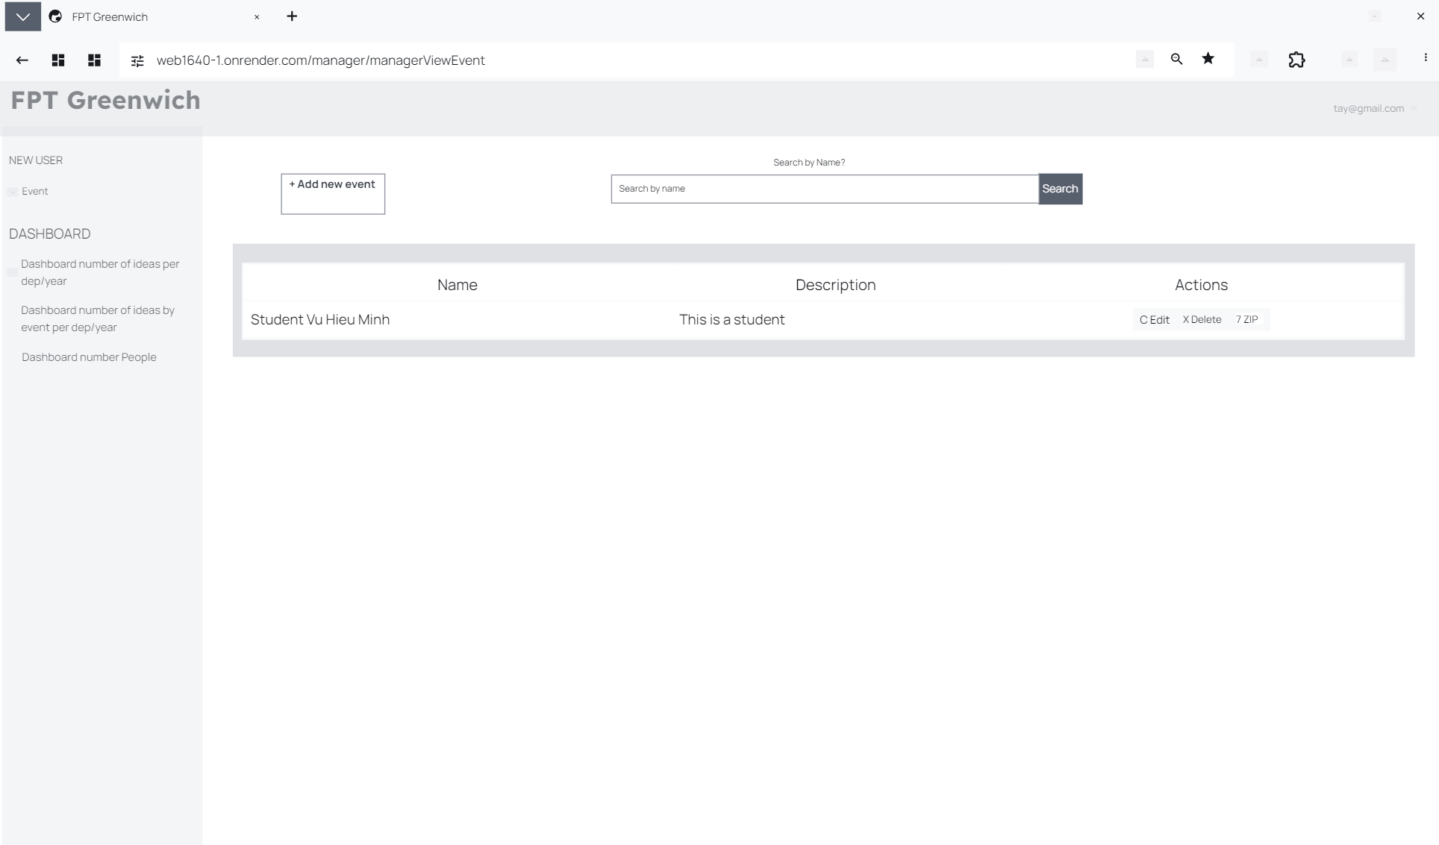

This is the information after the student's manager can edit the student's information. In addition, actions such as deleting and downloading Zip files are processed by the manager for the student.

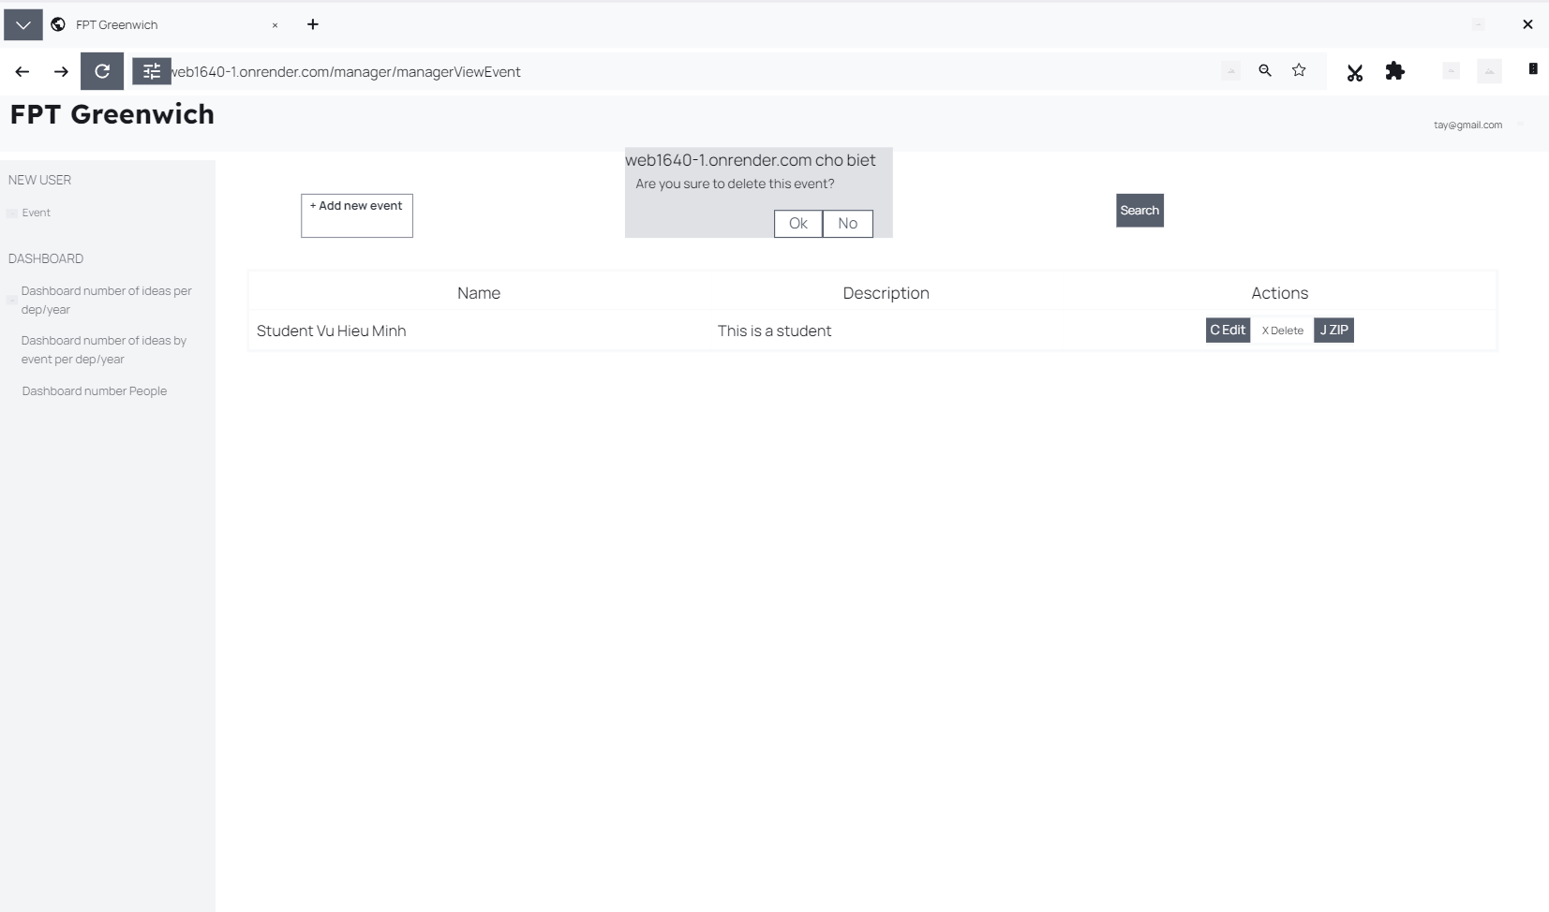

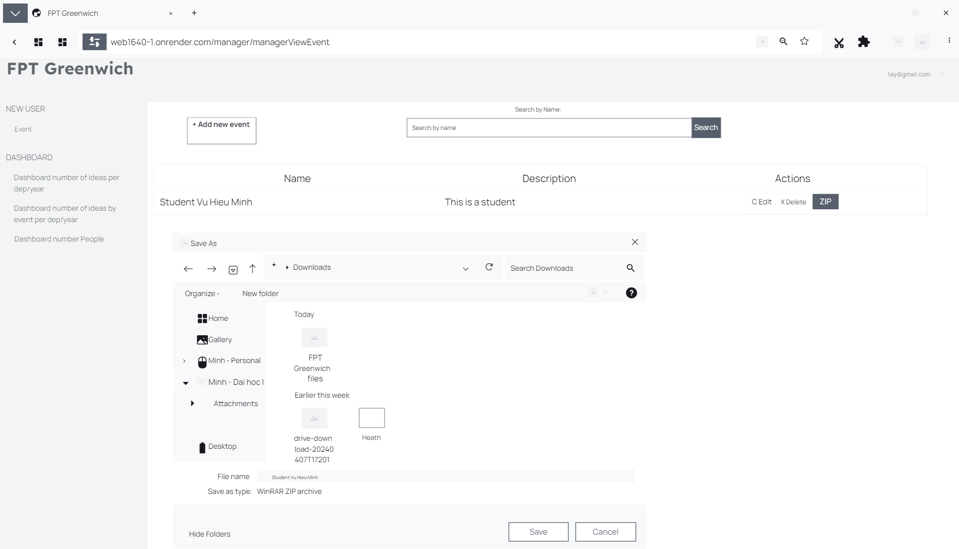

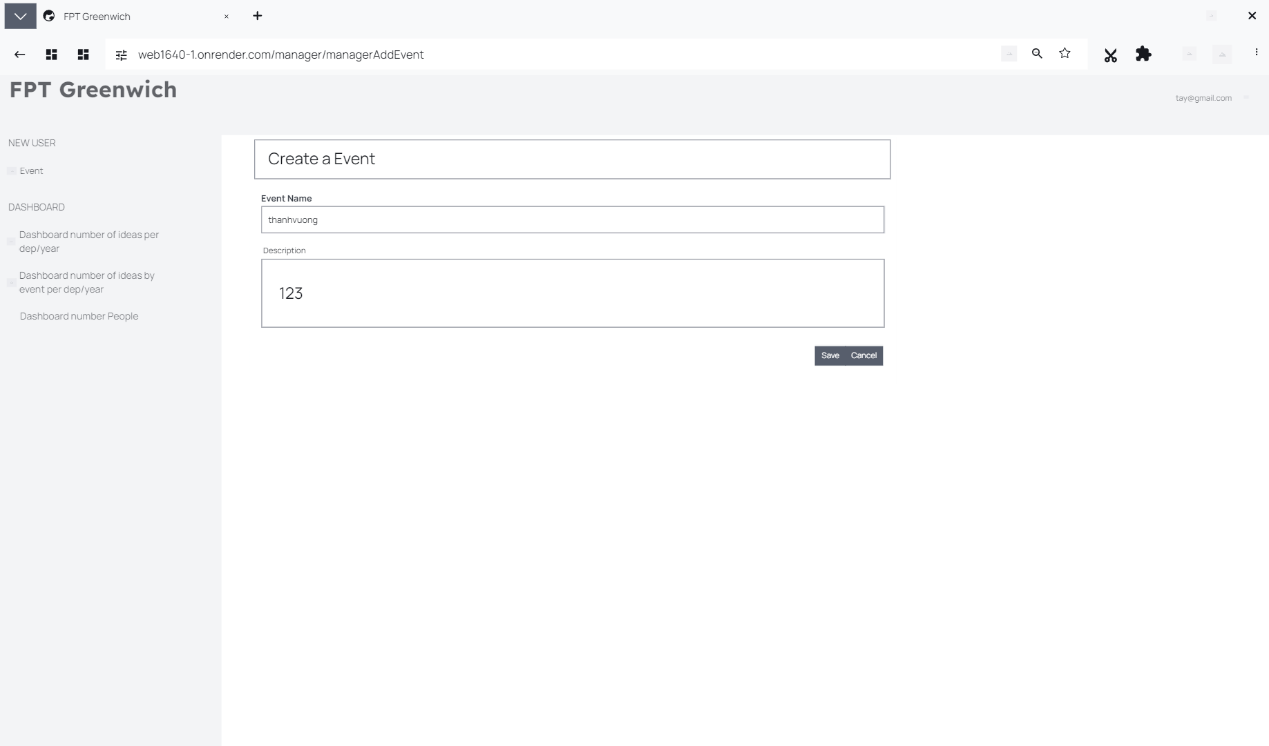

Figure 14 Add Event

After adding events, just click save and the site manager will be able to control student information.

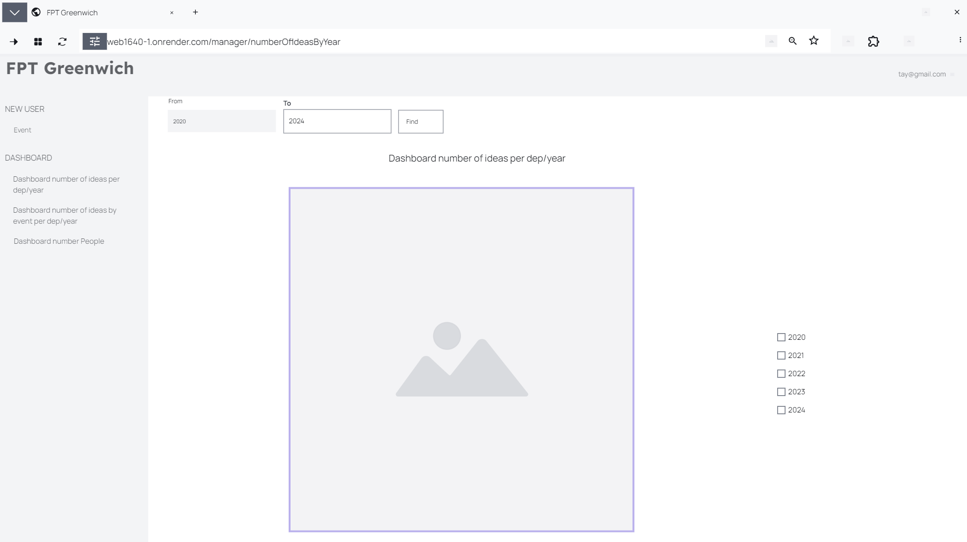

Figure 15 Number Of Ideas By Year

The number of ideas on the panel per charge/year is defined as the students participating in posting across the years.

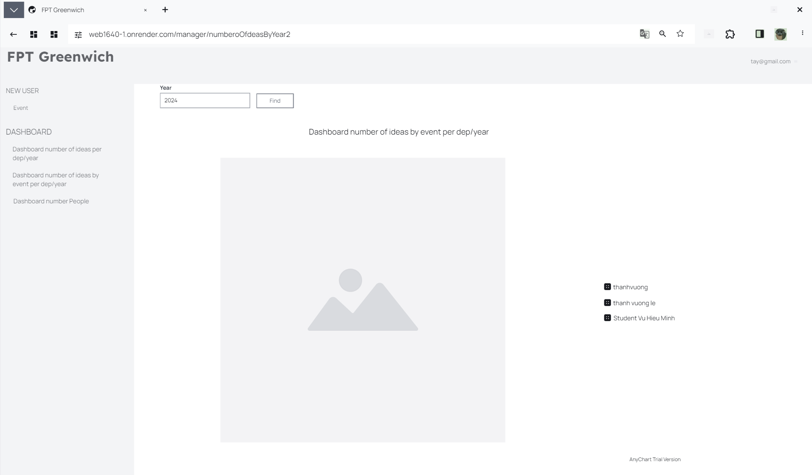

Figure 16 Number Of Ideas By Year2

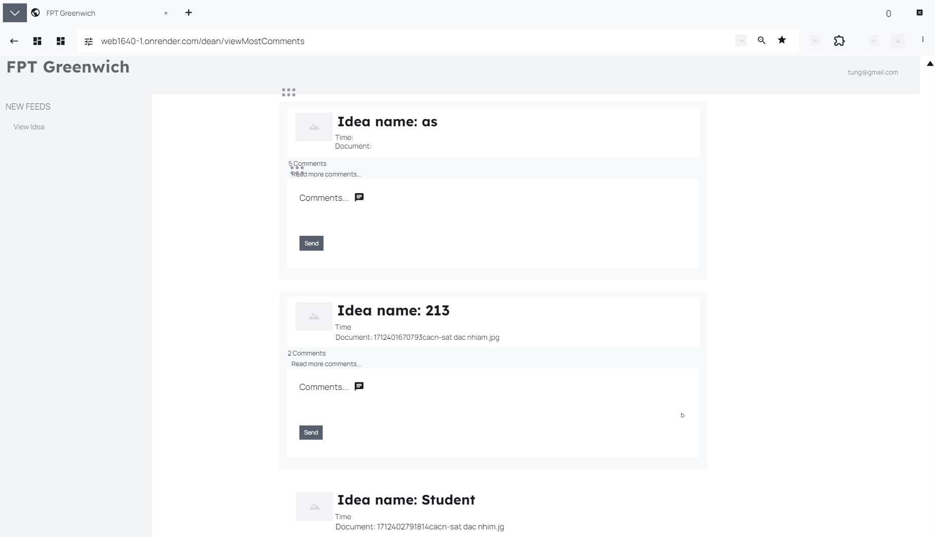

Figure 17 View Most Comment

On the department dean's page, lecturers can see the ideas that students post, in addition, lecturers can see all comments that students or lecturers make.

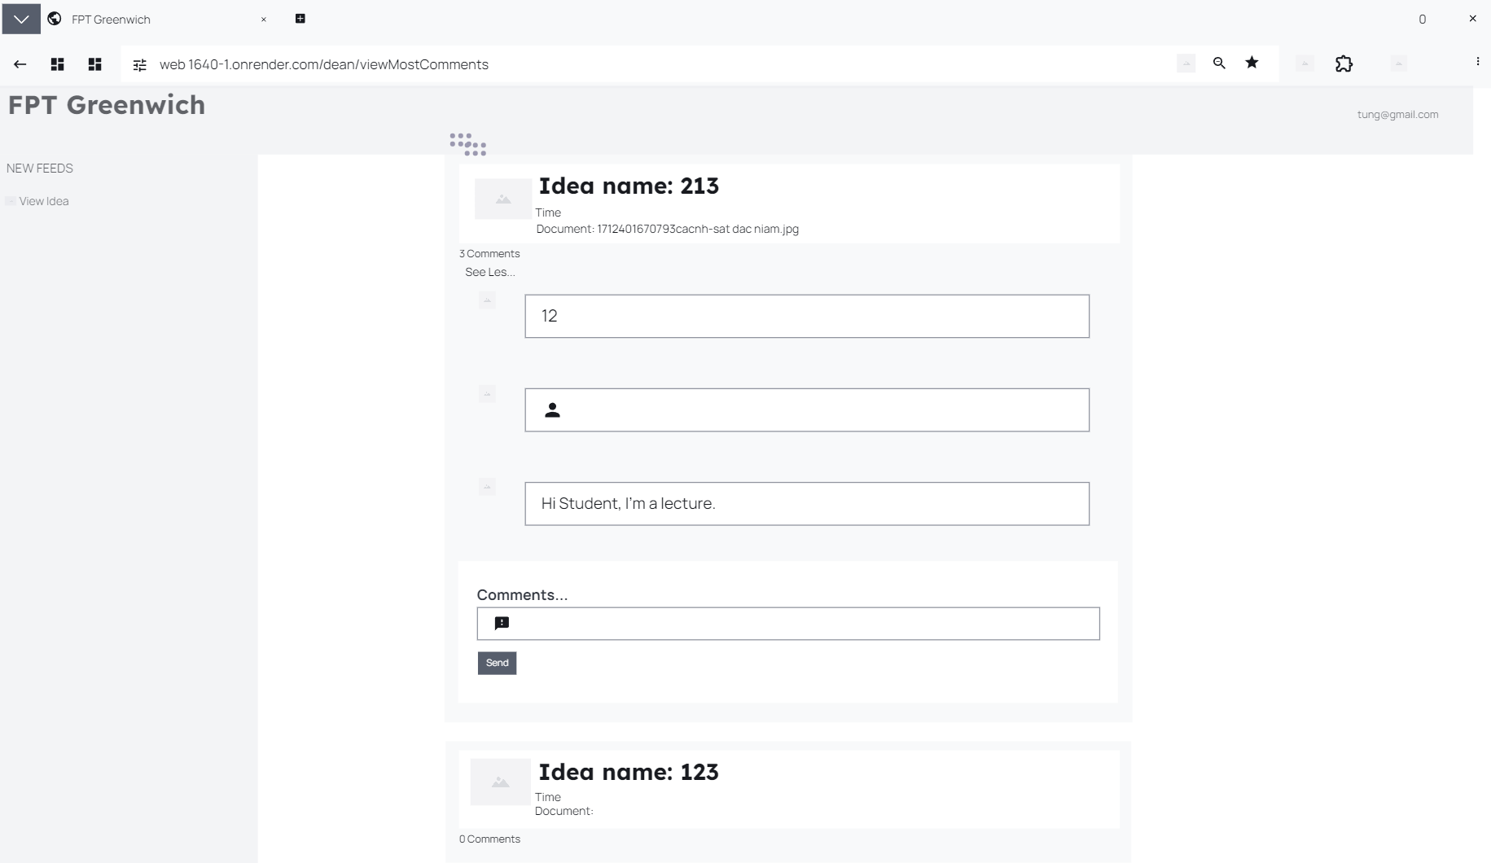

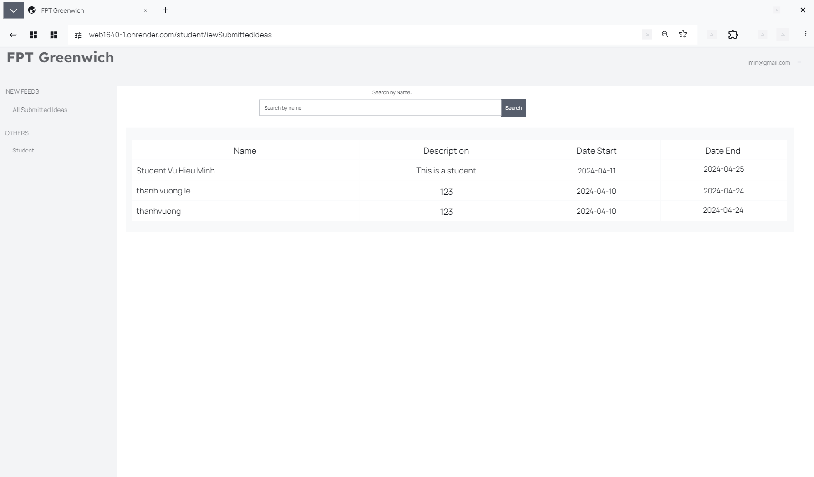

Figure 18 Student Page

Student pages can create headlines for articles and can view comments from students and deans. Students can also search for their name.

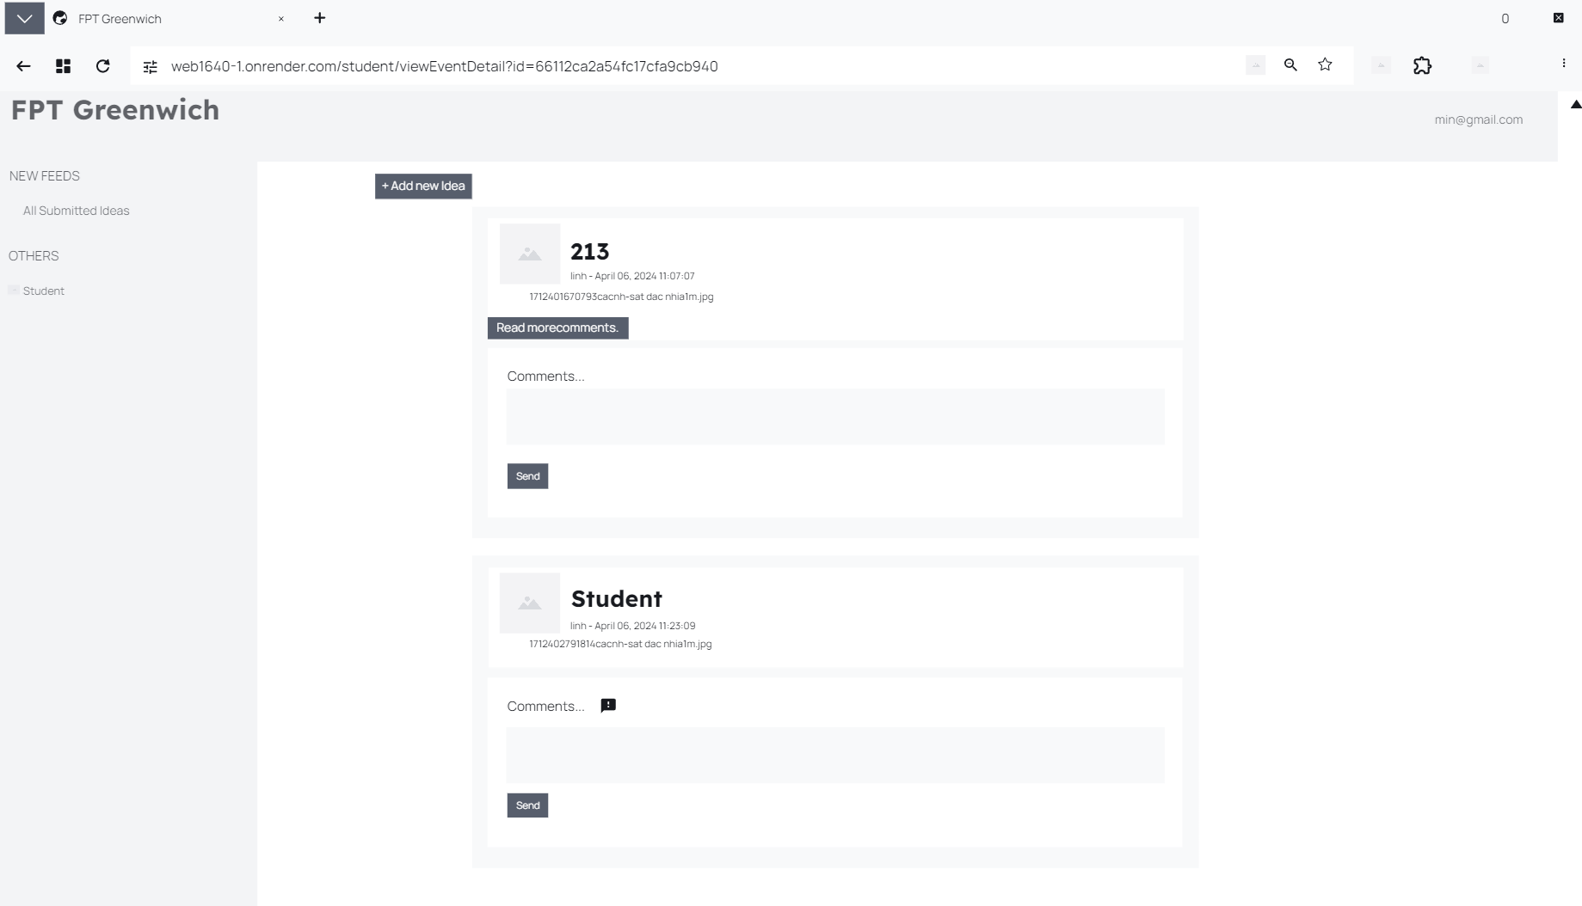

After students comment, they will be able to see the details of the comments or the titles given.

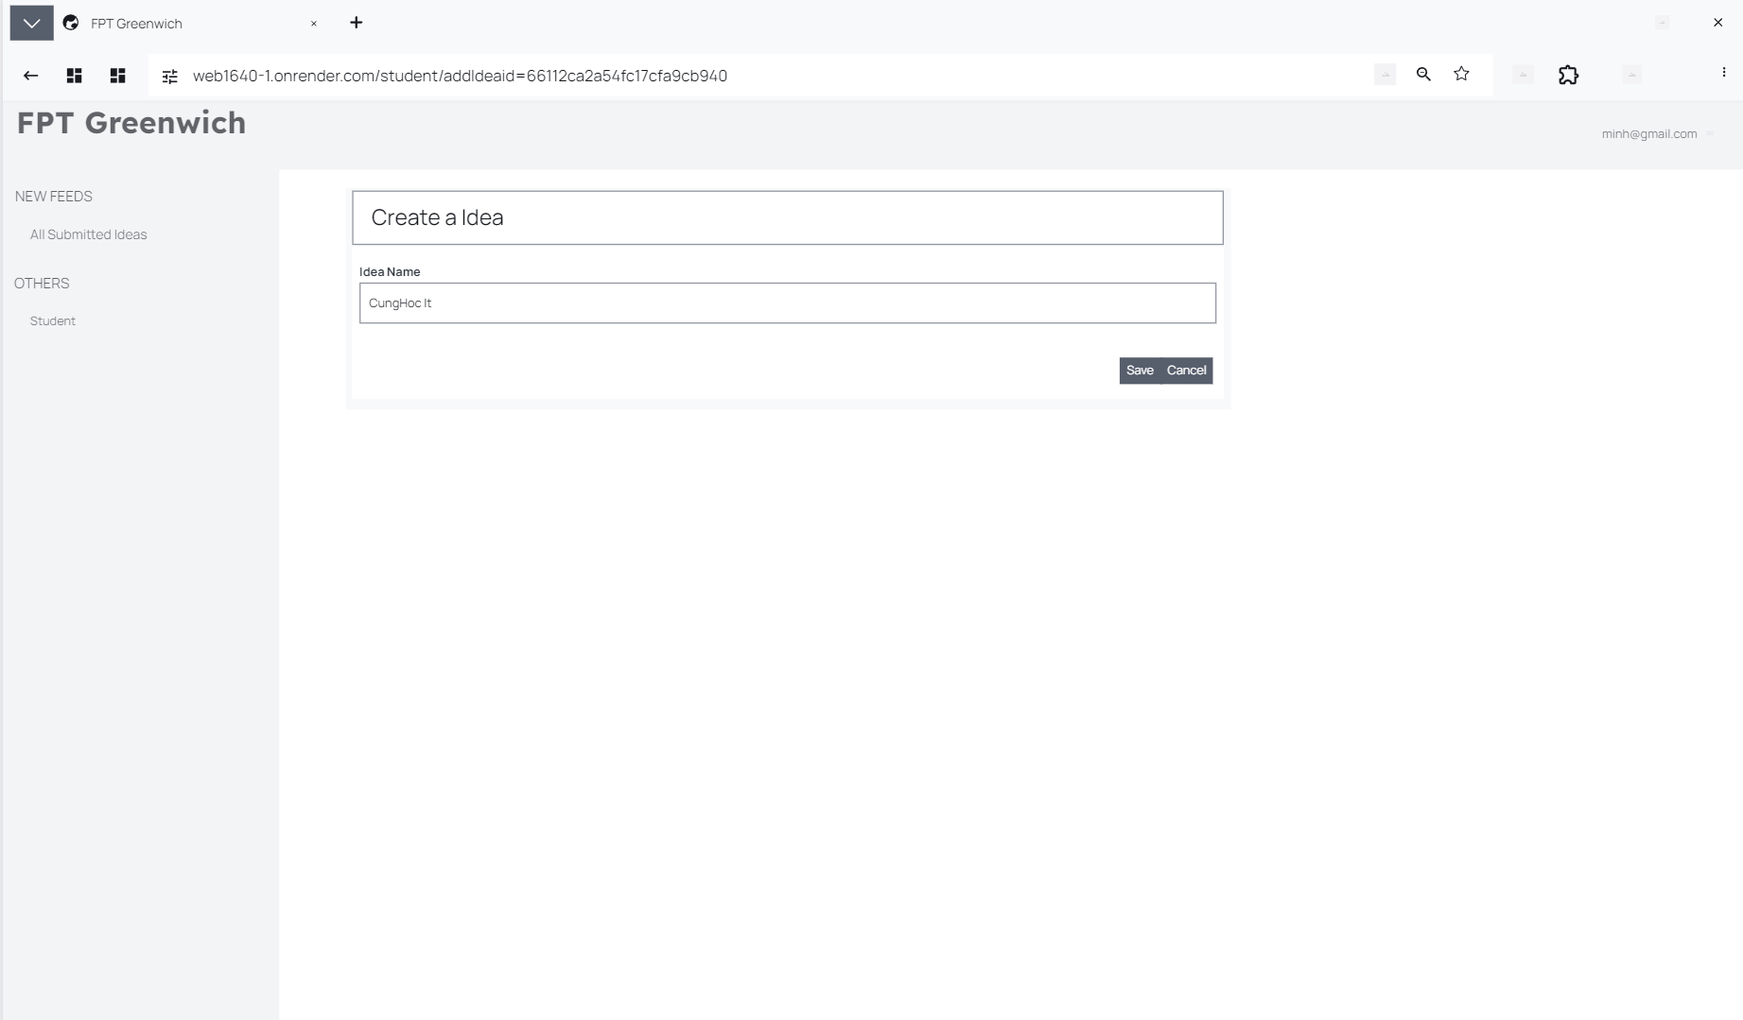

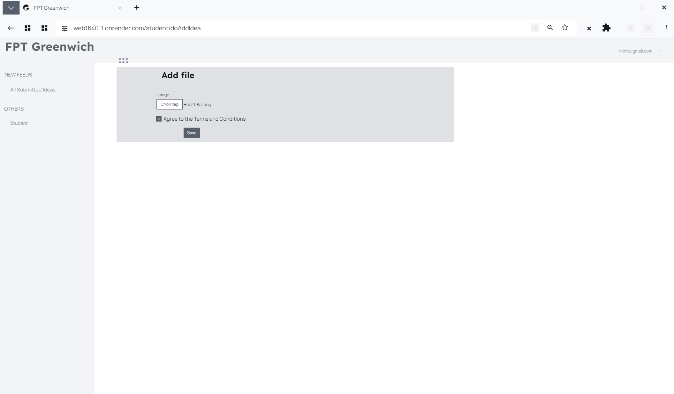

Once students want to post, they will need to select a photo for the title and will need to click "yes" to certain topics and click save to be redirected to the title and comments viewing page.

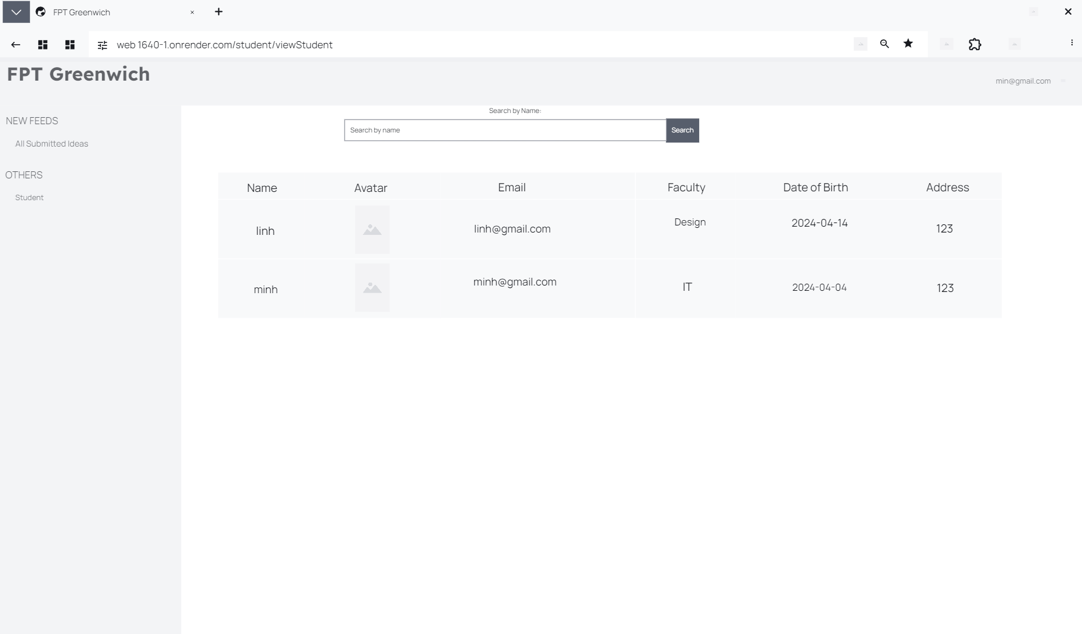

On the other hand, students can only view student details and are not given access to add, edit, or delete.

## 4.3 flowcharts

Flowchart View all selected contributions:

View all selected faculty entries (editing is not allowed): initially it gathers all contributions, then checks the number of valid contributions, otherwise it returns invalid and terminates program, if valid, returns true and prints those statements.

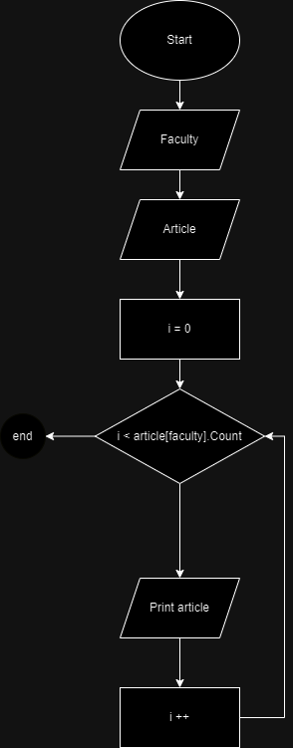

Flowchart Download contributions in ZIP format:

Upload file in ZIP format for download: First it gathers student contribution via student id, then compresses that contribution as zip file and prints link to download location of the file .

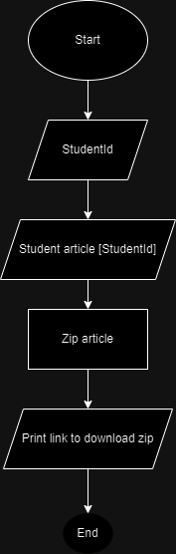

Diagram View statistics:

View statistics, first access all contributions and then check the number of contributions to see if they are guaranteed or not. If the number of contributions is guaranteed, calculate the number of submissions for this department with all departments, then print it out and close the program.

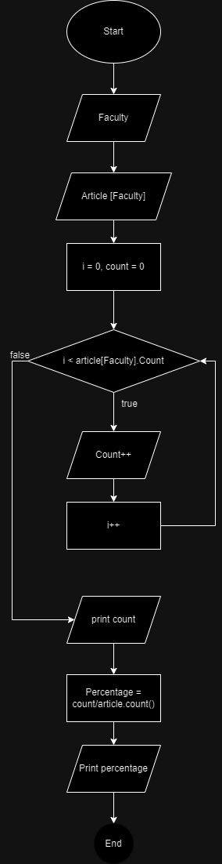

Flowchart View student contributions in a specific department.

View student contributions from a certain department: Coordinators can only view and cannot change contributions. The system performs a search on every student enrolled in the course the coordinator is teaching, prints them all, and then views it.

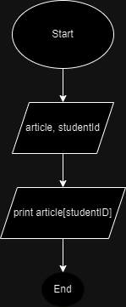

Flowchart Receive notifications (emails) of new contributions.

Receive email notifications when new contributions are made: After a student submits a contribution, the coordinator will be taken to the new contribution and comment and then confirm or ignore the post.

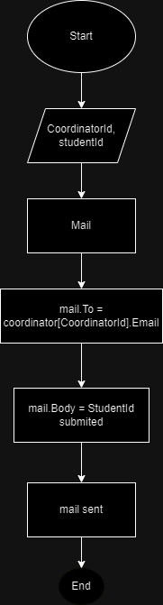

Flowchart Provide comments for each contribution submission.

Provide feedback for each contribution: Coordinators have 14 days after the deadline to provide feedback for student contributions. The system check date is now less than the end date. The Marketing Coordinator may not comment unless the coordinator does so first.

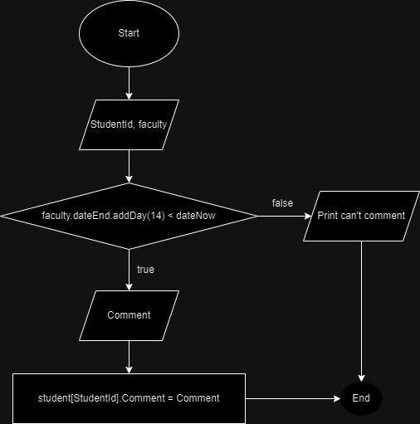

Flow diagram Determine acceptance or rejection of contributions

Choose to accept or decline contributions: Student contributions are marked as Accepted or Rejected by the coordinator. The coordinator enters Accept or Reject and the system saves the data to the database.

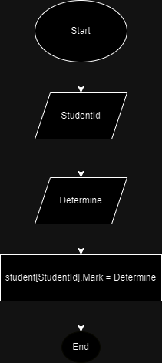

Flowchart Submit contributions in Word format (1 or more) before the first close date

Contributions must be submitted in Word format (1 or more) before the first closing date to allow editing before the final closing date (i.e. after the first closing date). If a student cannot submit before the system test date is shorter than the end date, the system will test this student. Submit before the deadline and verify that the date is less than the deadline. The system will not allow students to change their work if they submit it before the deadline and it is now past the deadline. If the student submits before the deadline and the current date is less than the deadline, the system will allow the student to update his or her contribution. The system does not allow students to change their contributions if they do not submit them by the deadline.

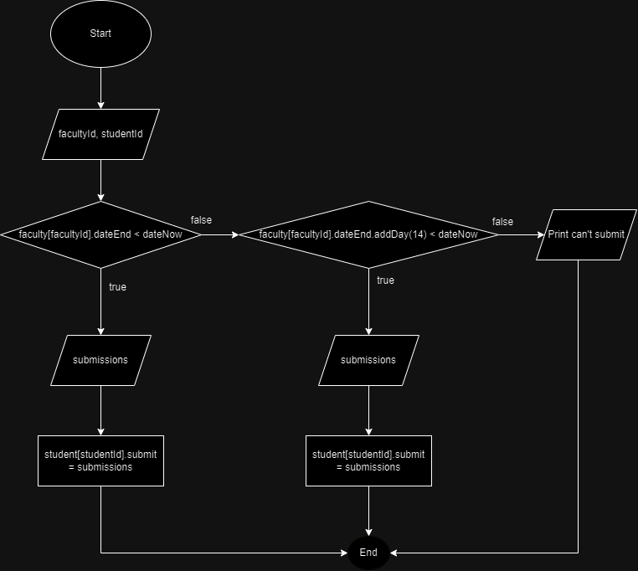

Flowchart Upload images

Students can upload photos of the highest quality. The system downloads and stores student images uploaded to the database.

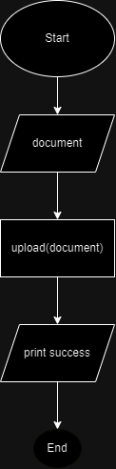

Flow chart Read comments to submit separately.

For each student's own contribution, they will see the comments section. Comments that the coordinator has made regarding those contributions are visible to students. The system will display the coordinator's comments with contributions if the student chooses to read.

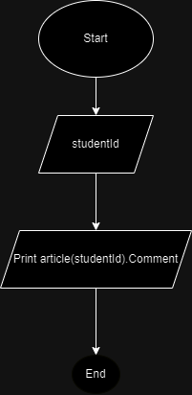

Flowchart Create new account.

New accounts can be created for all roles, including students, coordinators, and managers. When an administrator enters an account, the system will check to see if that account already exists, if not, it will create an account, if so, it will print a notification.

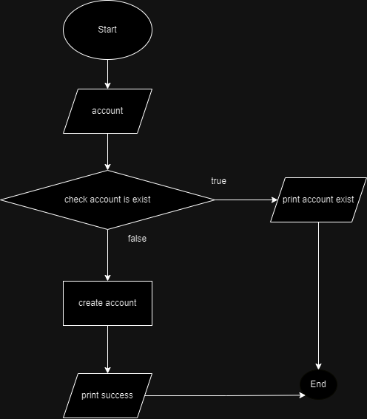

Flow chart for setting and editing end dates.

Set and change the end date for each course: Admins have the ability to change the end date for each course. The admin will enter the final end date, the End date will be the last date if the end date is less than the current date.

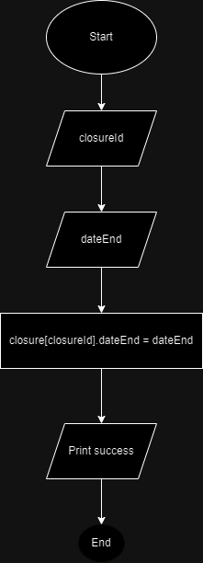

Flowchart View selected reports for each department.

View selected contributions of each faculty: Guests can view accepted contributions that are of course confirmed by the coordinator. The system takes the option this visitor selected and then prints all accepted posts. If you haven't received it yet, come back and check the number of posts.

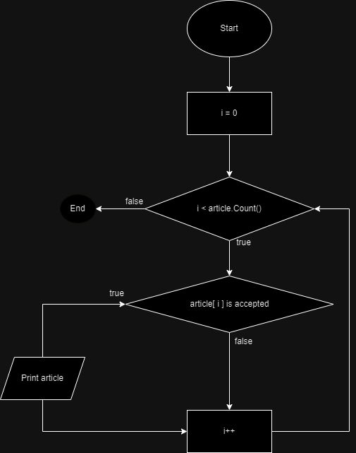

## 4.4 Sequence diagram

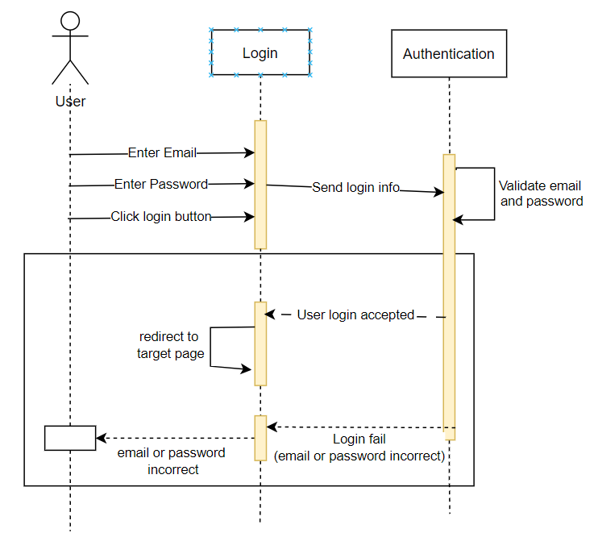

Figure 19 Sequence login

We'll proceed from left to right. Initially, the user inputs details like email and password into corresponding fields on the screen. Subsequently, the system transmits this login data to the information storage server, where it's scrutinized for accuracy. It cross-references the provided email and password with its records to determine a match. If there's an existing account associated with the provided credentials, the system signals success to the user. However, if the login details don't match the system's records, indicating incorrect email or password, the system notifies the user of a failed login attempt. The user then needs to retry entering the email or password until it aligns with what's stored in the system, initiating the validation process anew.

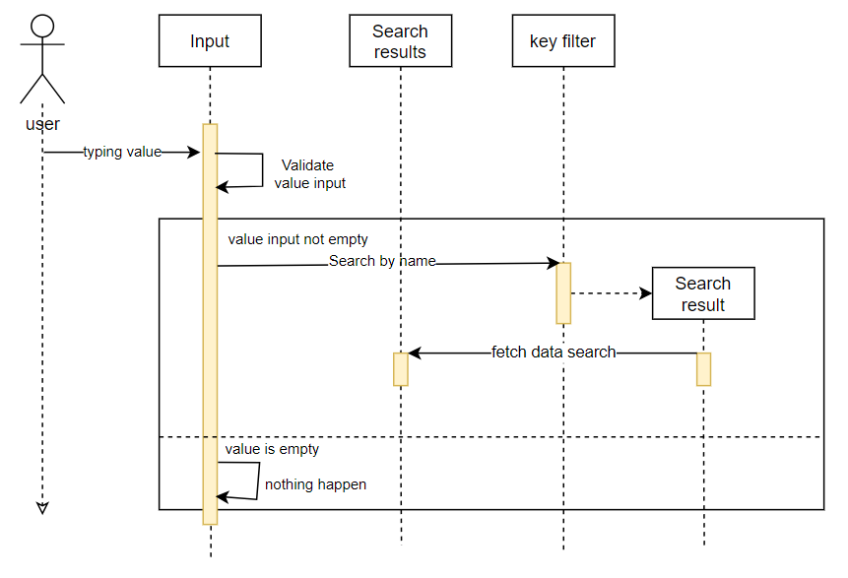

Figure 20 Search Sequence

When the user initiates a search, two scenarios may unfold. In the first case, if the user presses the search button without entering any text, the system will check the text input field. If it finds no value entered, the system will not yield any results, prompting the user to input a value. In the second case, if the user enters a character in the search box and then presses the search button, the system will filter ideas based on the entered character and display all ideas containing that character. As the user inputs more characters, the displayed results will progressively match the user's intended search more closely.

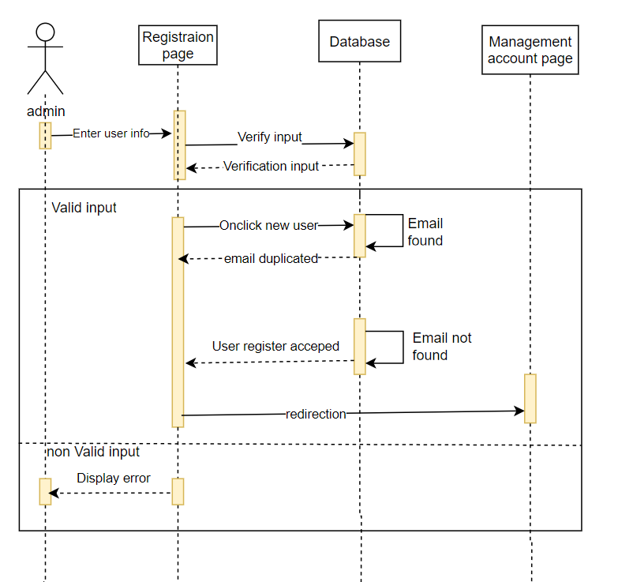

Initially, the administrator inputs all details of the desired account into the corresponding fields on the interface. Subsequently, the system validates the administrator's inputs against the database to identify any duplicates. Once this validation is complete, the program proceeds to execute the creation of the new account upon the administrator's command. During this process, if the entered email already exists in the database, the program prompts the administrator to provide an alternative email to proceed. Conversely, if the email is not found in the database, the program initiates the creation of a new account and returns to the initial page. In the event that the administrator attempts to create an account without entering any information, the program detects this action, notifies the administrator of the error, and requests new account details.

# **Implementation**

## 5.1 **Deployment code**

**Deployment.**

In this section, we introduce the techniques used in this project including both frontend and backend. Additionally, provide an overall structure for the system. Implement introductory features and provide explanations for featured code. As a result, there will be a better understanding of the project implementation process and the approaches used.

**Backend:**

Configure database connection to Mongodb.

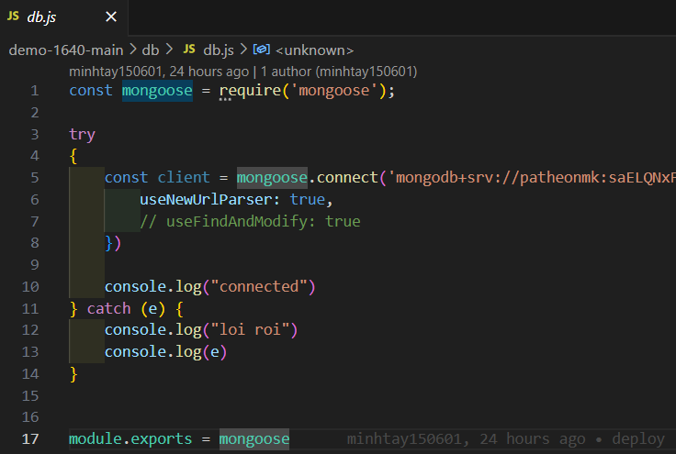

Deploy a middleware to delegate functions to each role.

1. **isAdmin**: This middleware checks if the user making the request is logged in and has the **admin** role in their session. If so, it calls the **next()** function to proceed to the next middleware or route handler. Otherwise, it sends a 401 Unauthorized status.
2. **isStudent**: Similar to **isAdmin**, this middleware checks if the user making the request is logged in and has the **student** role in their session. If yes, it allows the request to proceed; otherwise, it sends a 401 Unauthorized status.
3. **isMng**: This middleware checks if the user making the request is logged in and has the **manager** role in their session. If so, it allows the request to proceed; otherwise, it sends a 401 Unauthorized status.
4. **isDean**: Similar to the previous middleware, this one checks if the user making the request is logged in and has the **Dean** role in their session. If yes, it allows the request to proceed; otherwise, it sends a 401 Unauthorized status.

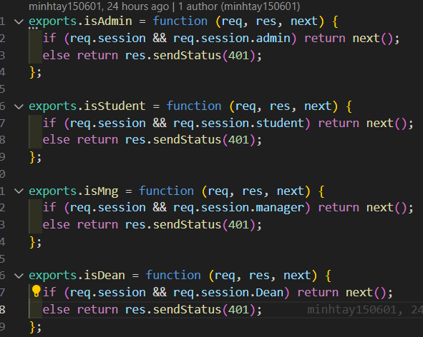

These are Express route handler functions that handle different functionalities related to the administration section of a web application. Let's break down each function:

1. **getAdmin**: This function renders the admin page view (**admin/admin**) and passes the logged-in user's email (**req.session.email**) to the view template as **loginName**. It's assumed that **req.session.email** contains the email of the currently logged-in user.
2. **changePassword**: This function renders the change password page view (**admin/changePassword**) and passes the logged-in user's email (**req.session.email**) to the view template as **loginName**. This route presumably allows administrators to change their passwords.
3. **doChangePassword**: This function is responsible for handling the actual password change process. It retrieves the user's account information from the database using their email (**req.session.email**) and then checks if the provided current password matches the stored password using bcrypt's **compare** function. If it matches, it further validates the new password, ensuring it meets the required criteria (at least 8 characters long) and matches the confirmation password. If any validation fails, appropriate error messages are stored in the **errors** object.
   * If validation fails, it renders the change password view again, passing the **errors** object and the **loginName** to the view.
   * If validation passes, it generates a new salt, hashes the new password with bcrypt, updates the user's password in the database, updates the session user object, and redirects the user to the admin page (**/admin**).

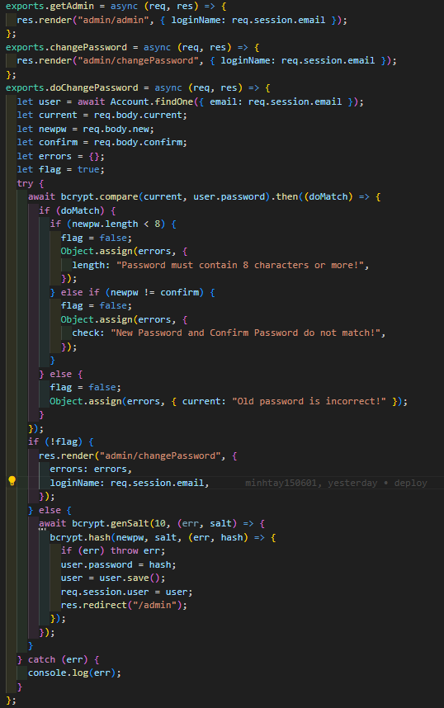

These are Express route handler functions that manage different functionalities related to managing managers in the admin section of a web application. Let's break down each function:

1. **viewManager**: This function retrieves a list of managers from the database using **Manager.find()** and renders the **admin/viewManager** view. It passes the list of managers (**listManager**) and the logged-in user's email (**req.session.email**) to the view template.
2. **addManager**: This function renders the **admin/addManager** view, allowing administrators to add a new manager. It passes the logged-in user's email (**req.session.email**) to the view template.
3. **doAddManager**: This function handles the addition of a new manager. It creates a new **Manager** object based on the form data received, including handling the file upload if an image is uploaded. Additionally, it creates a new **Account** object for the manager with a default password and saves both to the database after hashing the password using bcrypt.
4. **editManager**: This function renders the **admin/editManager** view for editing a specific manager's details. It retrieves the manager's information based on the provided ID and passes it to the view template along with the logged-in user's email.
5. **doEditManager**: This function handles the submission of edited manager details. It updates the manager's information based on the form data received, including handling the file upload for the manager's image if provided.
6. **deleteManager**: This function deletes a manager based on the provided ID. It first deletes the associated account from the **Account** collection using the manager's email, then deletes the manager from the **Manager** collection.
7. **searchManager**: This function handles searching for managers based on a keyword. It retrieves the search keyword from the request body, validates it, and performs a case-insensitive search using a regular expression (**RegExp**). If a valid keyword is provided, it searches for managers whose names match the keyword and renders the **admin/viewManager** view with the search results.

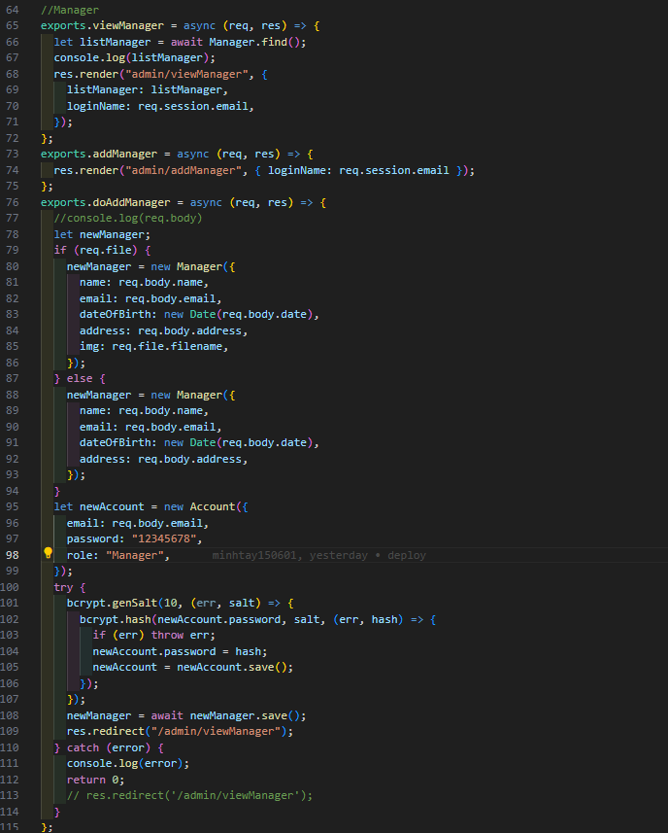

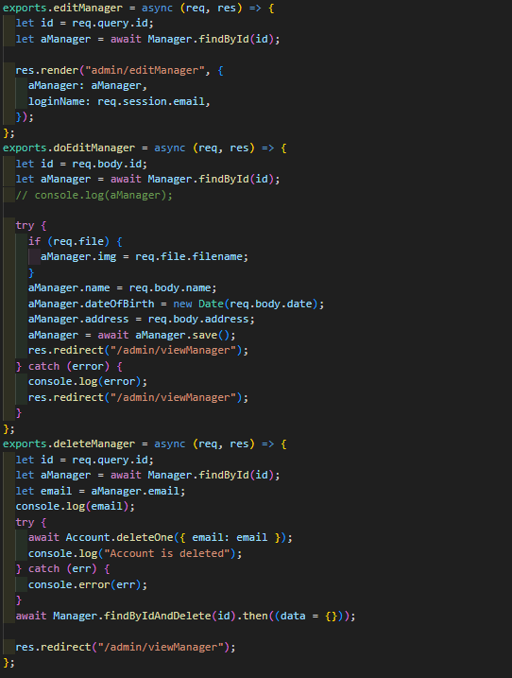

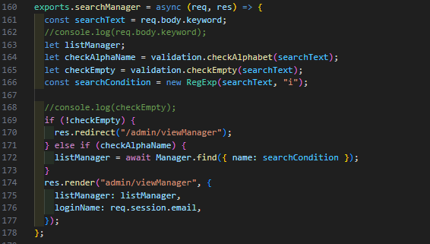

This is an Express route handler function that retrieves a list of faculties from the database and responds with a JSON representation of these faculties. Let's break down this function:

1. **getFaculties**: This function is an asynchronous function that handles the HTTP GET request to fetch a list of faculties. Inside the function:
   * It uses a try-catch block to handle potential errors that may occur during the database operation.
   * Inside the try block, it utilizes **Faculty.find({})** to query the database for all faculties. This query returns all documents from the **Faculty** collection.
   * Once the query is executed successfully, it responds with the list of faculties in JSON format using **res.json(faculties)**.
   * In case of an error during the database operation, it logs the error to the console and sends a 500 Internal Server Error response with a JSON object containing the error message.

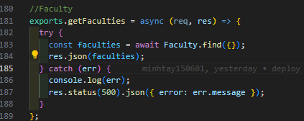

These are Express route handler functions that manage different functionalities related to coordinators in the admin section of a web application. Let's break down each function:

1. **viewCoordinator**: This function retrieves a list of coordinators from the database using **Coordinator.find().populate("faculty")**. It uses **.populate("faculty")** to populate the **faculty** field of each coordinator document with the actual faculty data. Then, it renders the **admin/viewCoordinator** view, passing the list of coordinators (**listCoordinator**) and the logged-in user's email (**req.session.email**) to the view template.
2. **addCoordinator**: This function renders the **admin/addCoordinator** view, allowing administrators to add a new coordinator. It passes the logged-in user's email (**req.session.email**) to the view template.
3. **doAddCoordinator**: This function handles the addition of a new coordinator. It creates a new **Coordinator** object based on the form data received, including handling the file upload if an image is uploaded. Additionally, it creates a new **Account** object for the coordinator with a default password and saves both to the database after hashing the password using bcrypt.
   * If the coordinator's image file is provided (**req.file**), it includes the filename in the coordinator object.
   * It then creates a new **Account** object with the coordinator's email, a default password, and the role set to "Coordinator".
   * It hashes the password using bcrypt, saves the hashed password, and then saves the account and coordinator objects to the database.
   * Finally, it redirects the user to the view coordinator page (**/admin/viewCoordinator**).

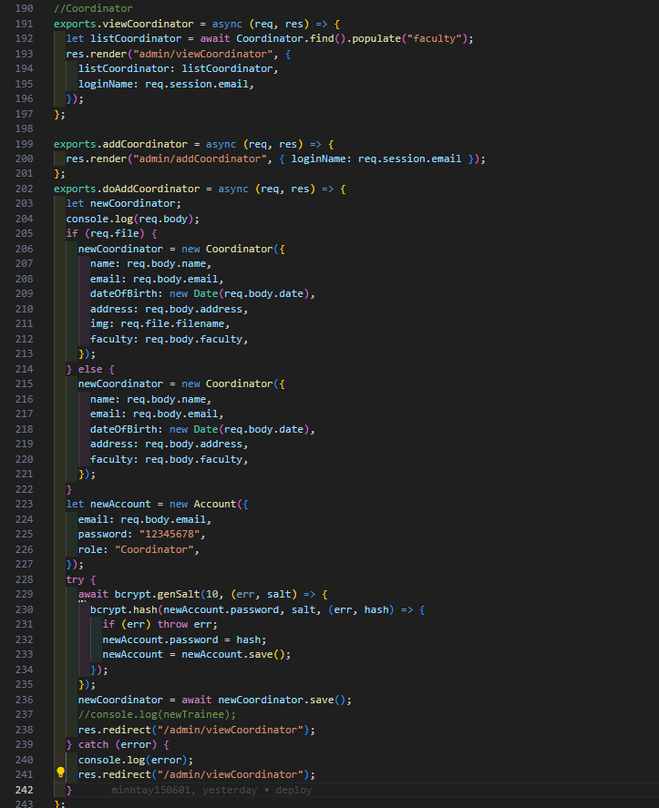

This is an Express route handler function that handles the editing of coordinator details. Let's break down this function:

1. **doEditCoordinator**: This function retrieves the coordinator's ID from the request body and uses it to find the corresponding coordinator document in the database using **Coordinator.findById(id)**.
2. Inside a try-catch block:
   * If a file is provided in the request (**req.file**), it updates the coordinator's image (**img**) with the filename of the uploaded file.
   * It updates other fields of the coordinator object (**name**, **dateOfBirth**, **address**, **faculty**) with the values provided in the request body.
   * It then saves the updated coordinator object back to the database using **aCoordinator.save()**.
   * If the update operation is successful, it redirects the user to the view coordinator page (**/admin/viewCoordinator**).
   * If an error occurs during the update operation, it logs the error to the console and redirects the user to the view coordinator page as well.

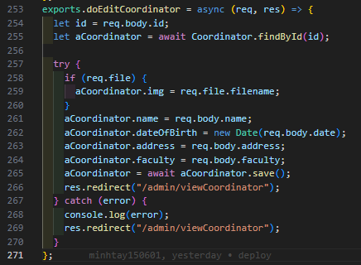

These are Express route handler functions that manage different functionalities related to coordinators in the admin section of a web application. Let's break down each function:

1. **deleteCoordinator**: This function handles the deletion of a coordinator. It retrieves the coordinator's ID from the query parameters (**req.query.id**), then finds the corresponding coordinator document in the database using **Coordinator.findById(id)**. It also retrieves the coordinator's email from the found document. Then, it deletes the corresponding account from the **Account** collection using the coordinator's email. Finally, it deletes the coordinator document from the **Coordinator** collection using **Coordinator.findByIdAndDelete(id)**, and redirects the user to the view coordinator page (**/admin/viewCoordinator**).
2. **searchCoordinator**: This function handles searching for coordinators based on a keyword. It retrieves the search keyword from the request body (**req.body.keyword**), validates it, and performs a case-insensitive search using a regular expression (**RegExp**). If a valid keyword is provided, it searches for coordinators whose names match the keyword using **Coordinator.find({ name: searchCondition })**. It then renders the **admin/viewCoordinator** view with the search results, passing the list of coordinators (**listCoordinator**) and the logged-in user's email (**req.session.email**) to the view template.

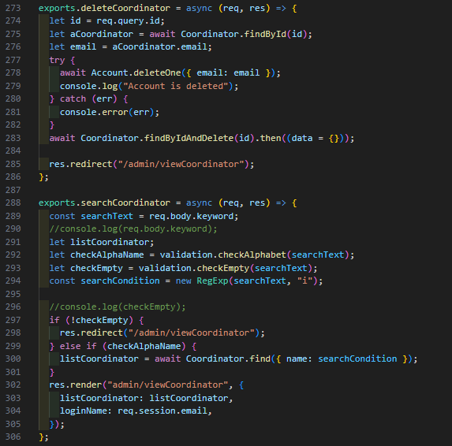

These are Express route handler functions that manage different functionalities related to students in the admin section of a web application. Let's break down each function:

1. **viewStudent**: This function retrieves a list of students from the database using **Student.find().populate("faculty")**. It uses **.populate("faculty")** to populate the **faculty** field of each student document with the actual faculty data. Then, it renders the **admin/viewStudent** view, passing the list of students (**listStudent**) and the logged-in user's email (**req.session.email**) to the view template.
2. **addStudent**: This function renders the **admin/addStudent** view, allowing administrators to add a new student. It passes the logged-in user's email (**req.session.email**) to the view template.
3. **doAddStudent**: This function handles the addition of a new student. It creates a new **Student** object based on the form data received, including handling the file upload if an image is uploaded. Additionally, it creates a new **Account** object for the student with a default password and saves both to the database after hashing the password using bcrypt.
   * If the student's image file is provided (**req.file**), it includes the filename in the student object.
   * It then creates a new **Account** object with the student's email, a default password, and the role set to "Student".
   * It hashes the password using bcrypt, saves the hashed password, and then saves the account and student objects to the database.
   * Finally, it redirects the user to the view student page (**/admin/viewStudent**).

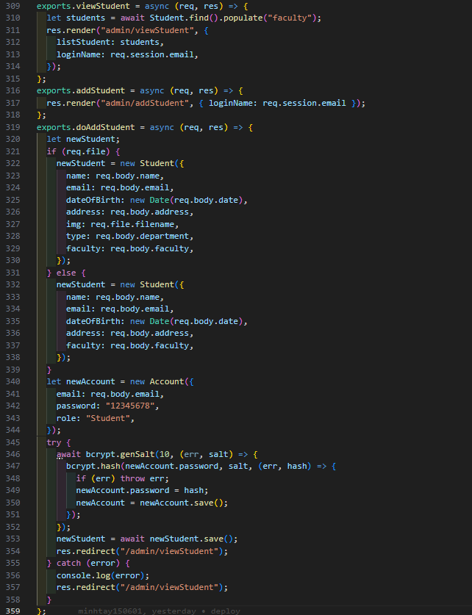

These are Express route handler functions that manage different functionalities related to editing and deleting students in the admin section of a web application. Let's break down each function:

1. **editStudent**: This function renders the **admin/editStudent** view for editing a specific student's details. It retrieves the student's ID from the query parameters (**req.query.id**) and finds the corresponding student document in the database using **Student.findById(id)**. Then, it renders the edit student view, passing the student's details (**aStudent**) and the logged-in user's email (**req.session.email**) to the view template.
2. **doEditStudent**: This function handles the submission of edited student details. It retrieves the student's ID from the request body (**req.body.id**) and finds the corresponding student document in the database using **Student.findById(id)**. Inside a try-catch block, it updates the student's details based on the form data received. If a file is provided in the request (**req.file**), it updates the student's image (**img**) with the filename of the uploaded file. Then, it saves the updated student object back to the database using **aStudent.save()**. If the update operation is successful, it redirects the user to the view student page (**/admin/viewStudent**).
3. **deleteStudent**: This function handles the deletion of a student. It retrieves the student's ID from the query parameters (**req.query.id**) and finds the corresponding student document in the database using **Student.findById(id)**. It also retrieves the student's email from the found document. Then, it deletes the corresponding account from the **Account** collection using the student's email. Additionally, it deletes related data such as ideas and comments associated with the student using the **idea** and **Comments** models. Finally, it deletes the student document from the **Student** collection using **Student.findByIdAndDelete(id)** and redirects the user to the view student page (**/admin/viewStudent**).

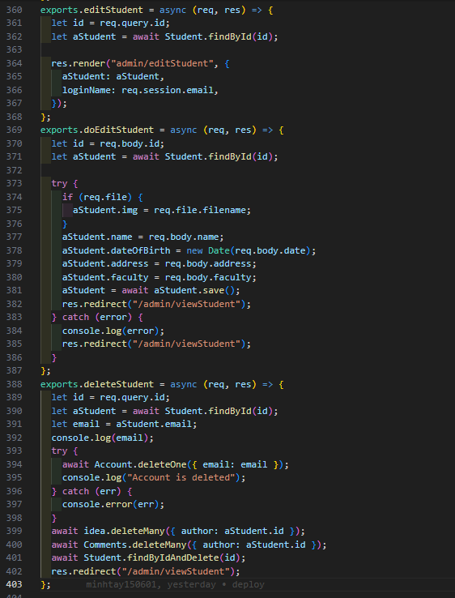

This is an Express route handler function that manages different functionalities related to events in the admin section of a web application. Let's break down each function:

1. **viewEvent**: This function retrieves a list of events from the database using **event.find()**. It renders the **admin/viewEvent** view, passing the list of events (**listEvent**) and the logged-in user's email (**req.session.email**) to the view template.
2. **searchEvent**: This function handles searching for events based on a keyword. It retrieves the search keyword from the request body (**req.body.keyword**), validates it, and performs a case-insensitive search using a regular expression (**RegExp**). If a valid keyword is provided, it searches for events whose names match the keyword using **event.find({ name: searchCondition })**. It then renders the **admin/viewEvent** view with the search results, passing the list of events (**listEvent**) and the logged-in user's email (**req.session.email**) to the view template.
3. **editDate**: This function renders the **admin/editDate** view for editing a specific event's date. It retrieves the event's ID from the query parameters (**req.query.id**) and finds the corresponding event document in the database using **event.findById(id)**. Then, it renders the edit date view, passing the event's details (**aEvent**) and the logged-in user's email (**req.session.email**) to the view template.

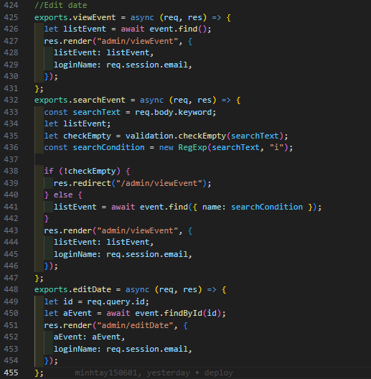

This is an Express route handler function that handles the editing of an event's date. Let's break down this function:

1. **doEditDate**: This function first logs the request body to the console to inspect the data received. Then, it retrieves the event's ID from the request body (**req.body.id**).
2. Inside a try-catch block:
   * It finds the corresponding event document in the database using **event.findById(id)**.
   * It checks if the end date provided (**req.body.dateEnd**) is greater than the start date provided (**req.body.dateStart**). If it is, it updates the event's start and end dates with the new values provided, converts them to Date objects, and saves the updated event object back to the database using **aEvent.save()**. Then, it redirects the user to the view event page (**/admin/viewEvent**).
   * If the end date is not greater than the start date, it sets an error message (**errors**) indicating that the end date must be greater than the start date. Then, it renders the **admin/editDate** view again, passing the error message, the event's details (**aEvent**), and the logged-in user's email (**req.session.email**) to the view template.
   * If an error occurs during the update operation, it logs the error to the console and redirects the user to the view event page as well.

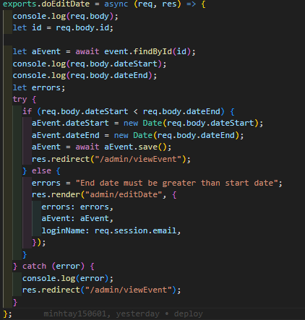

**Login/logout feature:**

These are Express route handler functions related to user authentication, specifically for handling login and logout operations. Let's break down each function:

1. **handleLogin**: This function is responsible for handling the login process. It retrieves the username and password from the request body (**req.body.username**, **req.body.password**). Inside a try-catch block:
   * It attempts to find a user in the database with the provided username using **Account.findOne({ email: username })**.
   * If a user is found, it compares the provided password with the hashed password stored in the user object using bcrypt's **compare** method. If the passwords match:
     + It checks the role of the user. If the user is an admin, it sets the session variables accordingly (**req.session.admin = true**) and redirects the user to the admin dashboard (**/admin**).
     + If the user is a student, manager, or QA coordinator, it sets the session variables accordingly (**req.session.student = true**, **req.session.manager = true**, **req.session.QAcoordinator = true**) and redirects the user to their respective dashboard routes (**/student**, **/manager_index**, **/dean**).
   * If the passwords don't match, it renders the login page (**index**) again, passing an error message indicating that the username or password is incorrect.
   * If an error occurs during the process, it logs the error and renders the login page with an error message.
2. **handleLogout**: This function handles the logout process. It simply destroys the session (**req.session.destroy()**) and redirects the user to the homepage (**/**).

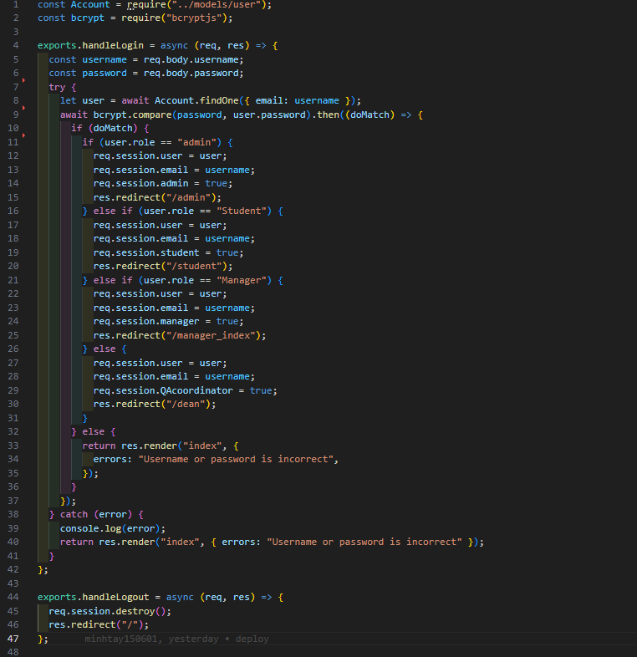

This is an Express route handler function that displays the most commented ideas to the dean. Let's break down the function:

1. **Authentication Check**: First, it checks if the user is authenticated as a dean. It queries the database to find a dean with the email stored in the session (**req.session.email**). If the user is not authenticated or the dean does not exist, it redirects the user to the homepage (**/**).
2. **Data Retrieval**: Inside the authenticated block, the function attempts to retrieve all ideas from the database and populate each idea with its associated comments using **idea.find().populate('comments')**.
3. **Data Processing**:
   * It calculates the total number of ideas (**n_ideas**) retrieved from the database.
   * It divides the total number of ideas into groups of 5 (**distance5_ideas**).
   * It initializes an array **visited_max** to keep track of the ideas that have already been visited.
   * It calculates the total number of views (comments) for each idea and stores them in **countViews** array.
   * It selects the top 5 most commented ideas and stores them in the **topViews** array.
   * It initializes an empty array **mostViewedIdeas** to store the most commented ideas along with their details.
   * It defines a callback function **callBack()** to sort the **mostViewedIdeas** array based on the number of comments once all ideas have been processed.
4. **Processing Ideas**:
   * It iterates over each idea in the **topViews** array.
   * For each idea, it reads the files in the directory specified by the idea's URL.
   * It constructs an object containing details of the idea along with the number of comments and pushes it into the **mostViewedIdeas** array.
   * It keeps track of the number of processed ideas using the **counter** variable.
   * Once all ideas have been processed, it calls the **callBack()** function to sort the **mostViewedIdeas** array based on the number of comments.
5. **Rendering View**: Finally, it renders the **dean/mostComments** view, passing the **distance5_ideas**, **mostViewedIdeas**, and the logged-in dean's email (**req.session.email**) to the view template.

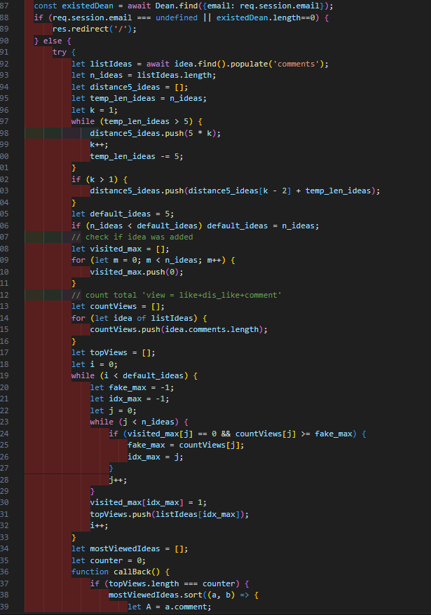

This Express route handler function is responsible for adding a comment to an idea. Let's break down the function:

1. **Data Retrieval**:
   * It retrieves the idea document associated with the ID sent in the request body (**req.body.idIdea**) using **idea.findById(req.body.idIdea)**.
   * It finds the coordinator (QAC) who is making the comment by querying the database for a coordinator document with the email stored in the session (**req.session.email**) using **Coordinator.findOne({ email: req.session.email })**.
   * It retrieves all coordinator documents from the database using **Coordinator.find()**.
2. **Filtering Deans**:
   * It initializes an empty array **deanEmails** to store the emails of all deans except the coordinator making the comment.
   * It iterates over all coordinator documents.
   * For each coordinator, if their email is not the same as the coordinator making the comment (**aQac.email**), it adds their email to the **deanEmails** array.
3. **Creating Comment**:
   * It creates a new comment object (**newComment**) with the provided details: idea ID (**req.body.idIdea**), author (coordinator making the comment), and comment content (**req.body.comment**).
4. **Saving Comment**:
   * It saves the new comment to the database using **newComment.save()**.
   * It adds the newly created comment to the **comments** array of the associated idea (**aIdea.comments.push(newComment)**).
   * It saves the updated idea document to the database using **aIdea.save()**.
5. **Redirection**:
   * After successfully adding the comment, it redirects the user to the view most commented ideas page for the dean (**/dean/viewMostComments**).

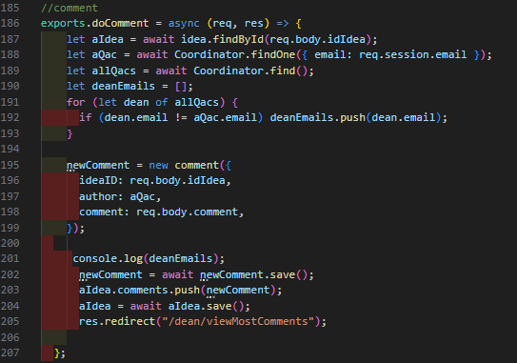

**Frontend:**

**This HTML template appears to be for creating a new coordinator in the admin section of a web application. Let's break down the structure and functionality:**

1. **Template Inclusion: This template includes partial templates for the head section ({{> head}}) and the admin header ({{> adminHeader}}). These partials likely contain common HTML elements and scripts shared across multiple pages.**
2. **Page Structure:**
   * **The page body has a fixed navigation bar (class="sb-nav-fixed").**
   * **It contains a modal dialog (class="modal-dialog modal-lg") for creating a new coordinator.**
   * **Inside the modal content (class="modal-content py-5"), there's a form for entering coordinator details.**
3. **Form Fields:**
   * **The form includes fields for the coordinator's full name, email, date of birth, image, address, and faculty selection.**
   * **The image field allows users to upload an image file.**
   * **There are options for selecting the faculty from a dropdown menu (select element).**
4. **Form Submission:**
   * **Upon submission, the form data is sent to the /admin/doAddCoordinator route via the POST method.**
5. **Faculty Selection Dropdown:**
   * **The dropdown menu for selecting the faculty is populated dynamically using JavaScript.**
   * **On page load, it fetches the list of faculties from the server using an asynchronous fetch request to /admin/getFaculties.**
   * **The fetched faculties are then dynamically added as options to the dropdown menu.**
6. **Script Inclusion:**
   * **The template includes a script (<script src="/js/validate.js"></script>) for form validation, assuming it's stored in validate.js.**
   * **There's an inline script that listens for the DOMContentLoaded event and fetches the list of faculties asynchronously. It then populates the faculty selection dropdown with the fetched data.**

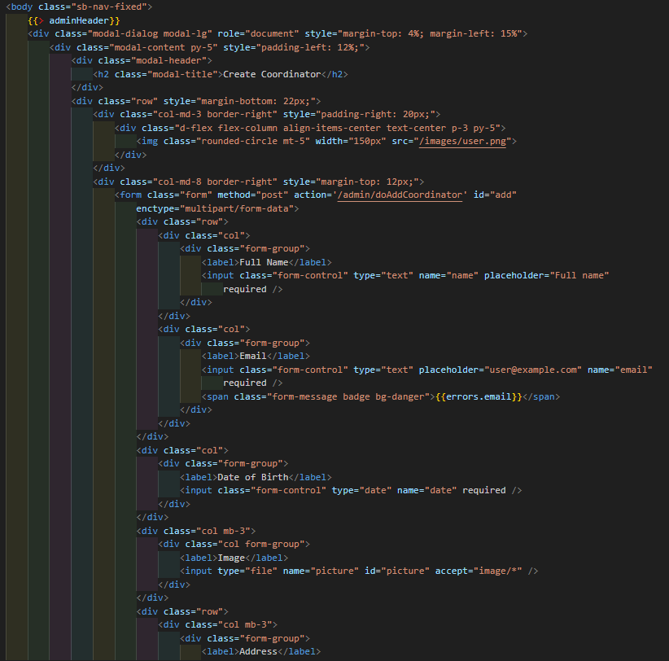

**This HTML template appears to be a view for managing coordinators in the admin section of a web application. Let's break down its structure and functionality:**

1. **Template Inclusion: This template includes partial templates for the head section ({{> head}}) and the admin header ({{> adminHeader}}). These partials likely contain common HTML elements and scripts shared across multiple pages.**
2. **Page Structure:**
   * **The page body has a fixed navigation bar (class="sb-nav-fixed").**
   * **It contains a container (class="container py-5") for holding the main content.**
   * **The content is vertically centered (<center>) within the container.**
3. **Search Functionality:**
   * **Users can search for coordinators by name using an input field and a "Search" button.**
   * **The search form submits data to the /admin/searchCoordinator route via POST method.**
4. **Add Coordinator Button:**
   * **Users can add a new coordinator by clicking on the "Add new Coordinator" button.**
   * **This button redirects users to the /admin/addCoordinator route.**
5. **Coordinator Table:**
   * **Coordinators are displayed in a table (<table class="table table-bordered">) with columns for their name, avatar, email, faculty, date of birth, address, and actions.**
   * **Each row represents a coordinator.**
   * **The avatar is displayed as an image sourced from the /uploads/Coordinator/{{img}} path.**
   * **Actions for each coordinator include editing and deleting.**
6. **Iterating Over Coordinators:**
   * **The template uses Handlebars syntax ({{#each listCoordinator}}) to iterate over the list of coordinators passed to it.**
   * **Coordinator details such as name, email, faculty, etc., are dynamically inserted into the table rows using Handlebars expressions ({{name}}, {{email}}, etc.).**
   * **Edit and delete buttons are provided for each coordinator row, linking to their respective routes (/admin/editCoordinator and /admin/deleteCoordinator).**

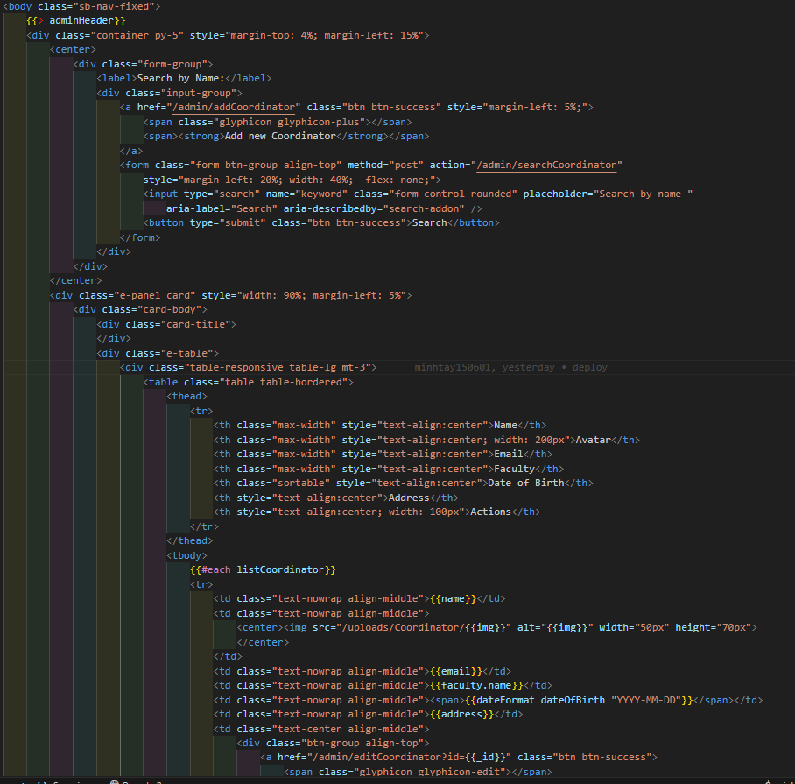

## 5.2 deployment screenshot website

**Login**



Figure 21 Login Page

**Admin Page**

**- Admin Manager**

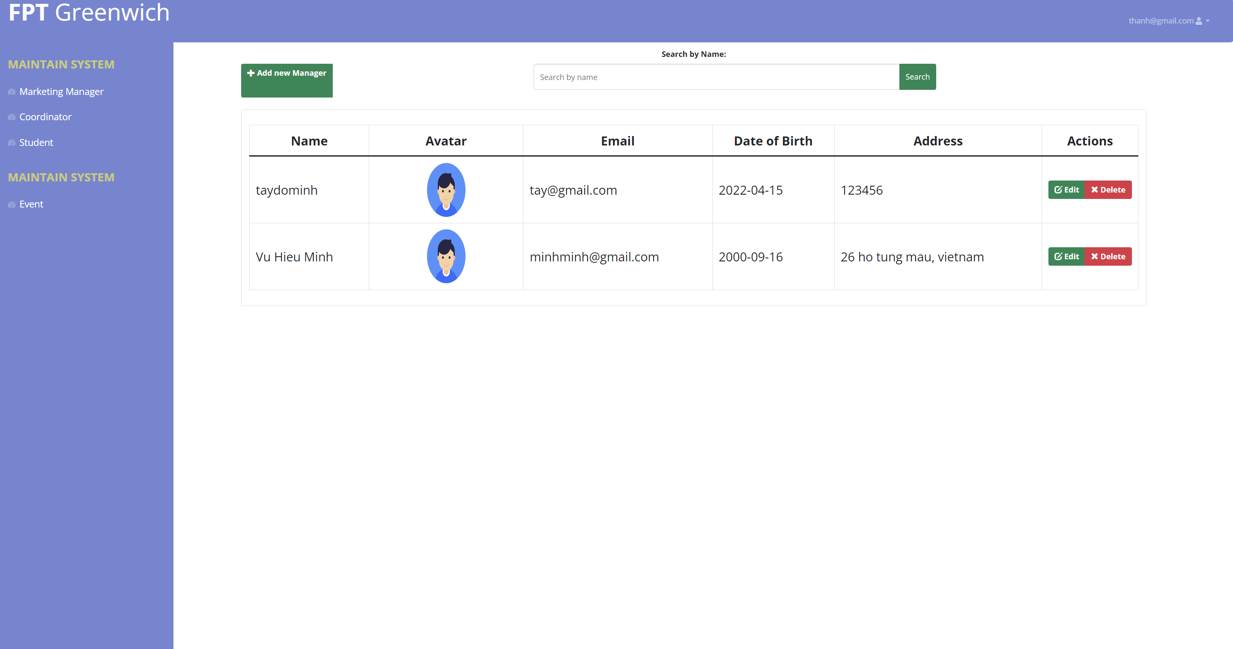

Figure 22 Manager Account

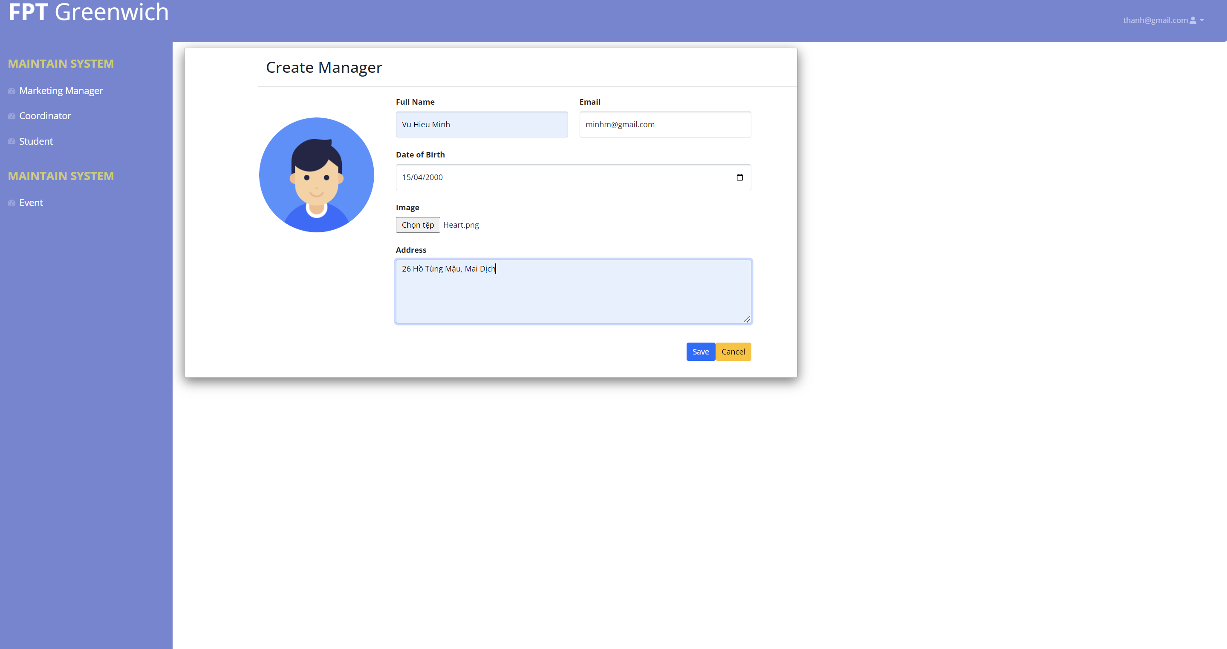

Figure 23 Add Manager

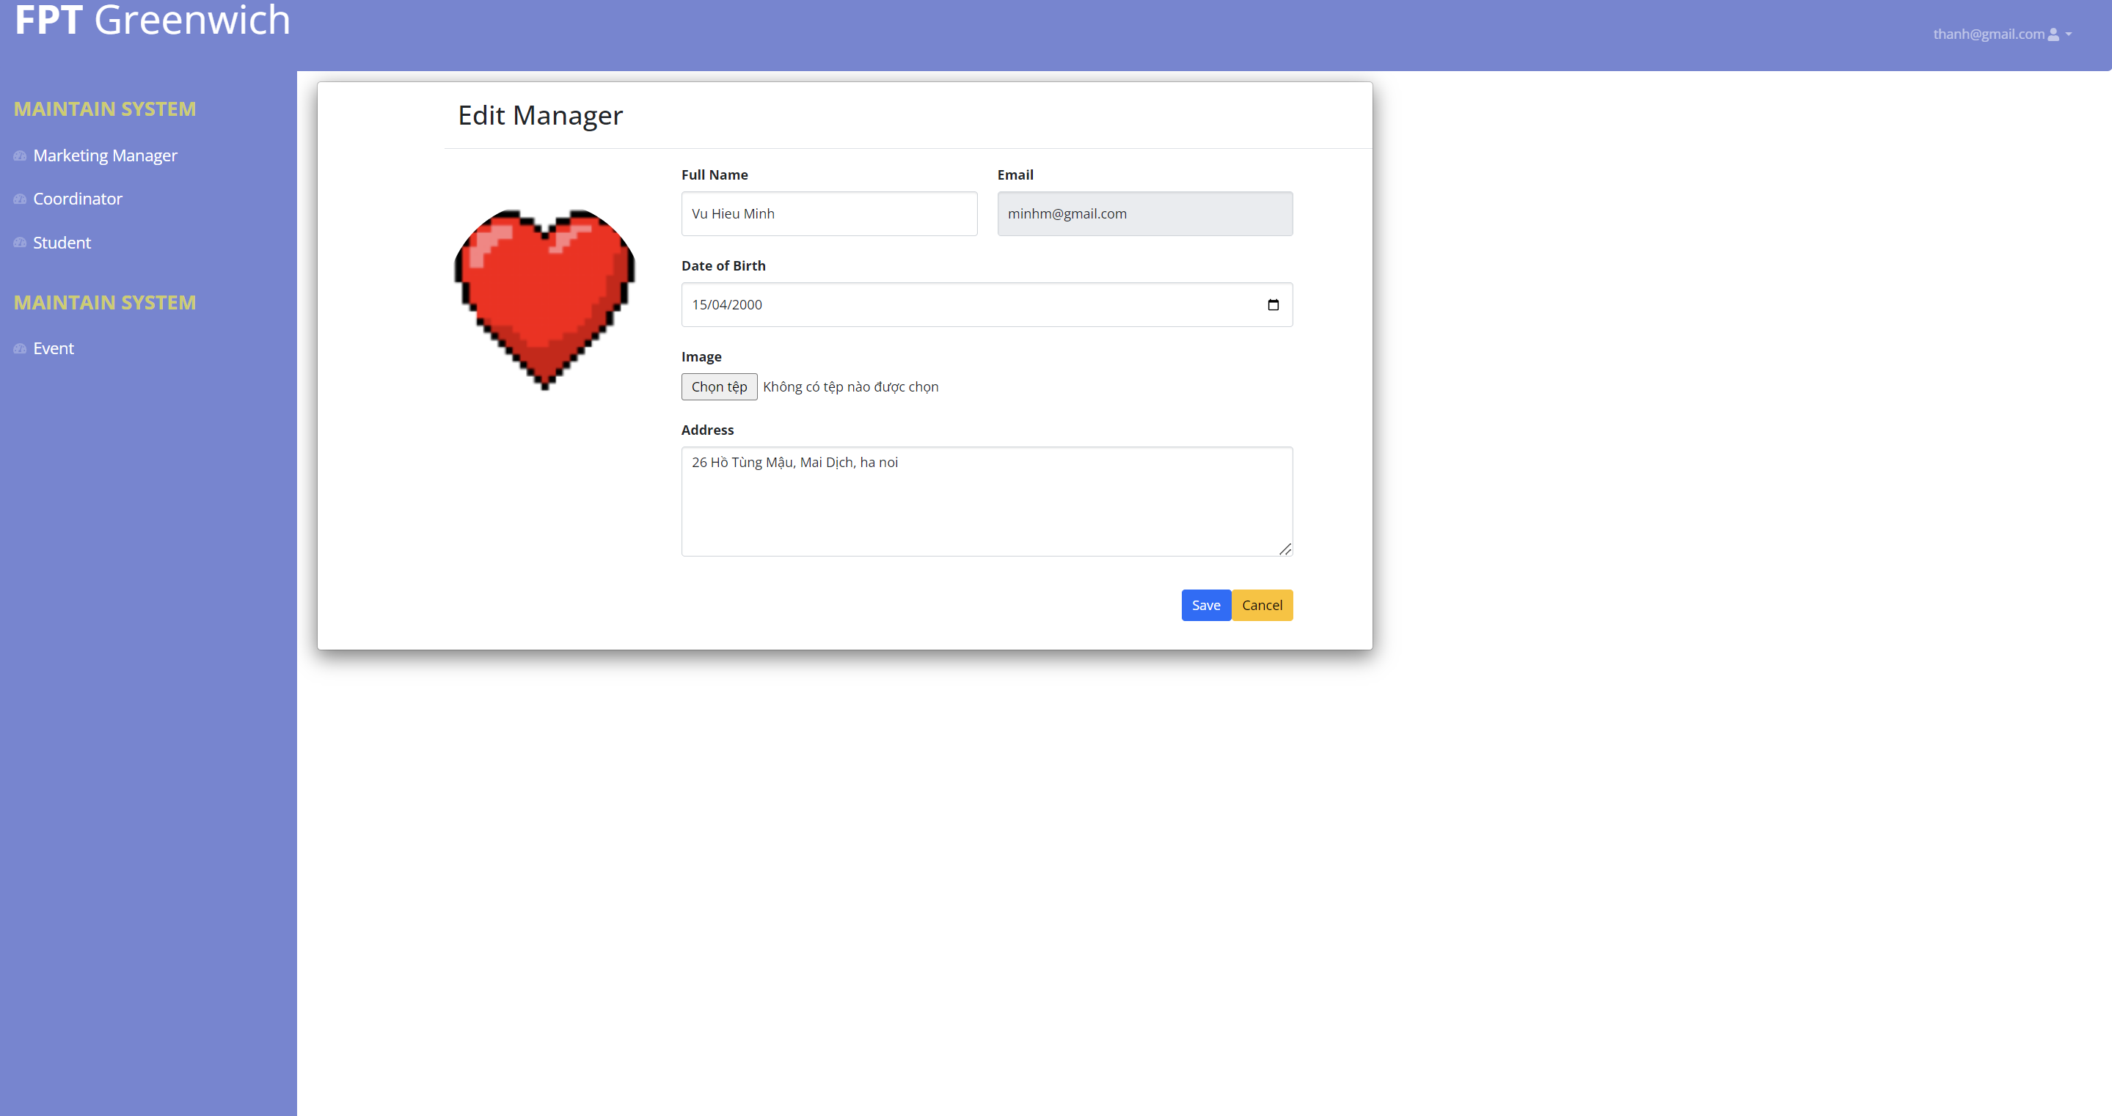

Figure 24 Edit Manager

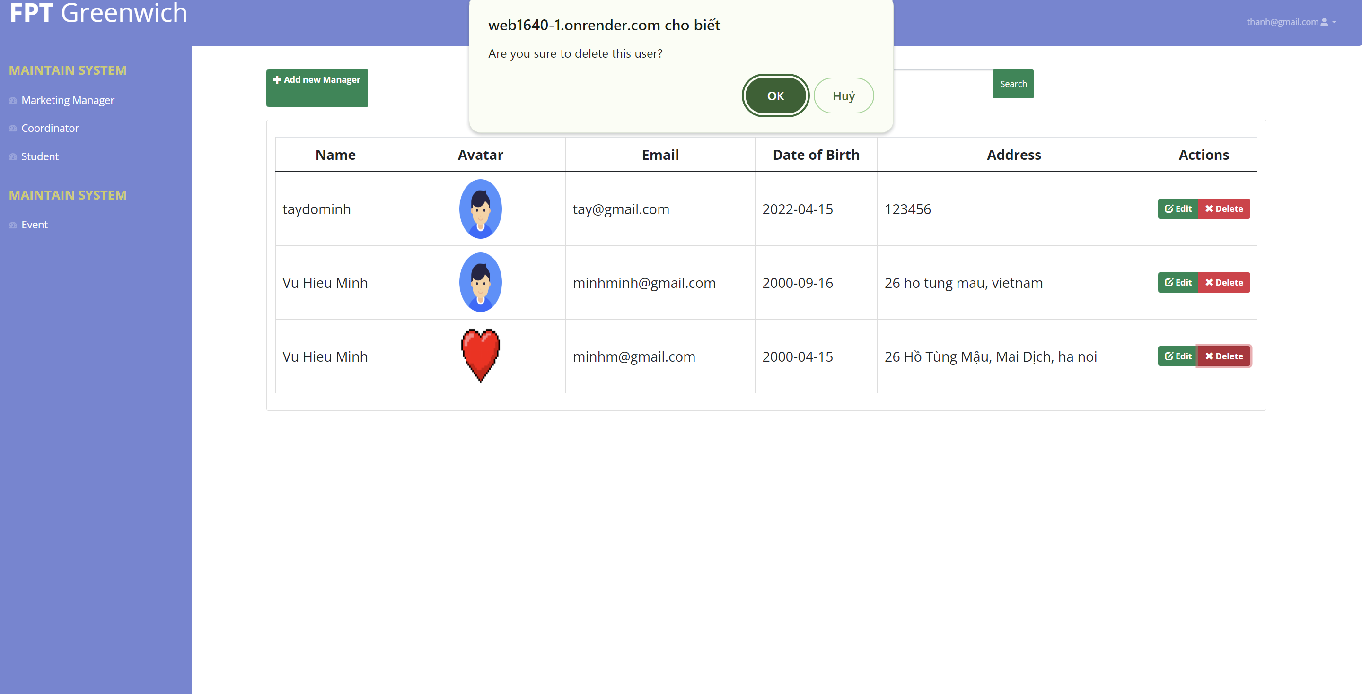

Figure 25 Delete Manager

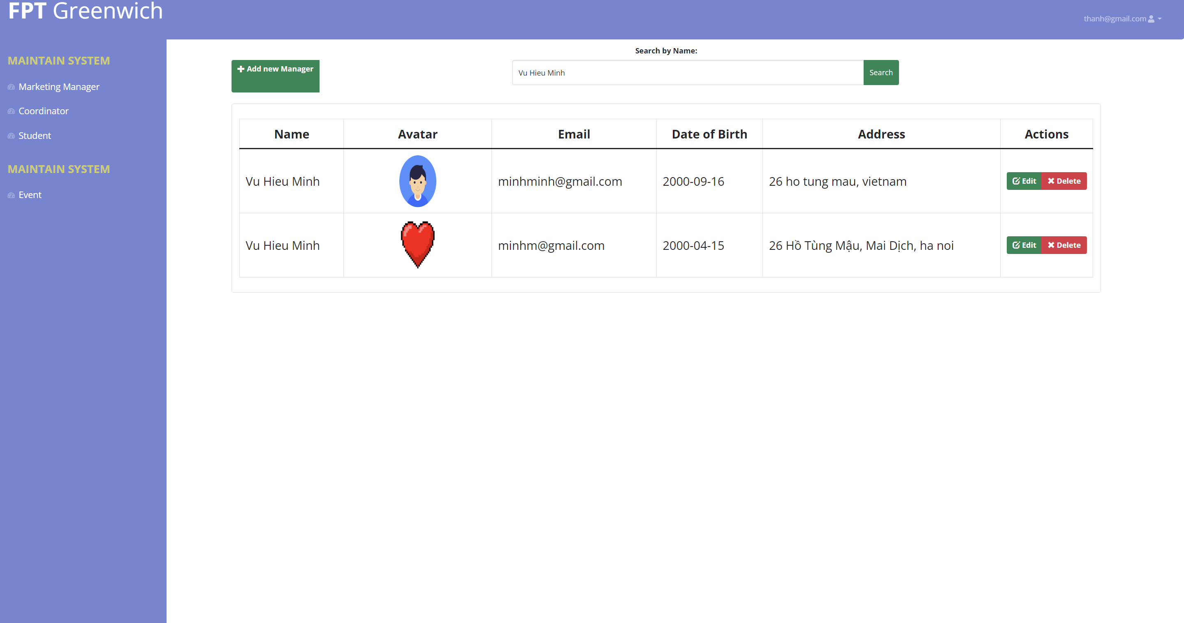

Figure 26 Search Manager

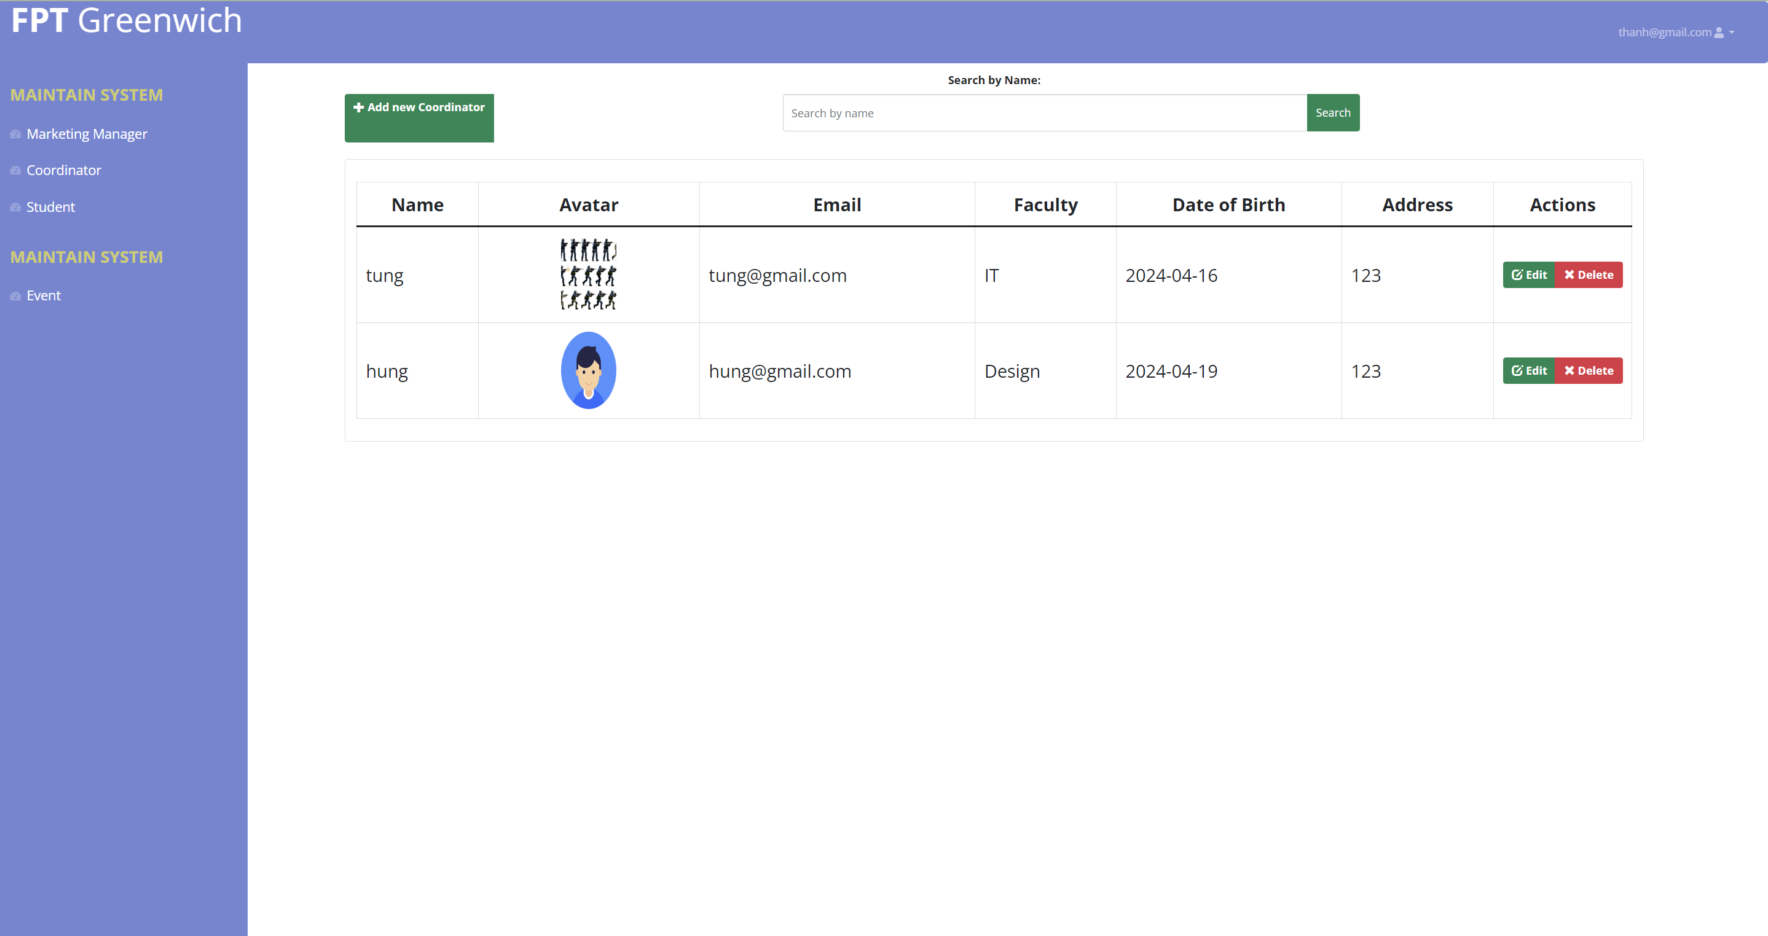

Figure 27 View Coordinator

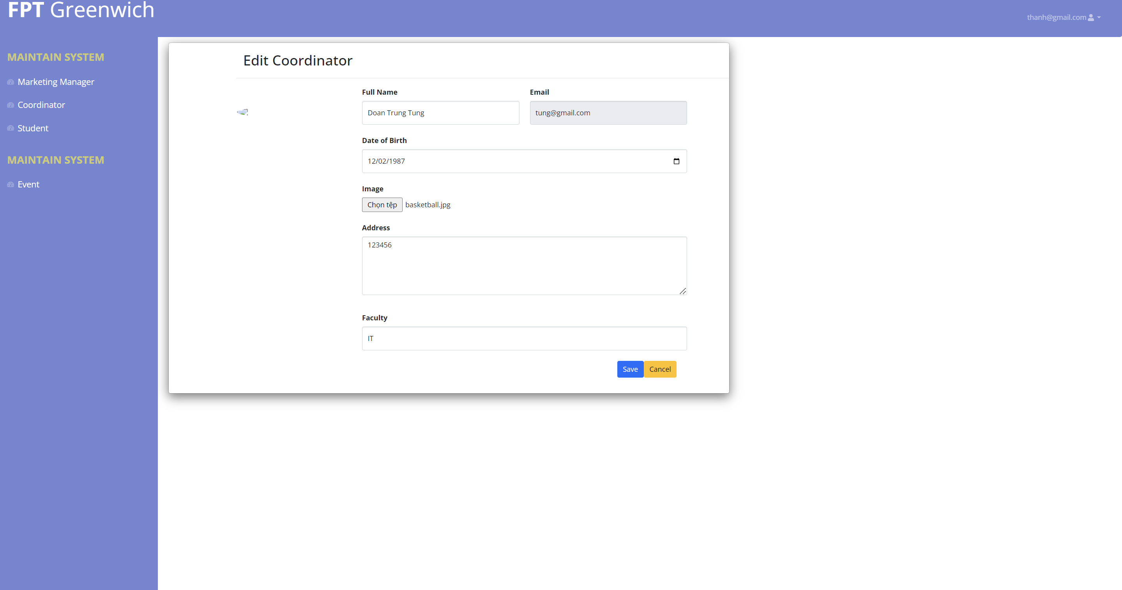

Figure 28 Edit Coordinator

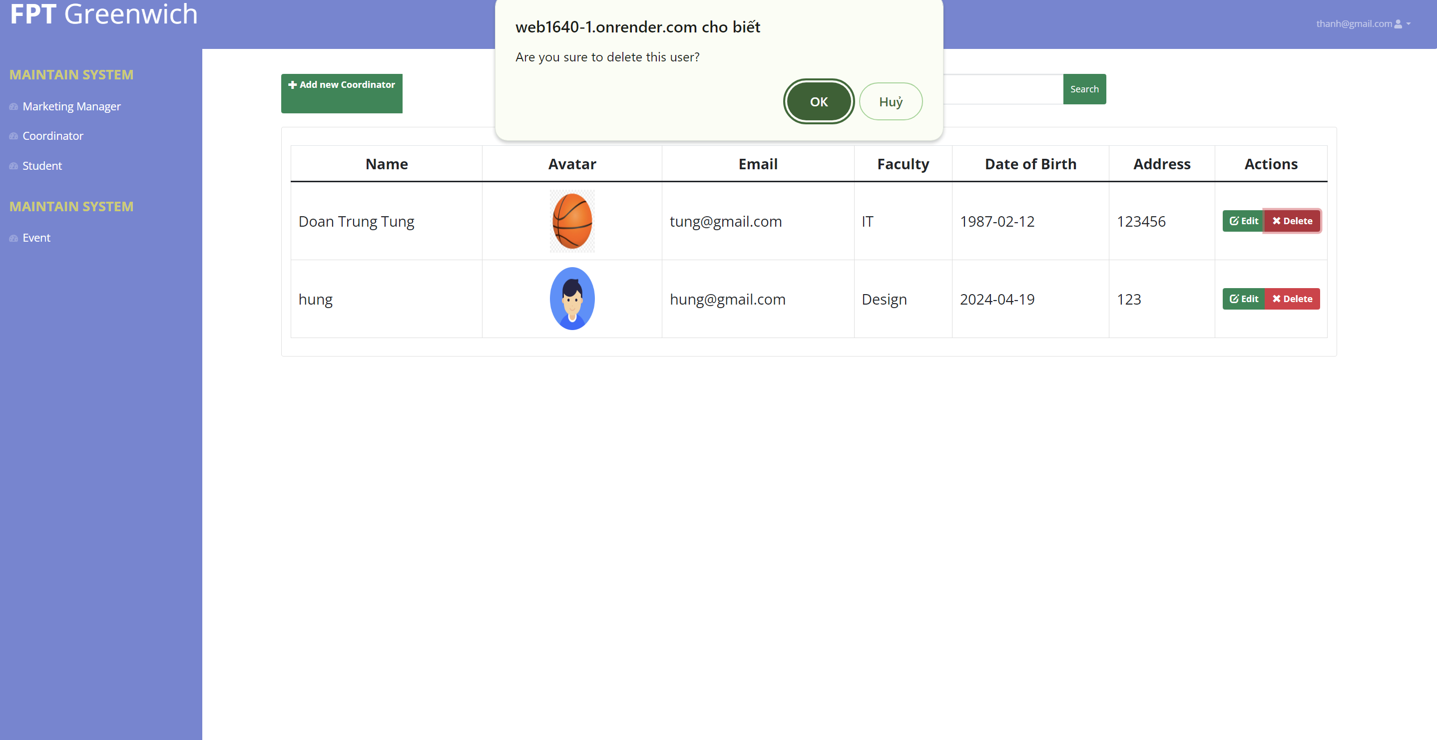

Figure 29 Delete Coordinator

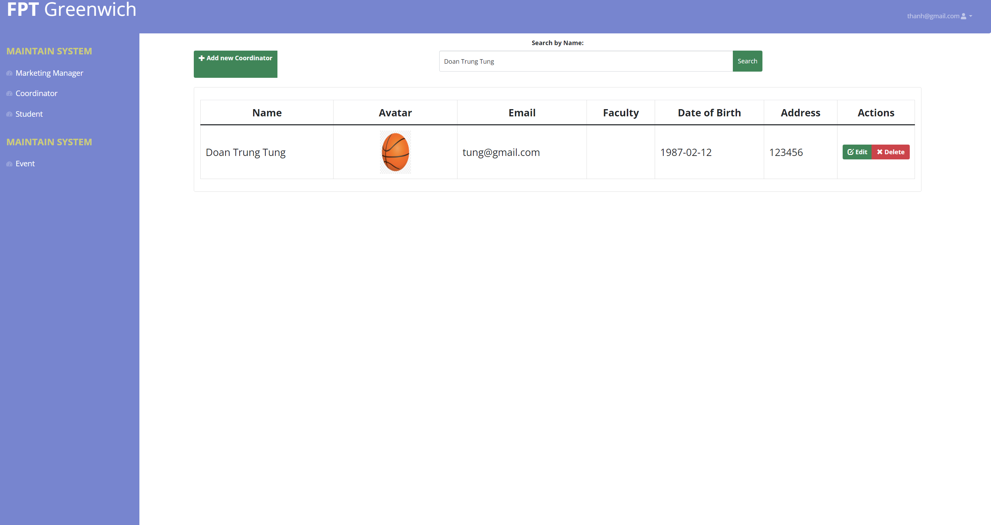

Figure 30 Search Coordinator

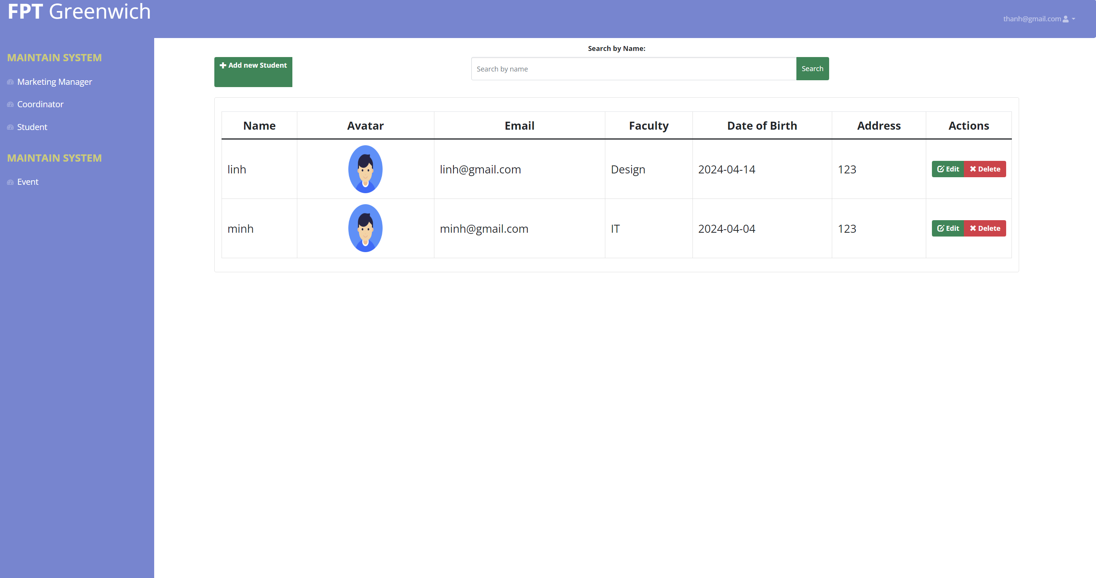

Figure 31 View Student

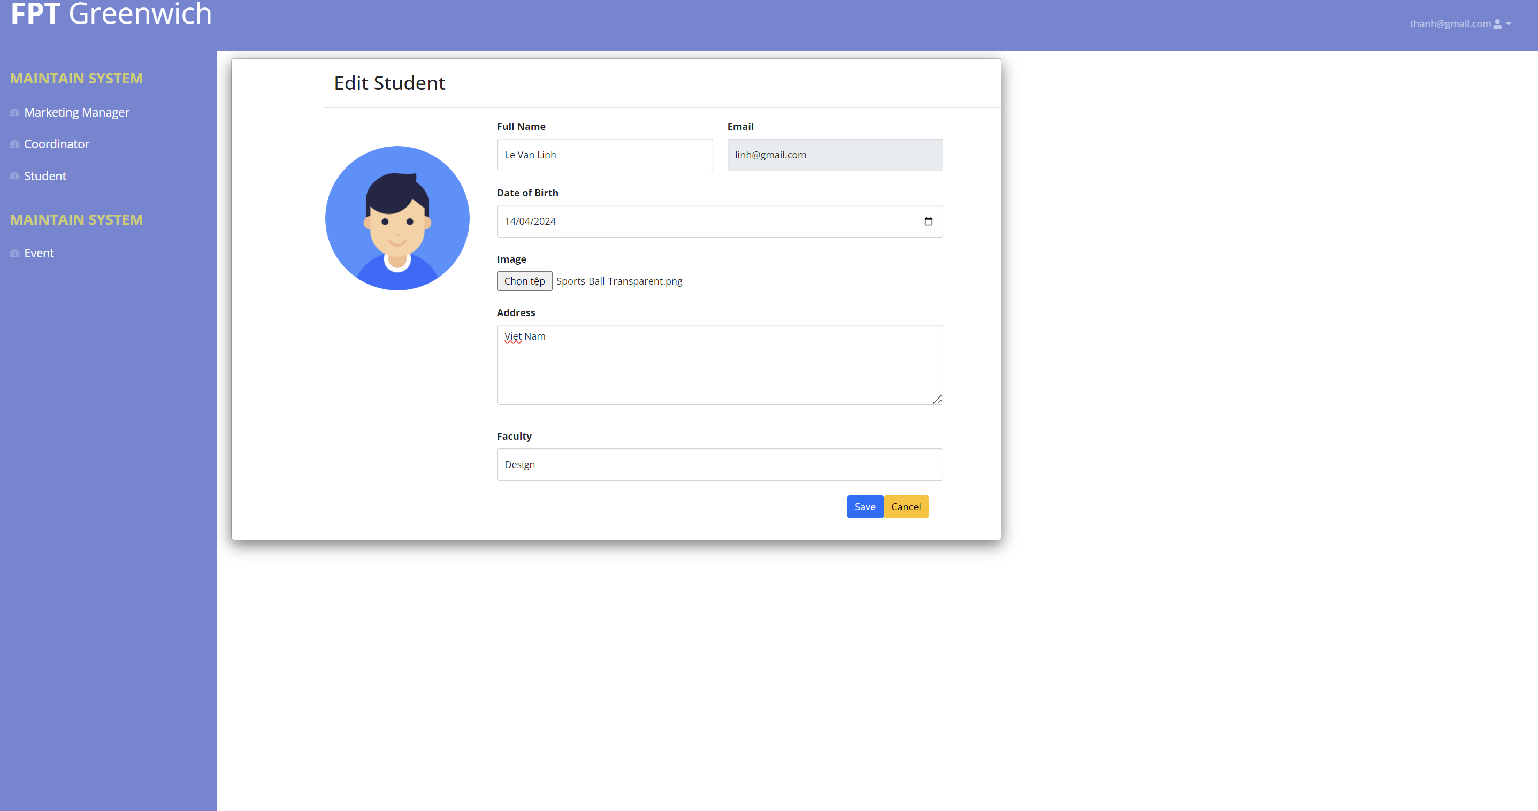

Figure 32 Edit Student

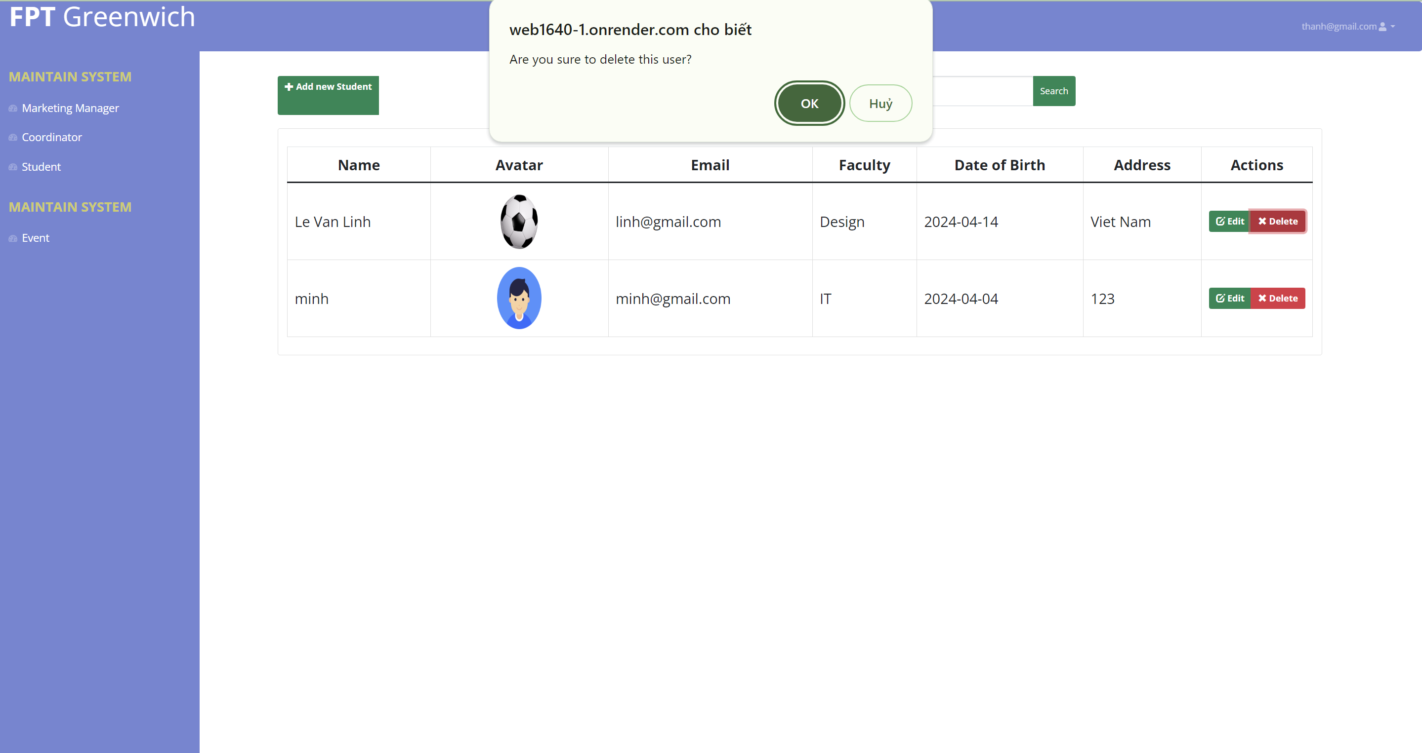

Figure 33 Delete Student

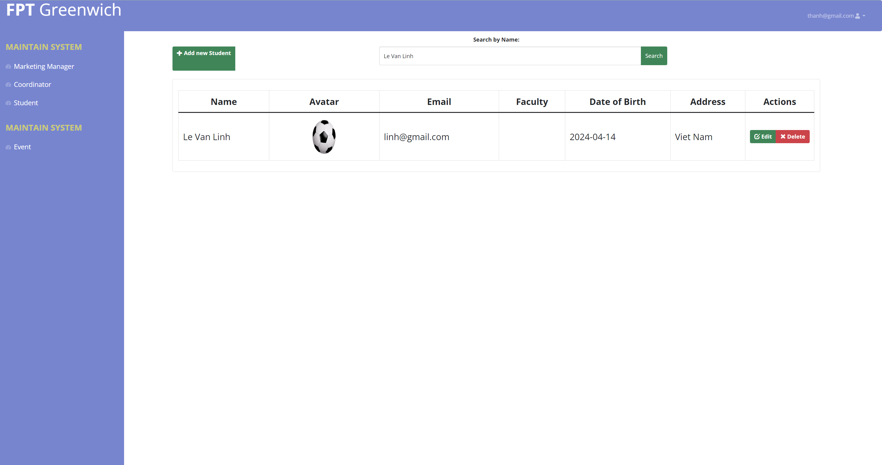

Figure 34 Search Student

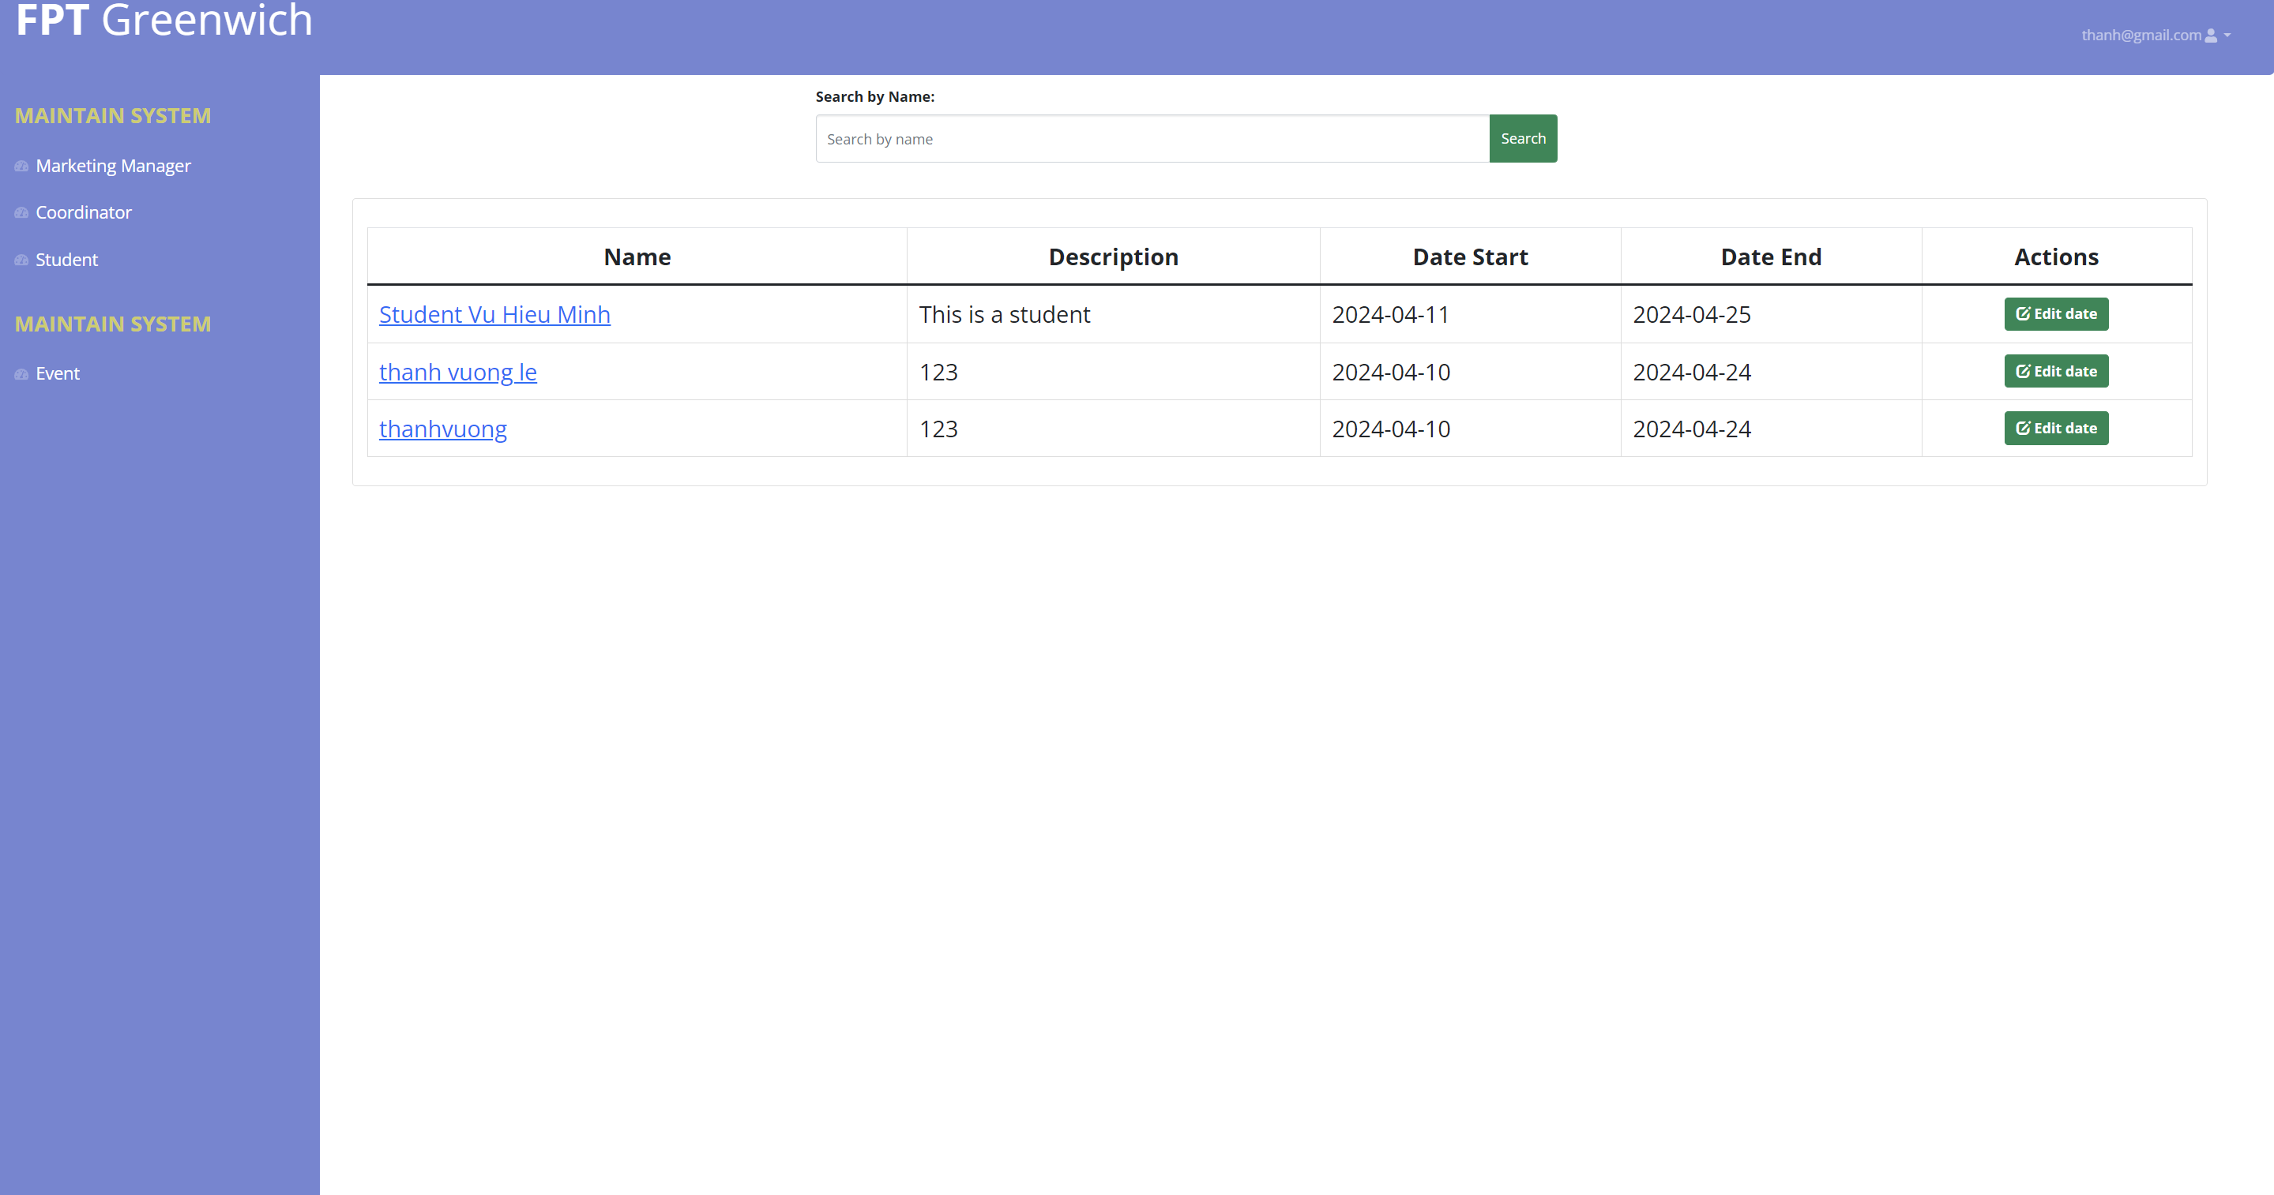

Figure 35 View Event

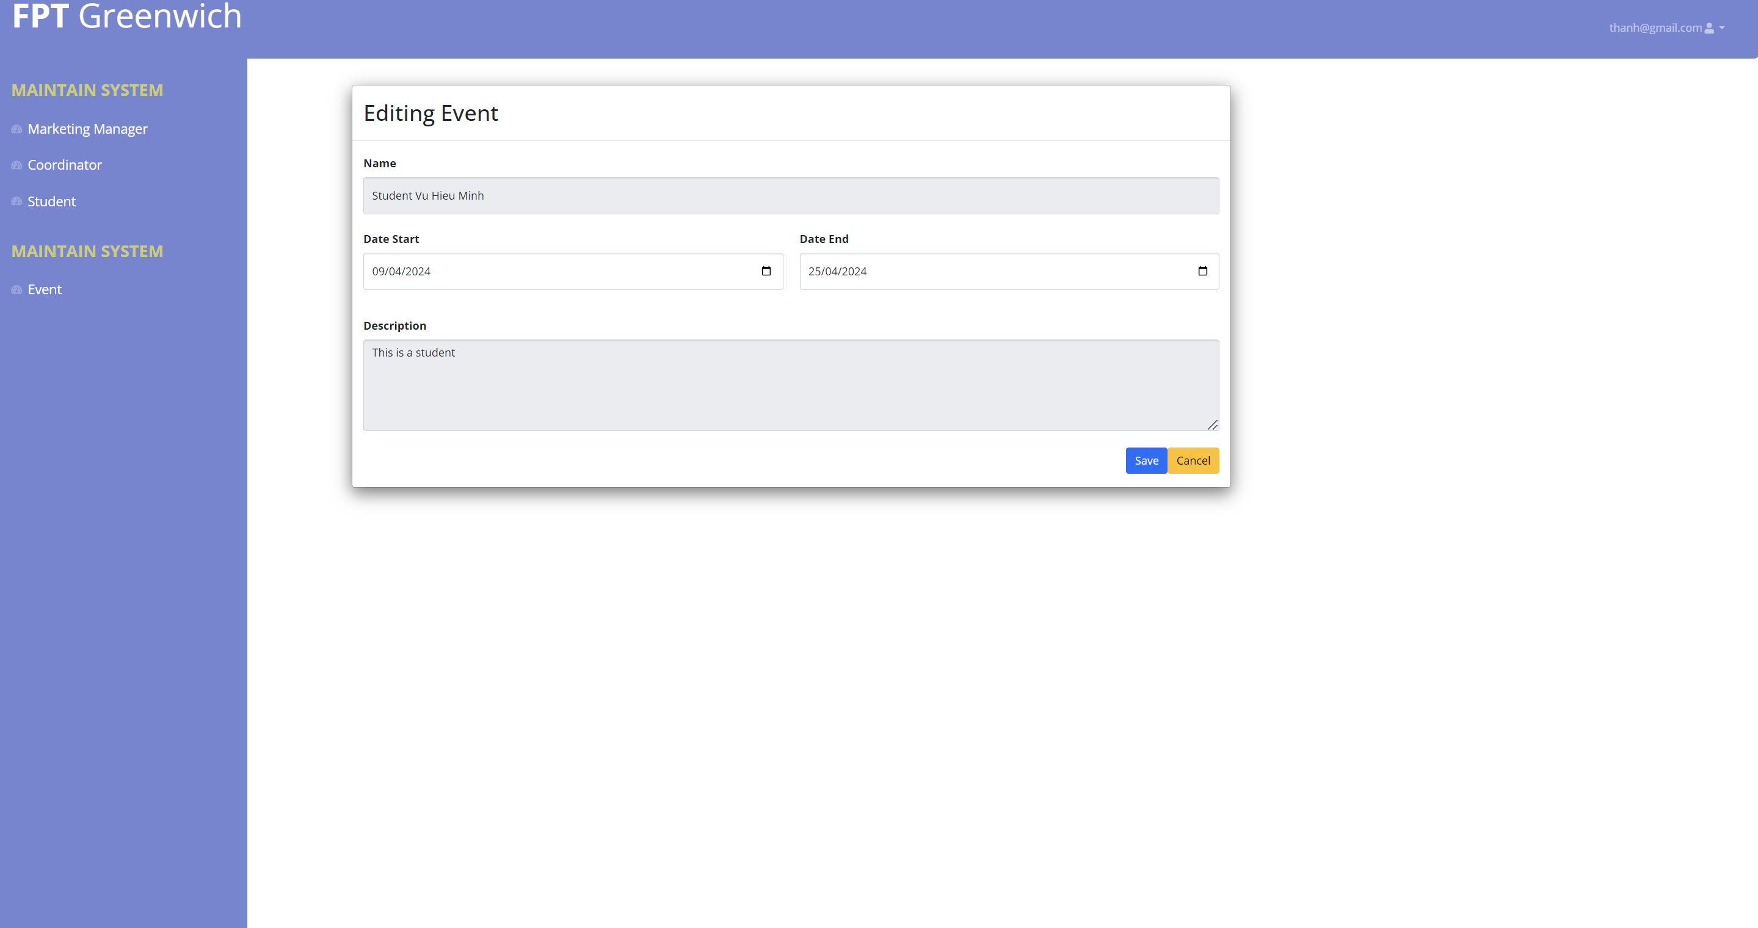

Figure 36 Edit Date Event

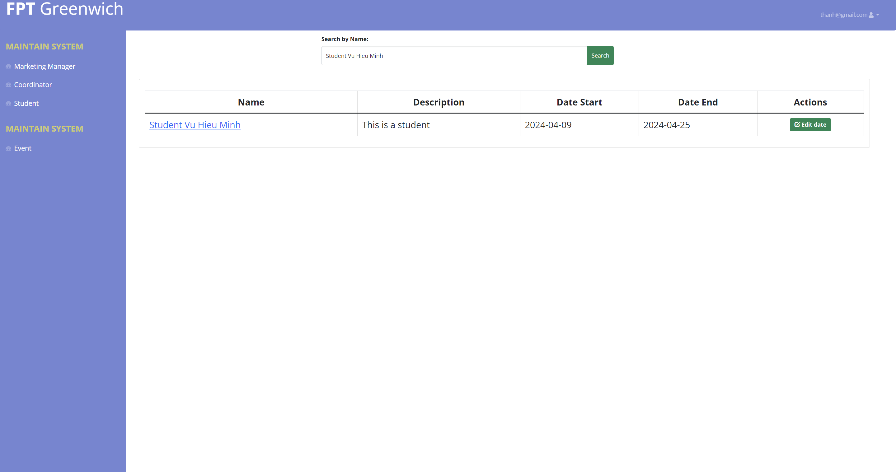

Figure 37 Search Event

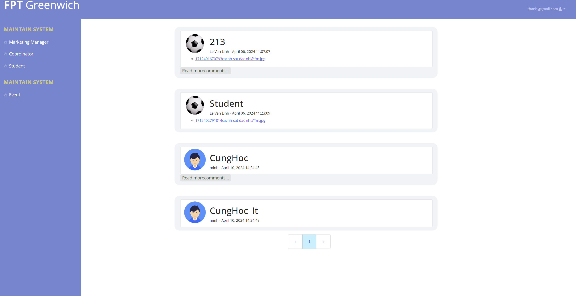

Figure 38 View Event Detail

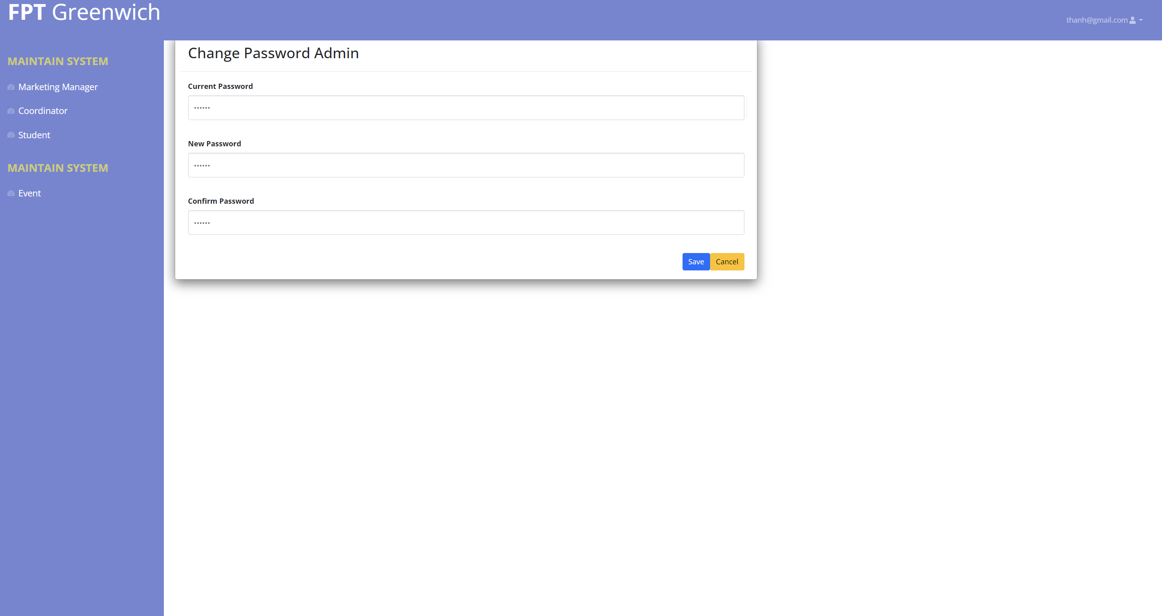

Figure 39 Change Password Admin Page

**- Manager Manage**



Figure 40 Manager Homepage

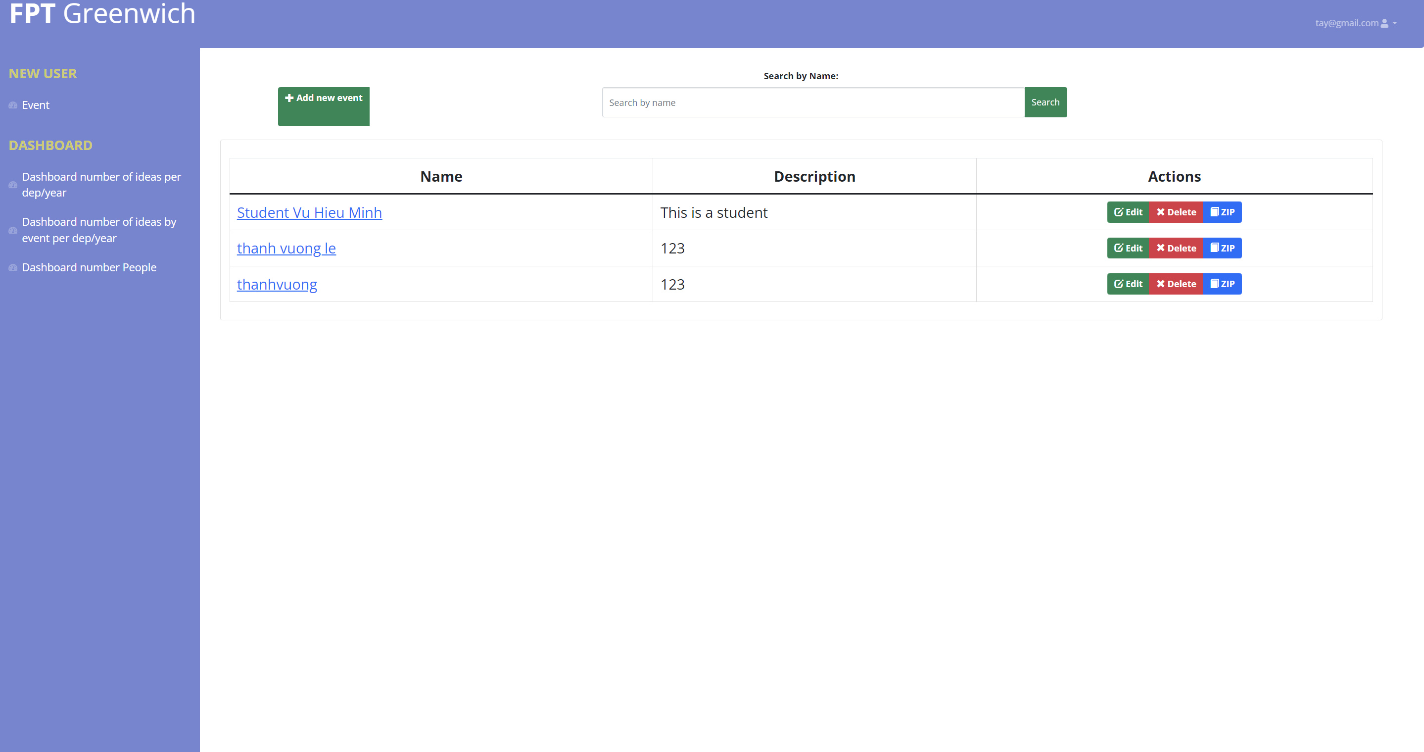

Figure 41 Manager View Event Page

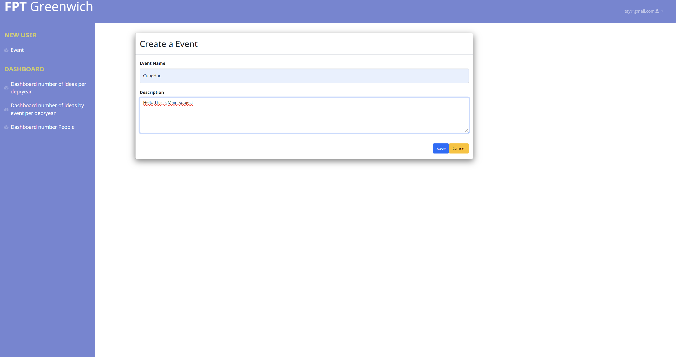

Figure 42 Add Event Page

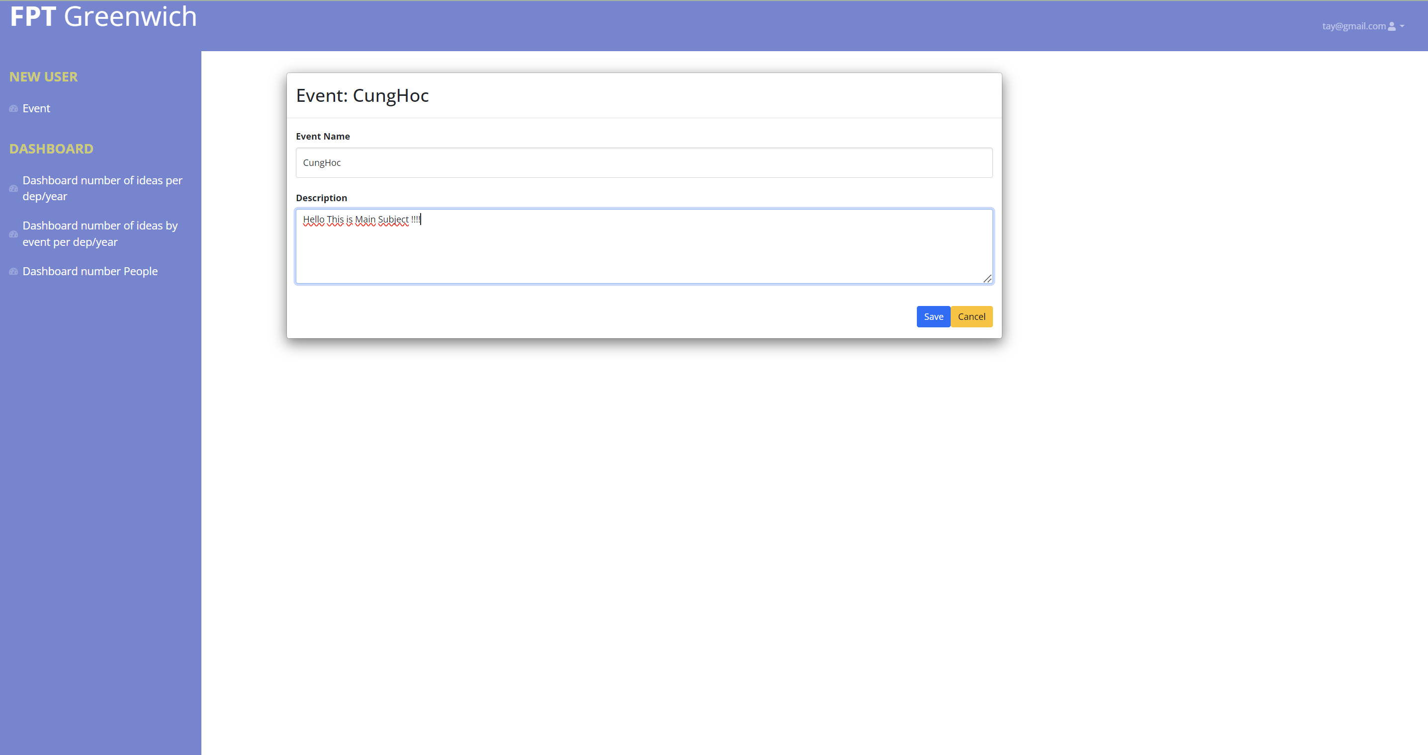

Figure 43 Edit Event Page

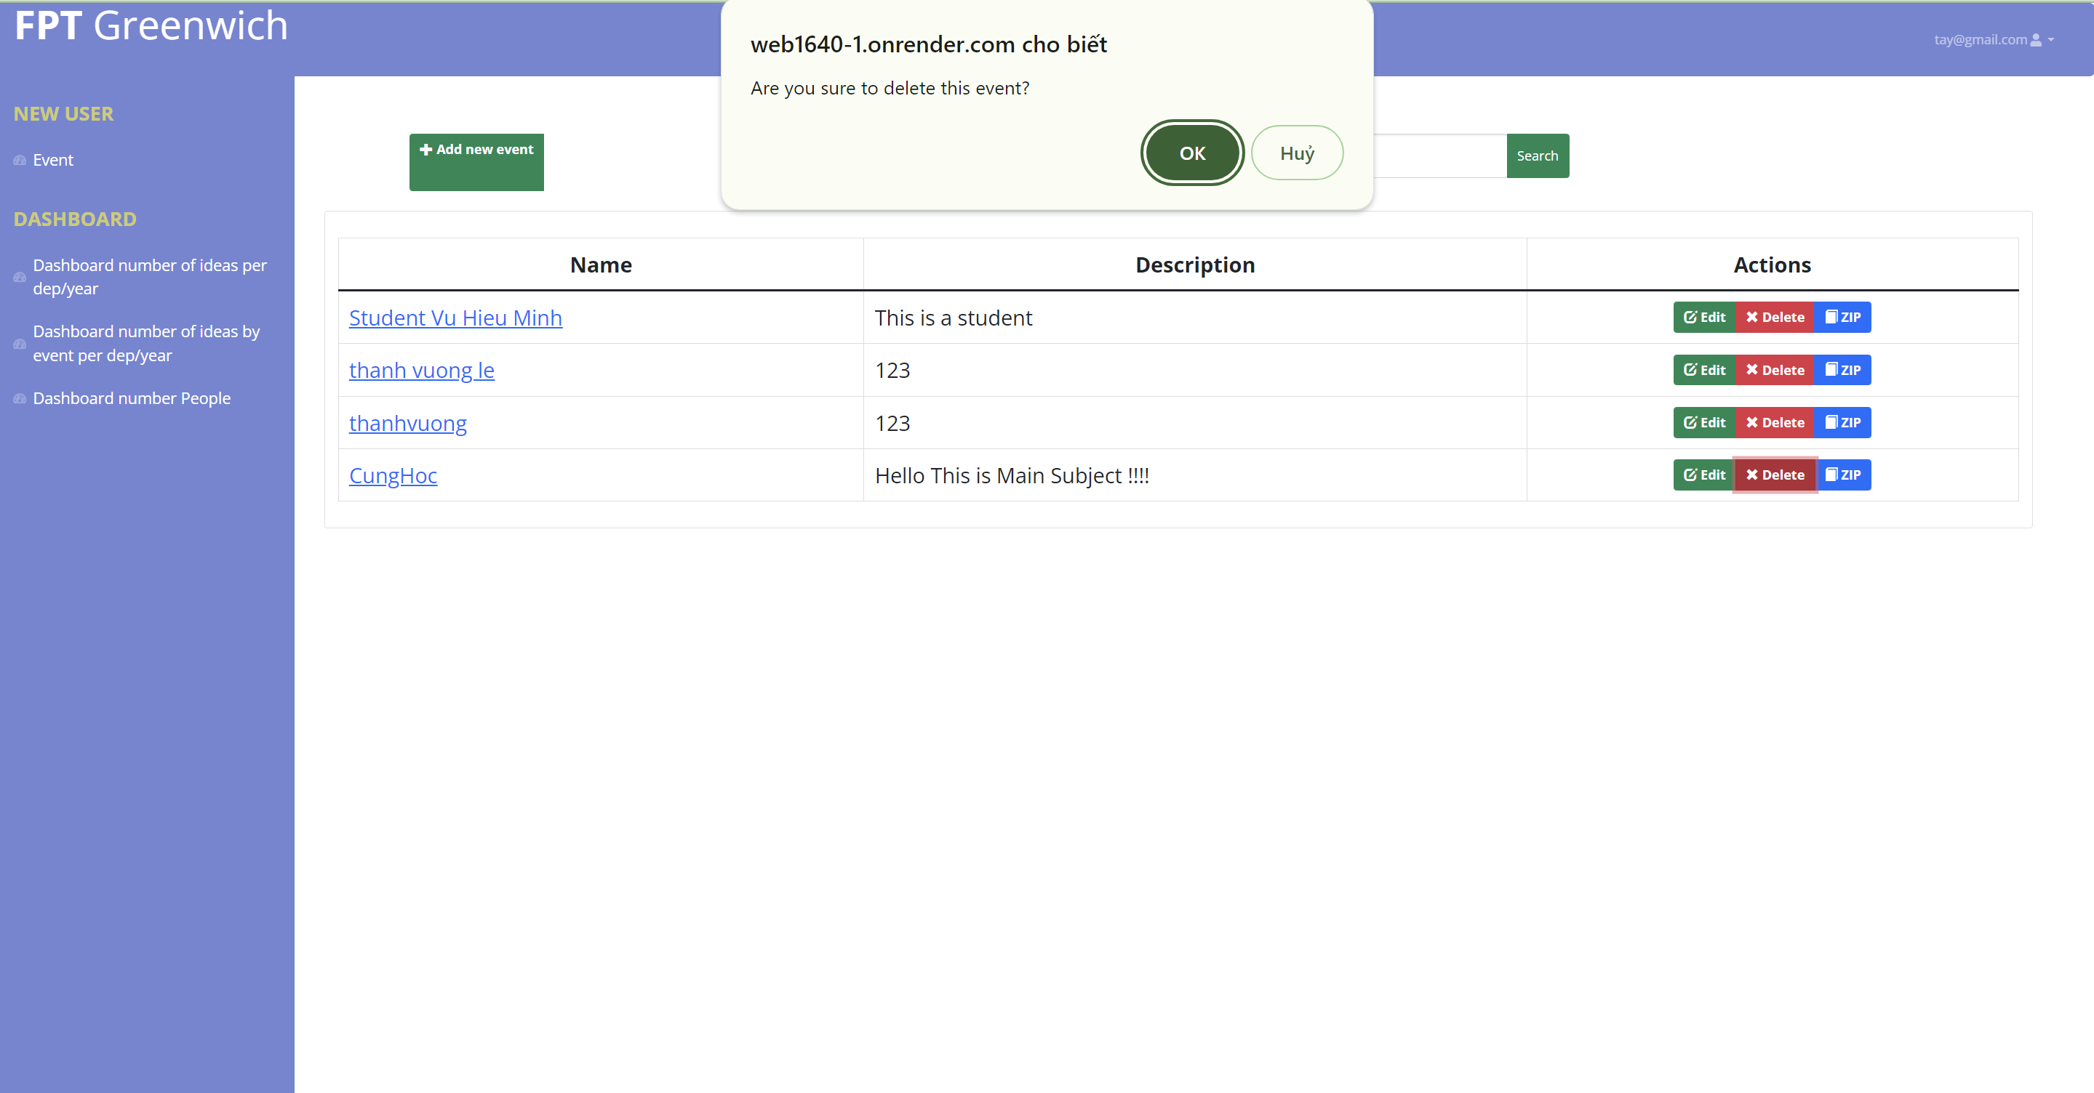

Figure 44 Delete Event Page

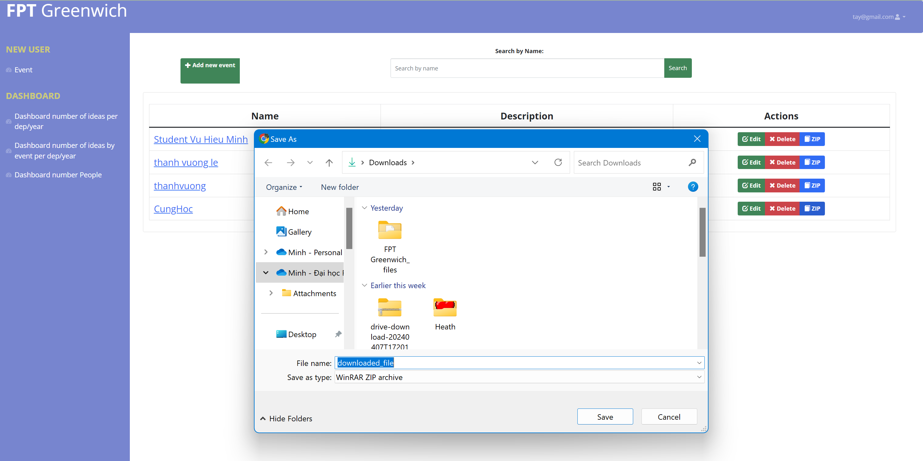

Figure 45 Download File Zip

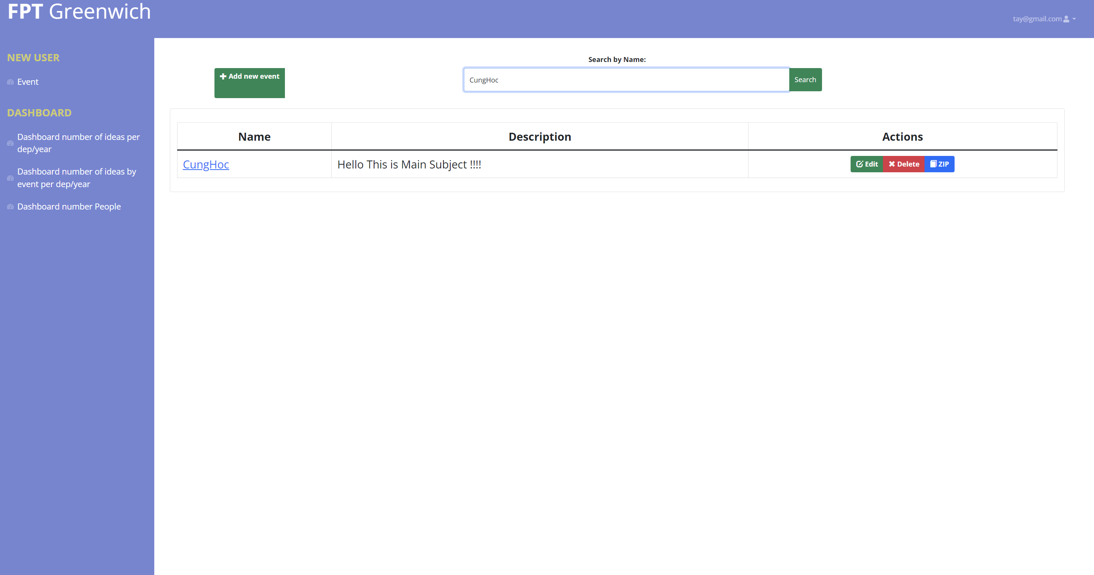

Figure 46 Search Event Page

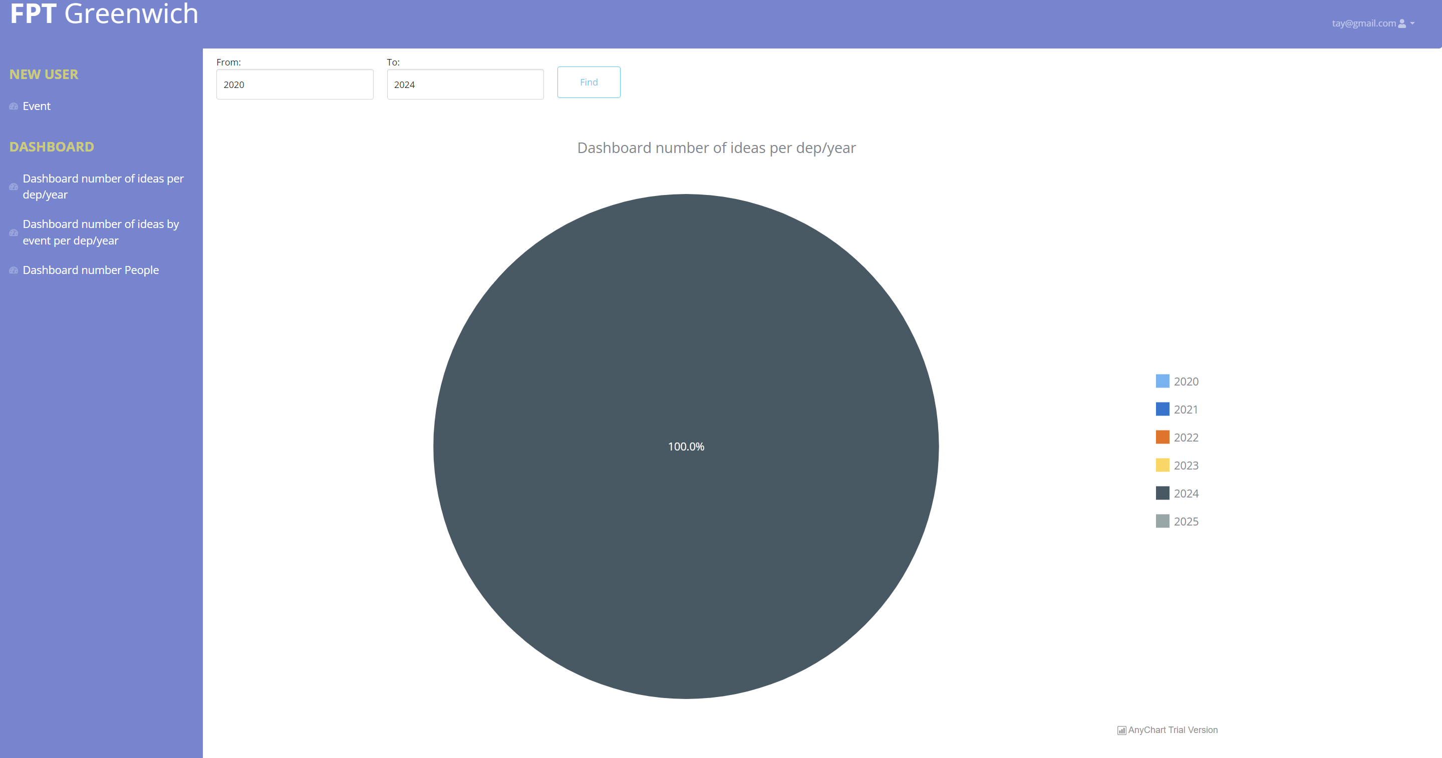

Figure 47 Number Of Ideas By Year Page

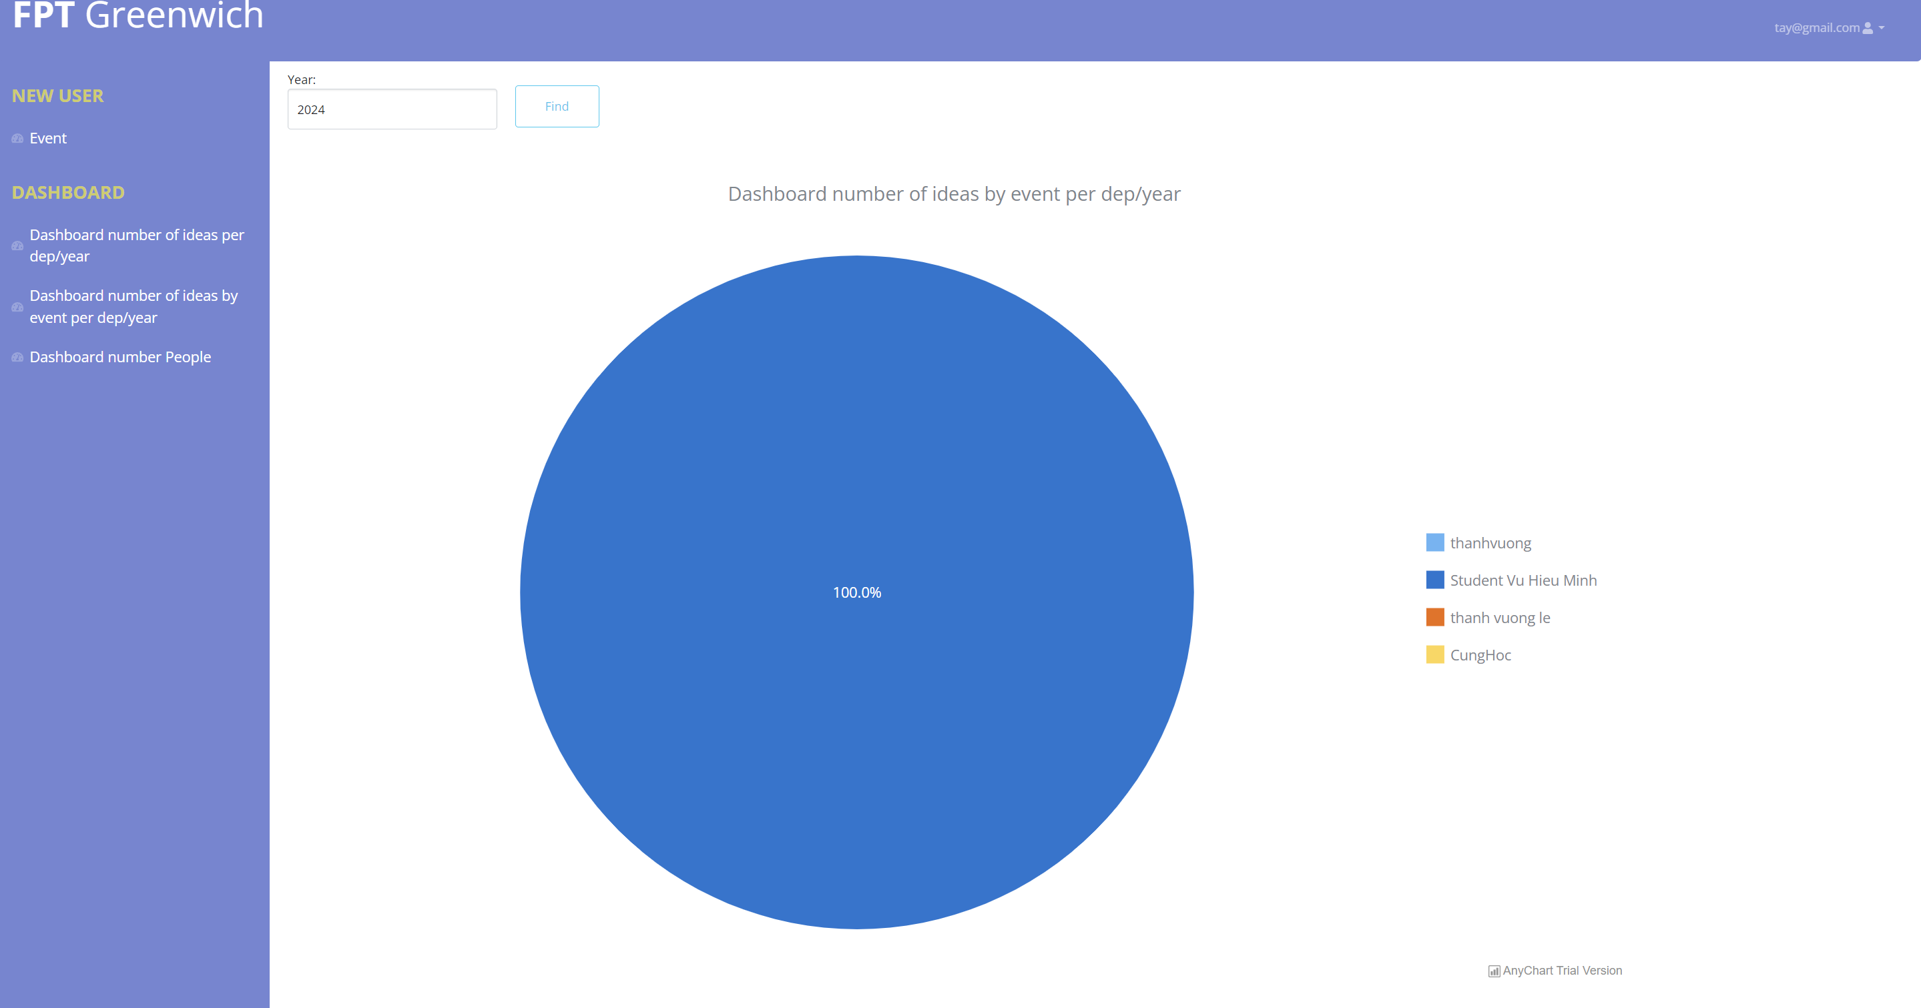

Figure 48 Number Of Ideas By Year Page 2

**- Coordinator**



Figure 49 Coordinator Home Page

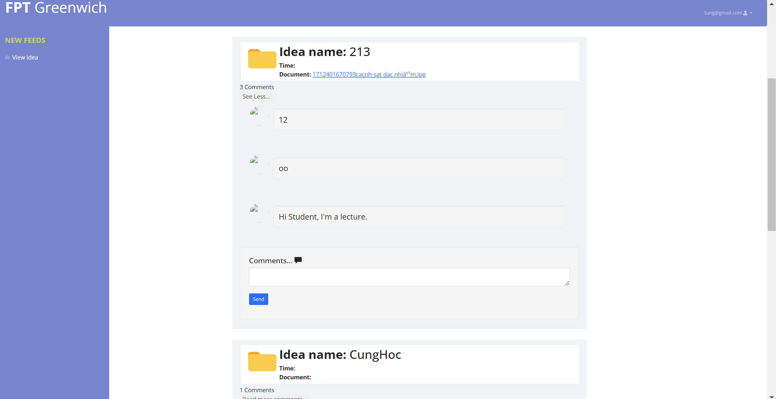

Figure 50 Most Comment Page

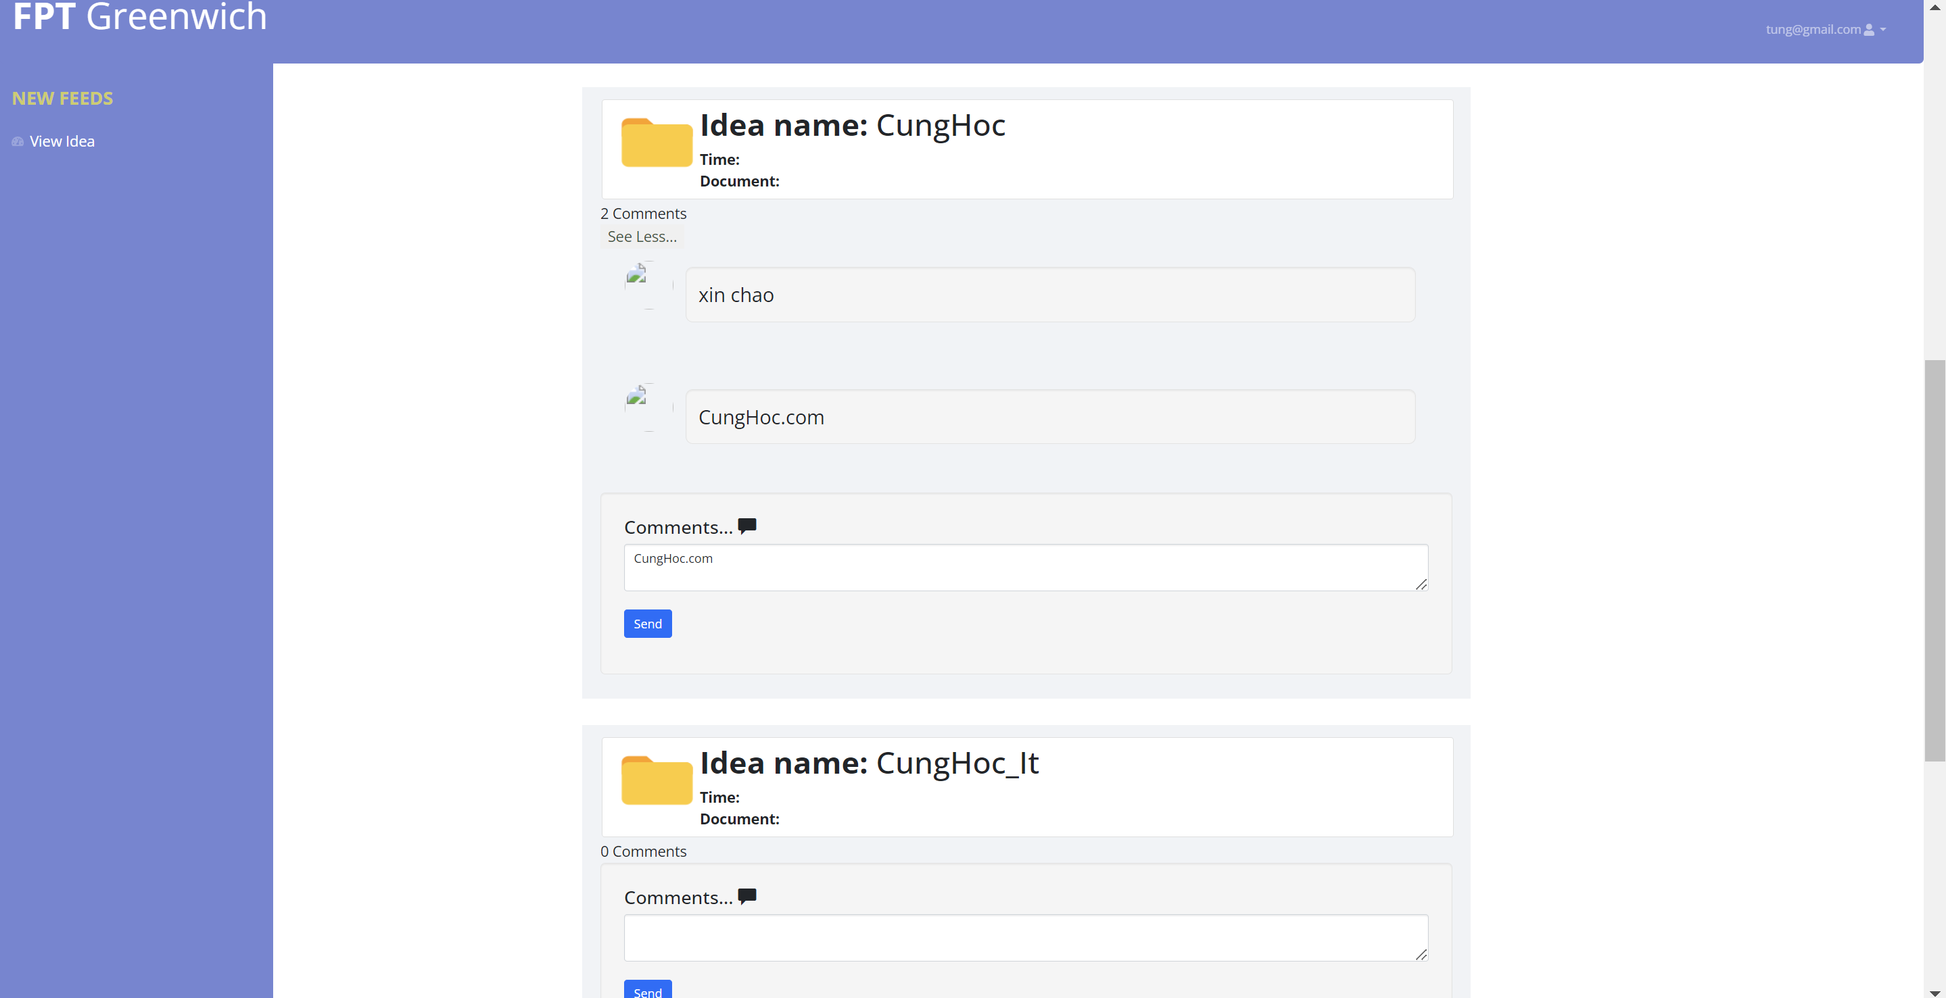

**- Student**



Figure 51 Student Home Page

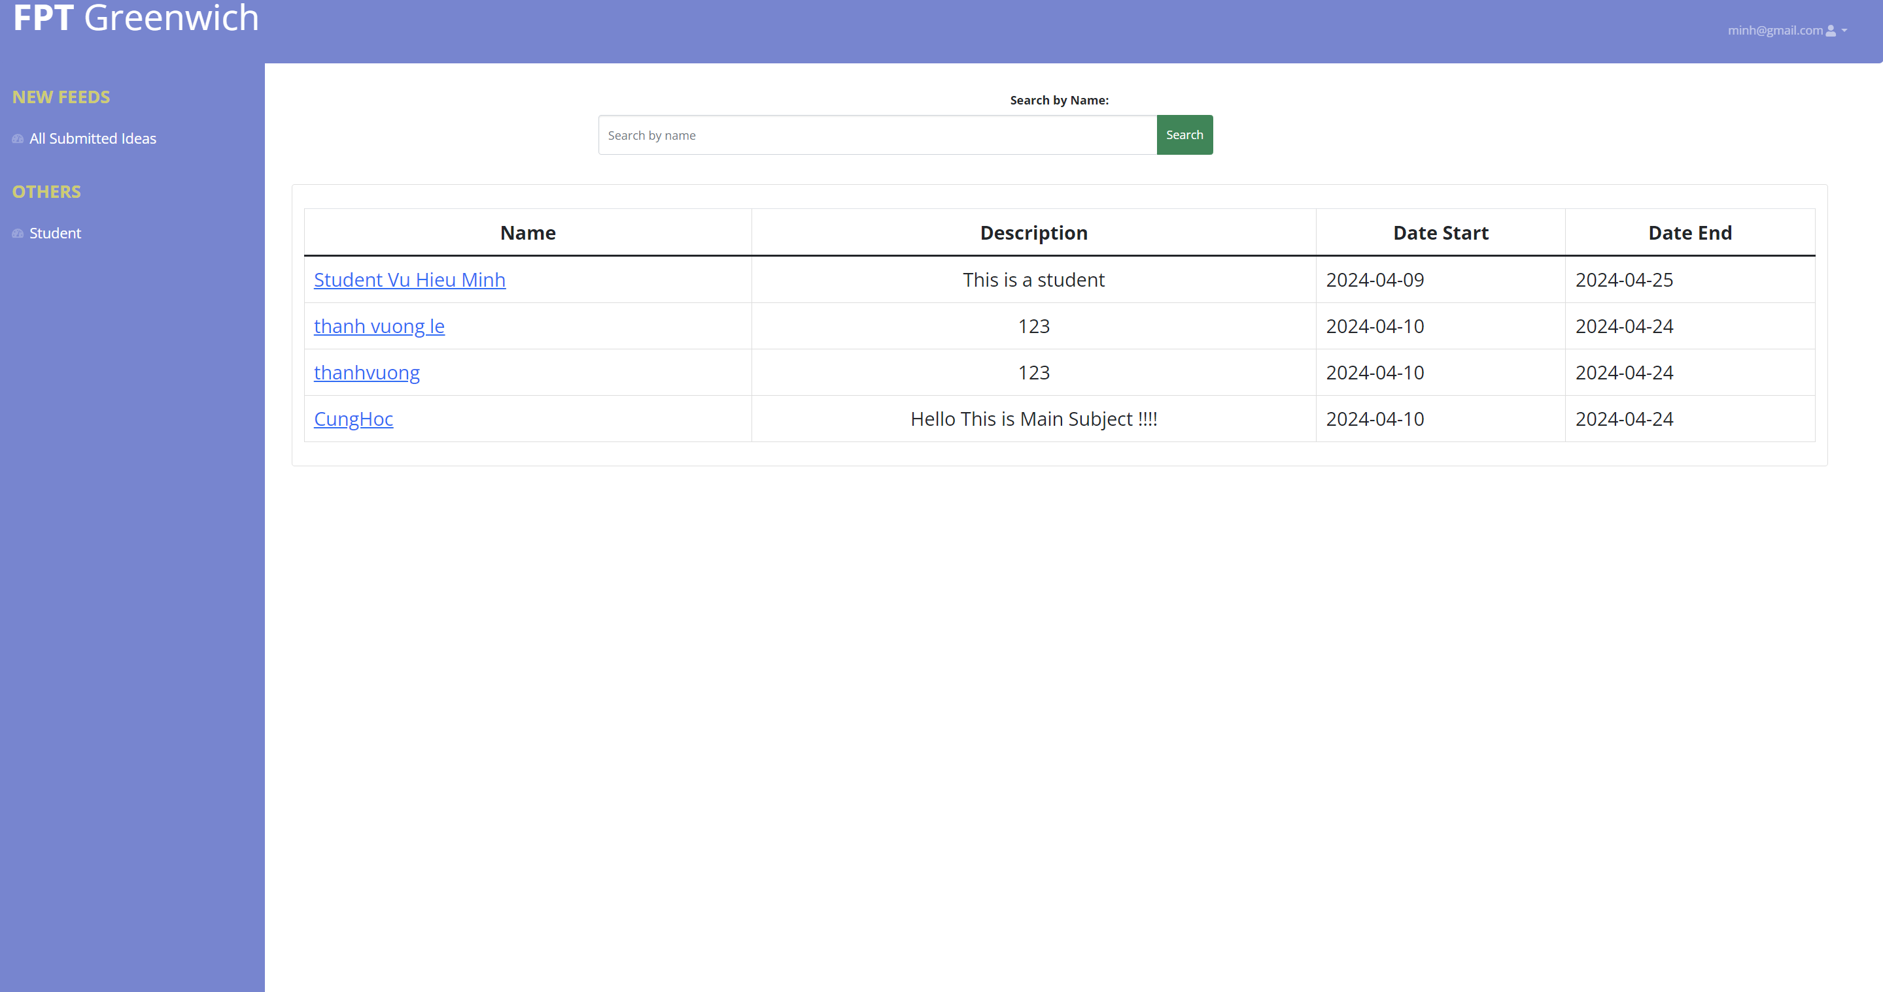Figure 52 View Idea

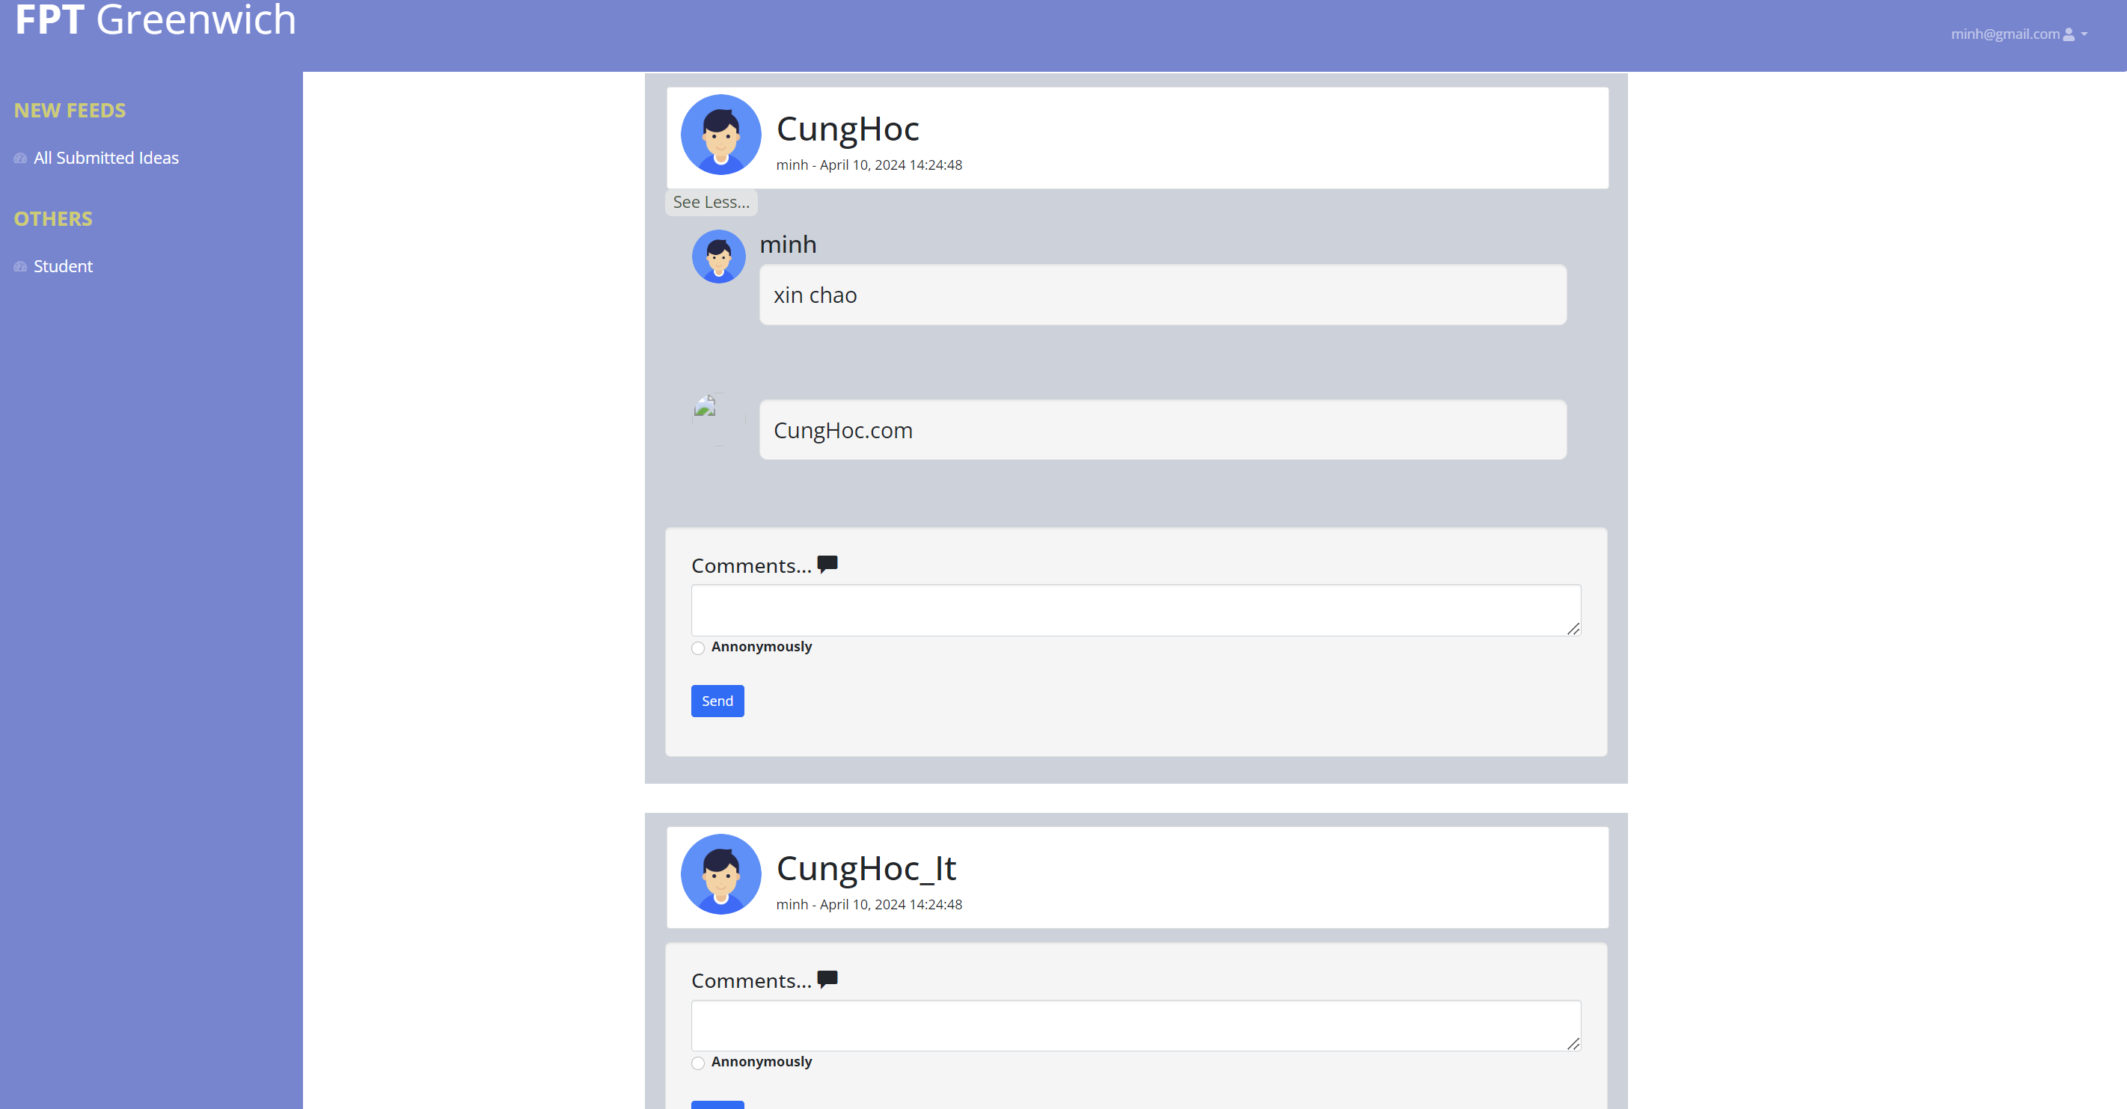

Figure 53 Event Detail

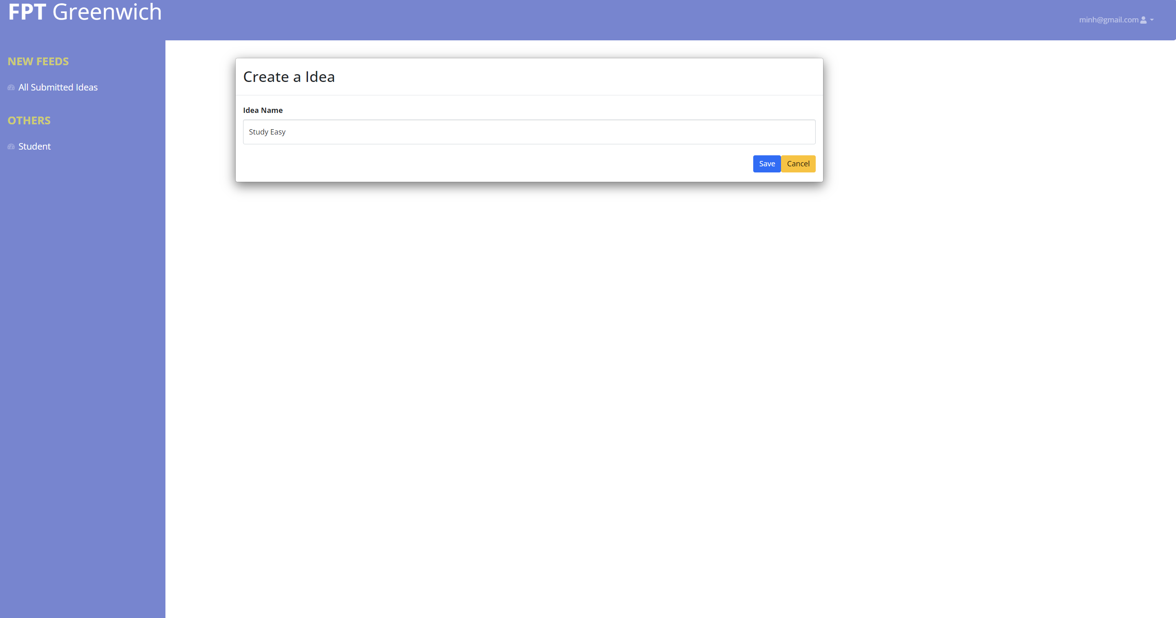

Figure 54 Add Idea page

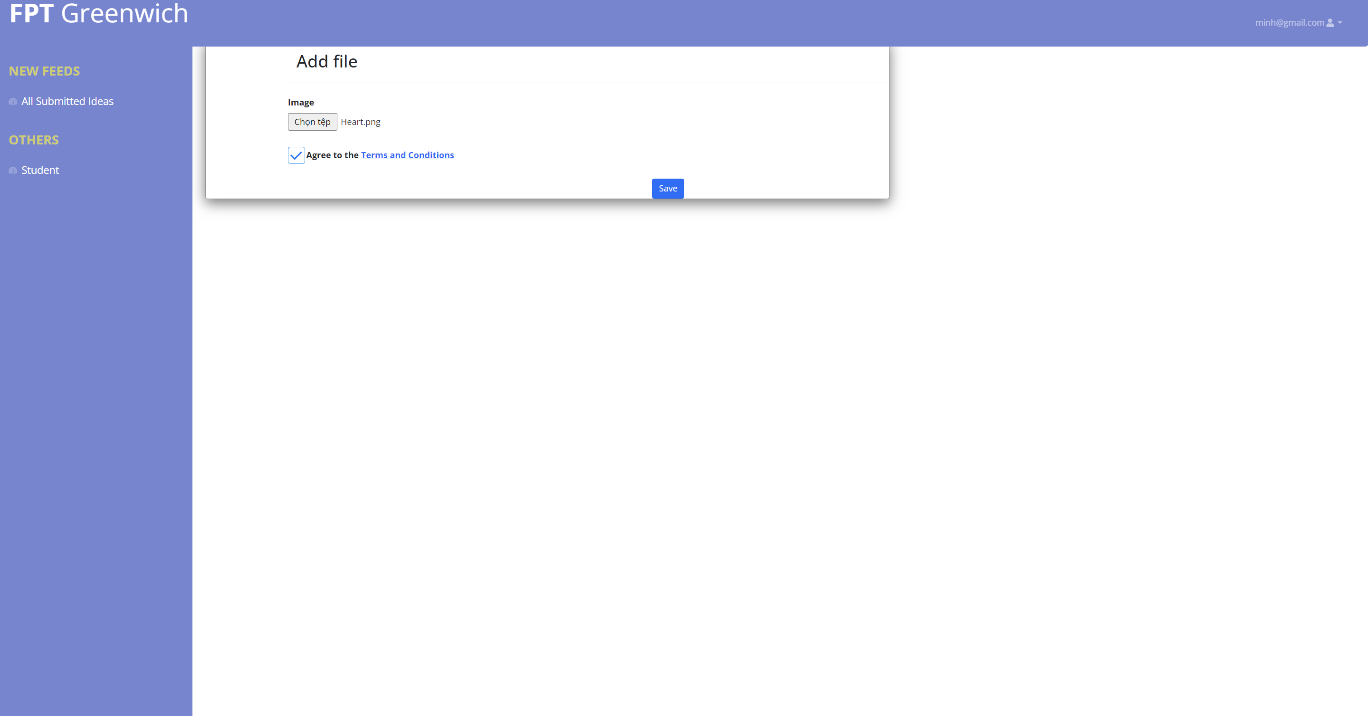

Figure 55 Add File idea page

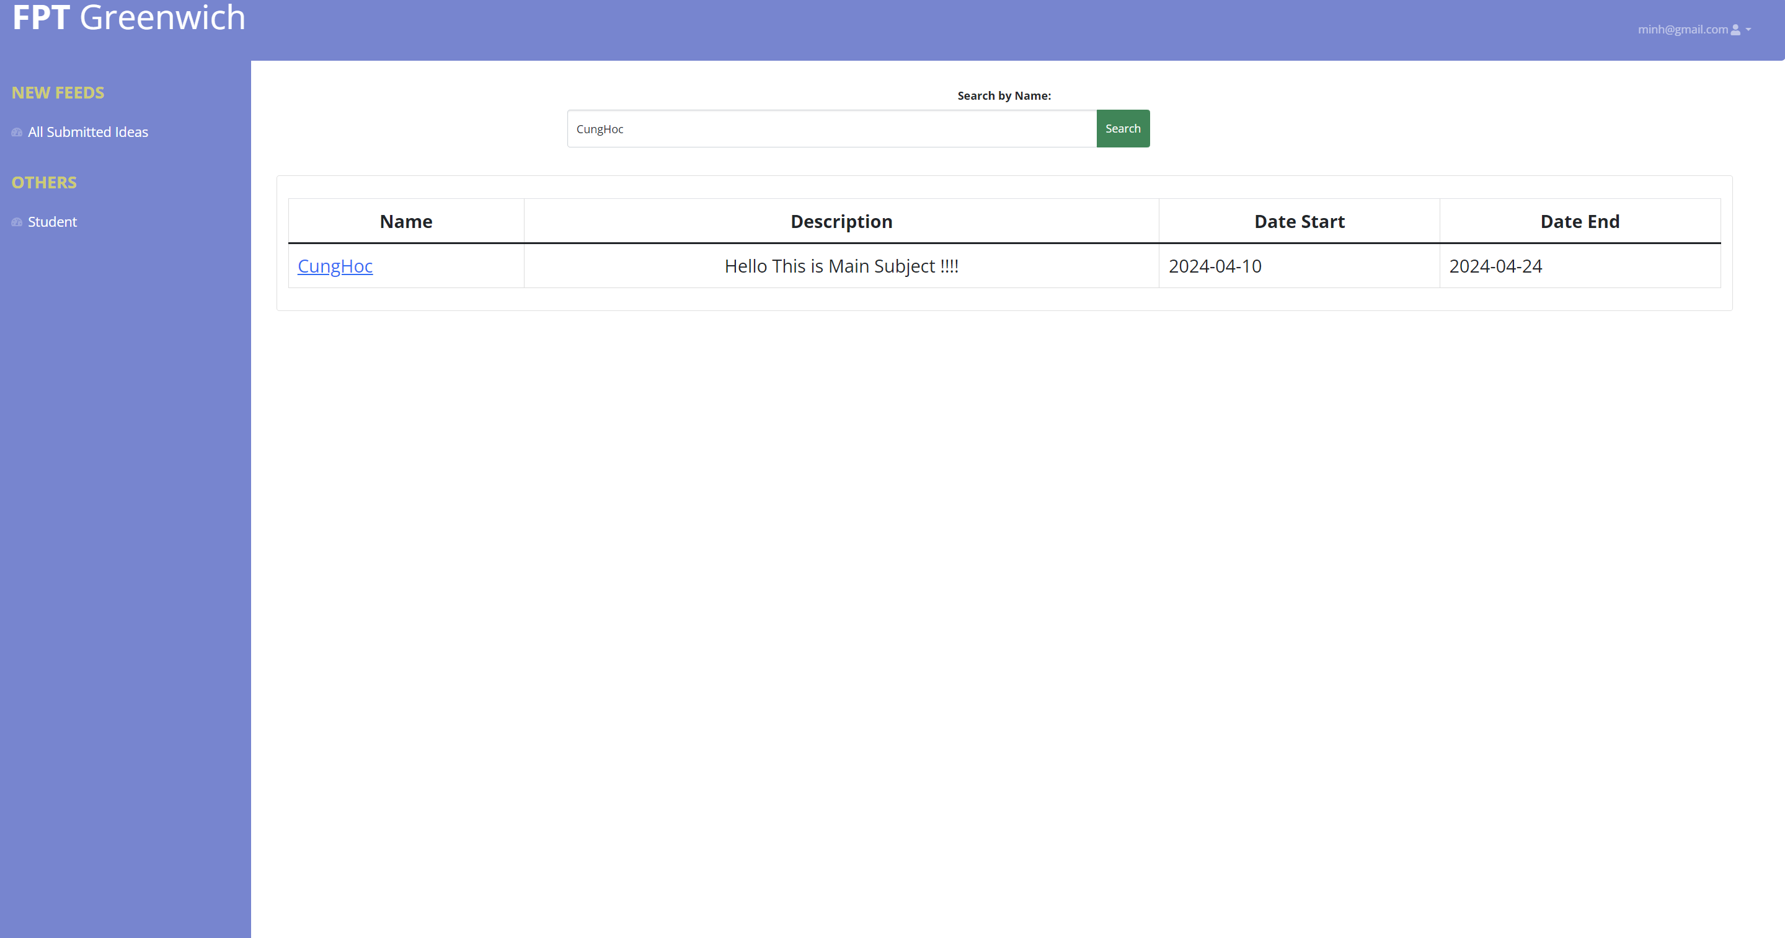

Figure 56 Search Event

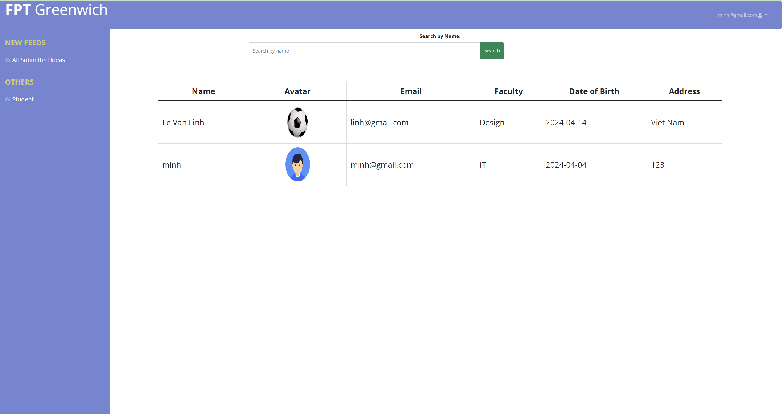

Figure 57 View Student page

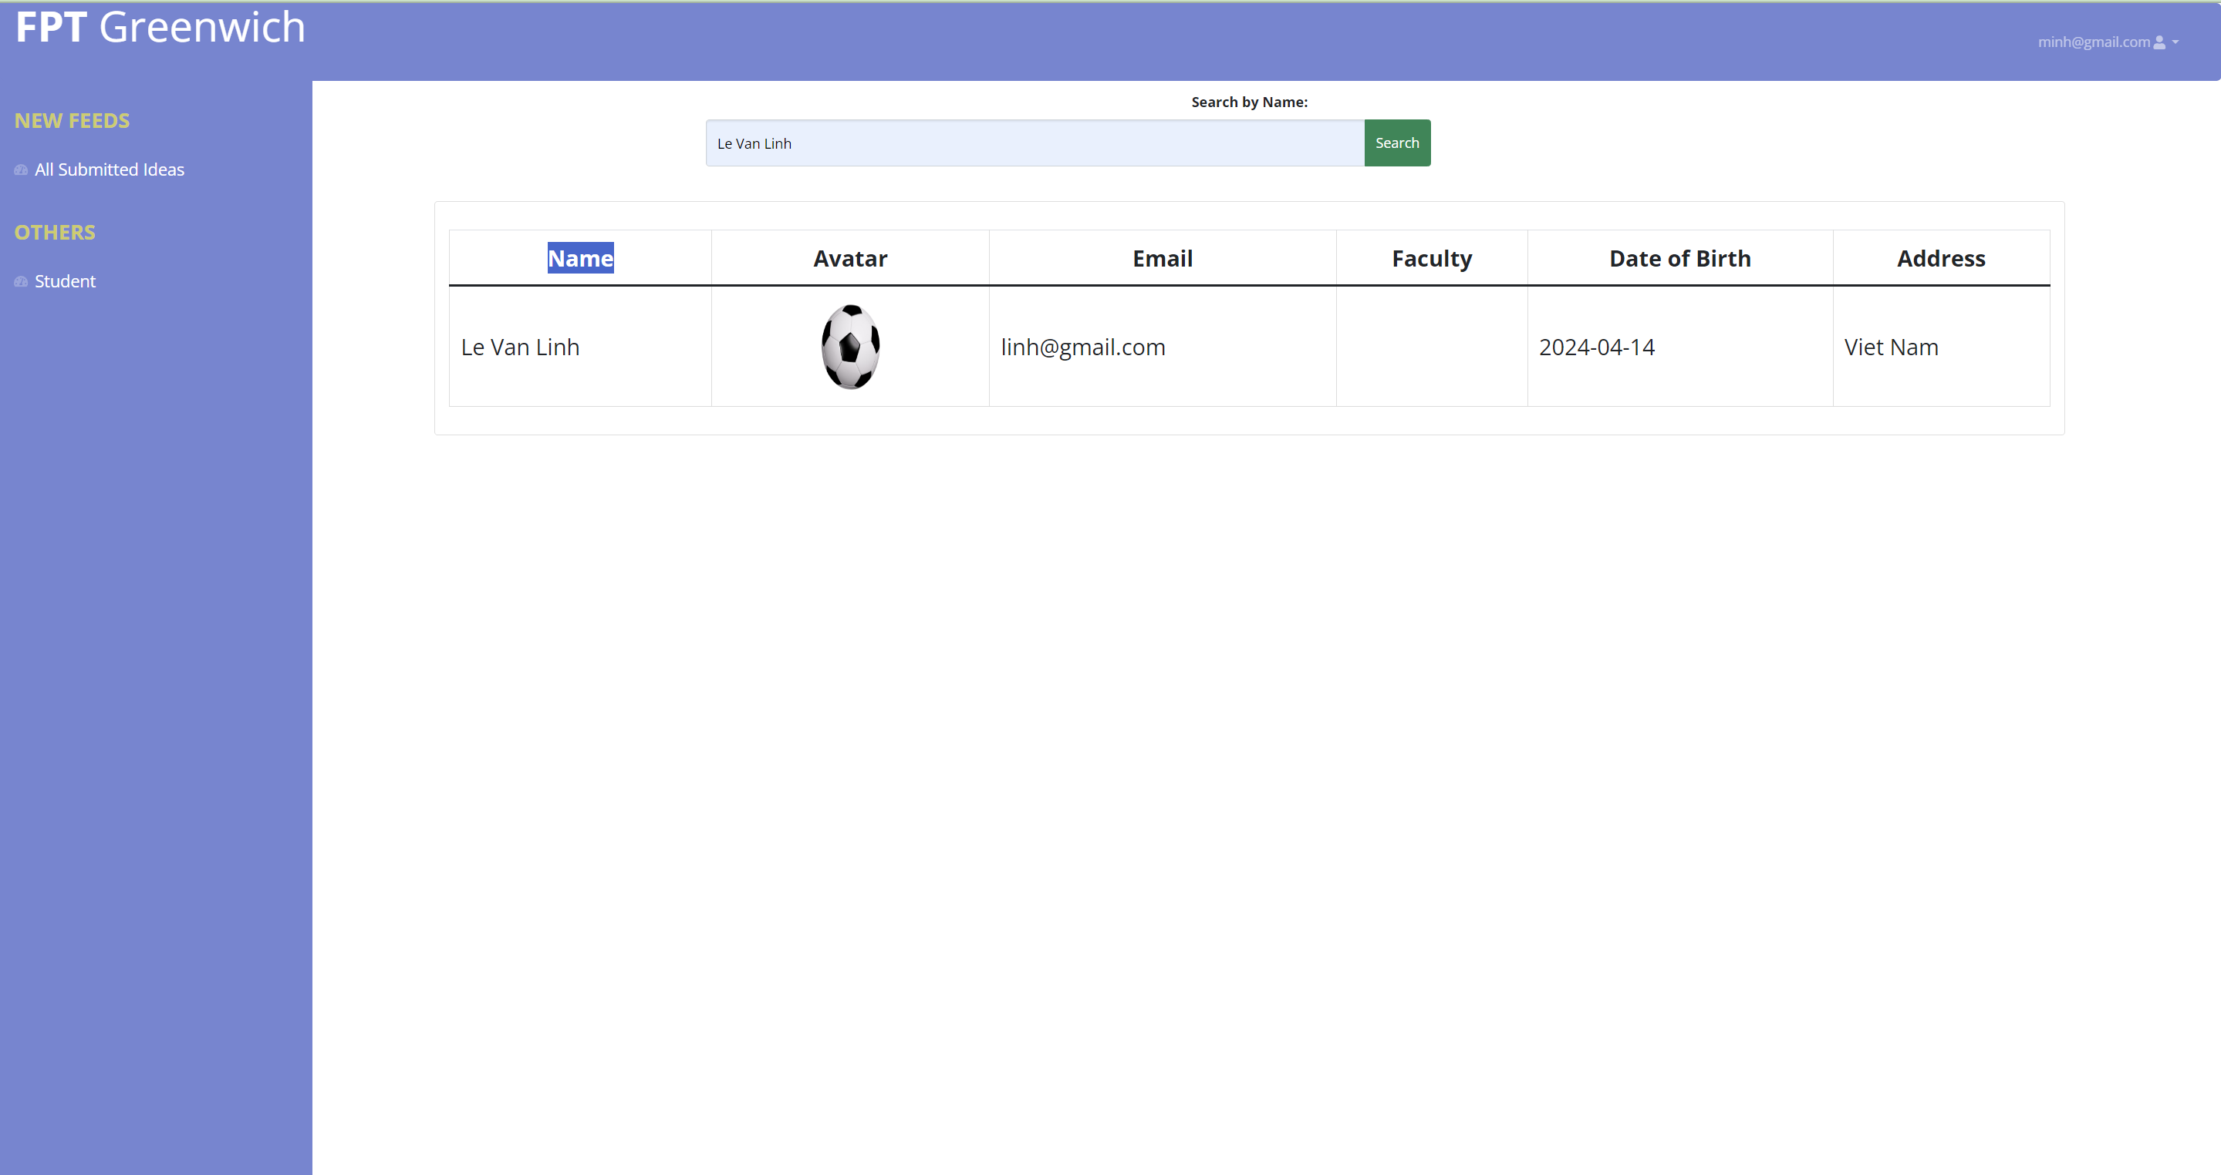

Figure 58 Search Student

# **Testing**

* 1. **Test plan**

A formal document known as a test plan provides a thorough and organized description of the testing procedures and approaches that will be used to evaluate the software system under test. This document offers comprehensive details about the project's approach, methodology, scope, goals, resources, schedule, and hazards. Depending on the approach the team choose, there may be variations in the test planning procedure.

QA managers run the danger of an uncoordinated testing effort that results in an inefficient use of resources if they don't have a solid test plan. A test plan isn't a static, singular document. QA managers can make complete adjustments to the initial metrics and timetables listed on it in order to maximize resource use. To have specific goals and objectives to adhere to during the sprint, team members would still want a test plan.

Technically speaking, a test plan usually contains comprehensive details about the methods, approaches, and instruments that will be utilized to carry out the testing. Along with any external dependencies or services needed for testing, it also contains details about the hardware, software, and network configurations that make up the test environment.

The test plan serves as a vital point of reference for the development team and other stakeholders, guaranteeing that everyone is working toward the same goal. The test plan's information can be used to monitor the testing process and take prompt action if an issue develops.

1. **Scope**

Sprint 1: (Admin)

* Authorization and authentication for each role
* CRUD account (Manager, Student, Coordinator)
* Create event
* Divide Coordinator into each department
* View the list of latest contributions
* See comments on contributions
* View all departments, events, accounts, contributions

Sprint 2: (Student)

* + Add new contributions
  + Like and create comments for posts
  + Receive email notifications when the Coordinator reflects on your contributions
  + View the list of published contributions
  + See comments in contributions

Sprint 3: (Marketing Management)

* View the list of Contributions by category
* See most Contributions comments and comments.
* Table summarizing the number of contributions of each student of each department
* Download all uploaded documents in ZIP format.
* Sign in Sign out

Sprint 4: (Coordinator)

* Receive email notifications of new submissions from students
* Chat with students via email.
* Publish contributions within 14 days
* Sign in Sign out

1. **Limitation**

The limitations can affect the quality of testing:

* Time
* Technology

1. **Risk management**

A plan for risk mitigation that details the precise actions to be done to address hazards that have been identified should also be included in the risk management strategy. This should include a precise division of duties and allocation of resources, such as staff, funds, and time, that will be necessary to manage the risks that have been identified.

|  |  |  |  |
| --- | --- | --- | --- |
| **No** | **Risk** | **Description** | **Mitigation** |
| 1 | Time and work schedule | Not completing work within the established deadline, slowing down the project's progress | For each task, prioritize important tasks |
| 2 | Functions of the system | Functionality is not as intended causing impact  user experience |  |
| 3 | Dev knowledge | During the project development process, many errors were encountered because of lack of knowledge | Study and train more to improve skills |

1. **Test Environment**
2. **Test resource**
3. **Test scenario**
4. **Test estimate time**

# **Methodology**

* 1. **User Story**

To create an effective system, the team must analyze the goals and requirements of the problem. To achieve this, we use a streamlined approach that breaks down the overall functionality of the site into smaller, more manageable parts. These user stories are arranged in a table structured like "Is..., I want, I can..., so I can...". Along with that, we recorded each function's estimated size, execution priority, sprint speed, and respective status.

During the second sprint, our team divided up the larger tasks to work on. From the beginning, our team was committed to a meticulous approach. We can achieve better results understanding user needs and creating a roadmap that exactly matches the project goals.

* **Marketing Manager**

|  |  |  |
| --- | --- | --- |
| User Story | Requirement | Significant |
| As a marketing manager, I would like to be able to access the account and use it for Marketing Manager. | Login to the system for Marketing Manager | High |
| As a marketing manager, I would like to see all the contributions. | Information about the contribution is stored in database. | High |
| Front-end code for contributions view |
| Back-end code for contributions view |
| As a marketing manager, I would like to download all upload documents in ZIP format. | Download file in ZIP format | High |
| Download all file | Low |
| As a marketing manager, I would like t view statistics in dashboard such as:   * Number of contributions per faculty * Percentage of contributions by each faculty * Number of contributions per faculty | Information about contribution is stored in database | High |
| Front-end code view for dashboard | High |
| Back-end code send data to front-end | High |

* **Marketing coordinator:**

|  |  |  |
| --- | --- | --- |
| User Story | Requirement | Significant |
| As a marketing coordinator, I would like to be able to access the account and use it for Marketing Coordinator | Login to the system for Marketing Coordinator | High |
| As a marketing coordinator, I would like to be able to view all the contributions of my faculty’s students. | Information about contribution is stored in database | High |
| Front-end code for contributions view | High |
| Back-end code for contributions view | High |
| As a marketing coordinator, I would like to be able to receive email notifications for new submissions from student. | Student need to submit contribution first and then marketing coordinator will receive email later | Medium |
| As a marketing coordinator, I would like to be able to select good contributions for publication. | Front-end code views all the idea that published | High |
| Back-end code for published idea | High |
| As a marketing coordinator , I would like to be able to comment for contributions within 14 days from submission date. | Upload comment function for contributions | High |

* **Student**

|  |  |  |
| --- | --- | --- |
| User Story | Requirement | Significant |
| As a student, I would like to be able to submit article(contributions) in Words or Images. | Upload functions for contributions | High |
| Checkbox to allow for terms to be agreed upon by student before submitting the contribution | Medium |
| As a student, I would like to be able to update my contribution until the final closure date. | Update contribution function for contribution | High |
| As a student, I would like to be able to access the account and use it as student | Login to the system as Student | High |

* **Administrator**

|  |  |  |
| --- | --- | --- |
| User Story | Requirement | Significant |
| As an administrator, I would like to be able to access the account and use it as administrator | Login to the system as Administrator | High |
| As an administrator, I would like to be able to create new accounts (marketing manager, marketing coordinator, manager, student) | Front-end code view for managing account | High |
| Back-end code CRUD for managing account | High |
| As an administrator, I would like to be able to create new event as well as set first closure date and final closure date(deadline) | Course database table with 2 deadlines | High |
| Front-end code for managing contributions | High |
| Back-end code CRUD for managing contributions | High |

* **Gust**

|  |  |  |
| --- | --- | --- |
| User Story | Requirement | Significant |
|  |  |  |

* 1. **Team challenges**

During project implementation, the Team assigned clear tasks to each member. However, there are still some challenges in implementing the process.

First of all, the group does not have much experience working in groups, so it takes a lot of time to divide the bond between members. There are many conflicting opinions and lack of understanding among members. There were some difficult functions expected and the team did not complete the initial project progress, so the team had to meet continuously to complete the schedule.

Next, the members have different jobs so they only have time to meet late at night and during class sessions with teachers, so there are many obstacles and there is not much time to discuss.

Finally, the team decided to use languages like React.j, Nodejss and use Mongodb database. Some members were using this language for the first time, so there were many surprises and obstacles at first. It took some members some time to get used to the language because they were not experts and rarely used this language.

* 1. **Scum model**

Scrum is an agile approach to software development that emphasizes growth and iteration. Scrum is made to help with the creation, implementation, and enhancement of complicated products. The product is developed using Scrum through a sequence of iterative procedures known as sprints. As a result, working conditions, teams, products, and methods may all be continuously improved. Scrum is a framework used in software development projects with the goal of delivering new products regularly, every 1-4 weeks.

Below are 4 project sprints, each sprint takes 2 weeks to complete.

* 1. **Sprint**

1. **Product backlog**

The team uses Nulab to design the Backlog, and manage the team's work progress. In the Backlog, all tasks are divided into 4 Sprints to manage progress, each member is assigned a name with each task that must be done, and when completed, it will be marked as completed as well as tasks being done and completed. do not. Each member of the group will monitor each member's work progress so that they can support and promote each other's progress.

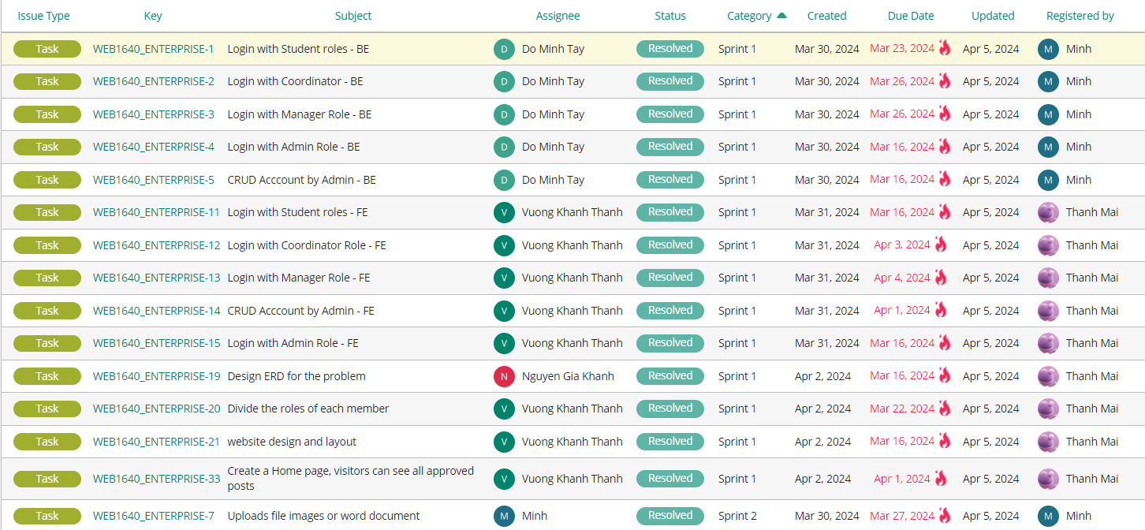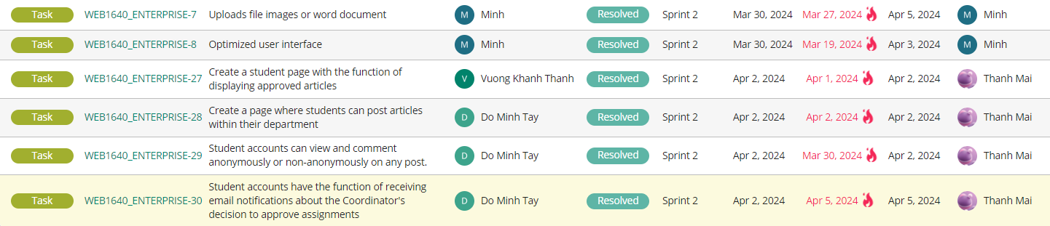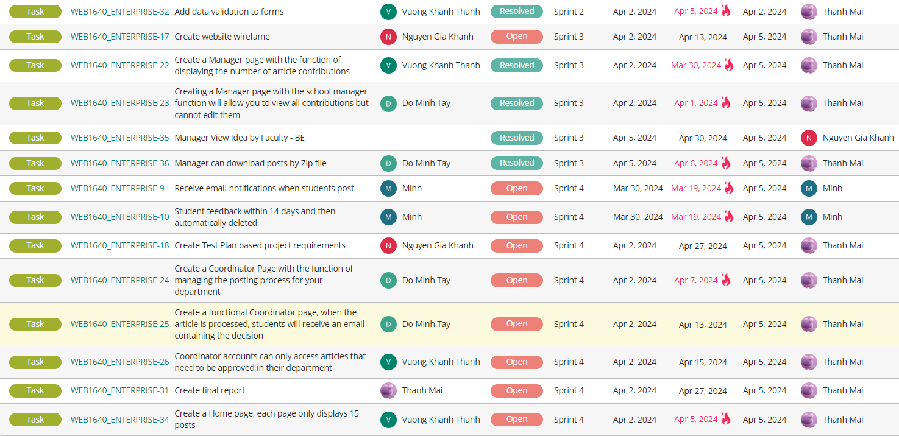

1. **Sprint 1**

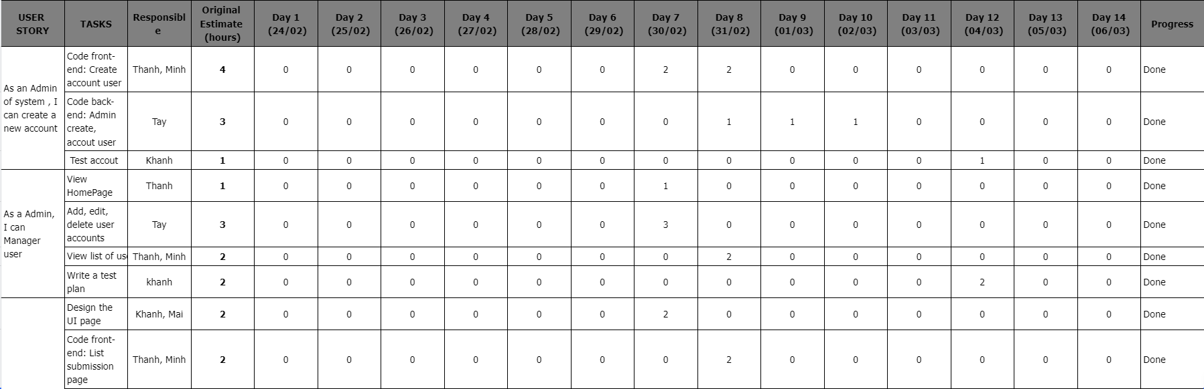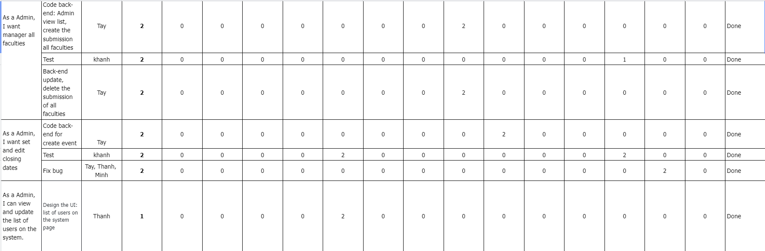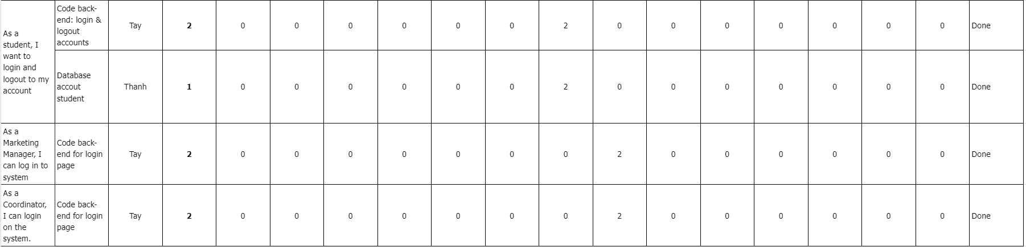

Looking at the Sprint, we can see that the team's work progress in the first few days was a bit slow, it took the first few days for the team to stabilize and start working on the project. However, the team spent a lot of time to be able to keep up with progress. Finally, the team has completed the work of Sprint 1

1. **Sprint 2**

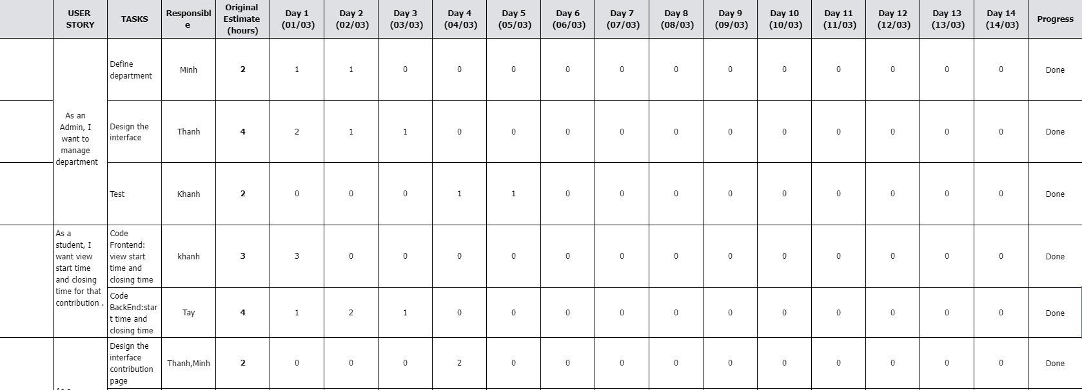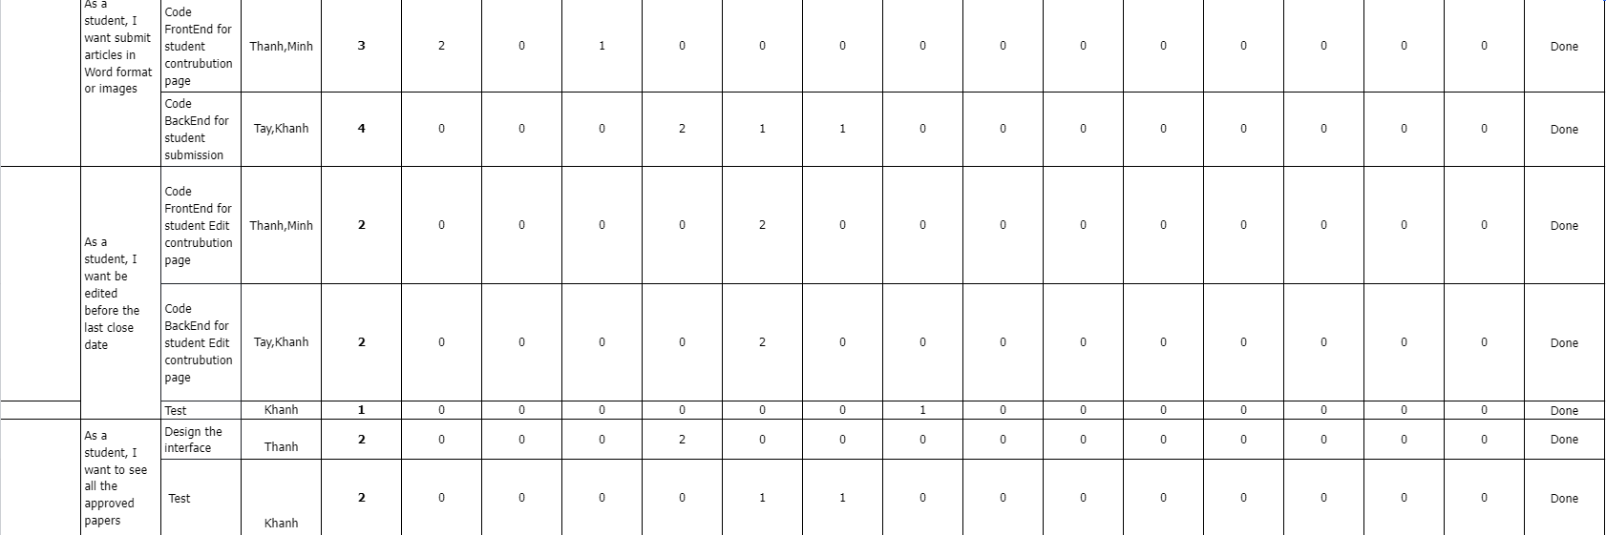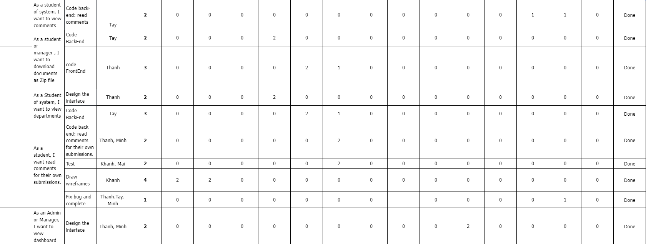

Look at the time chart on the Sprint. It can be seen that the group's working speed this week is faster than planned. The estimated time to complete these tasks is 14 days. The actual time the group completed was 13 days. Finally, the team successfully completed the work 1 day ahead of schedule, all activities were completed

1. **Sprint 3**

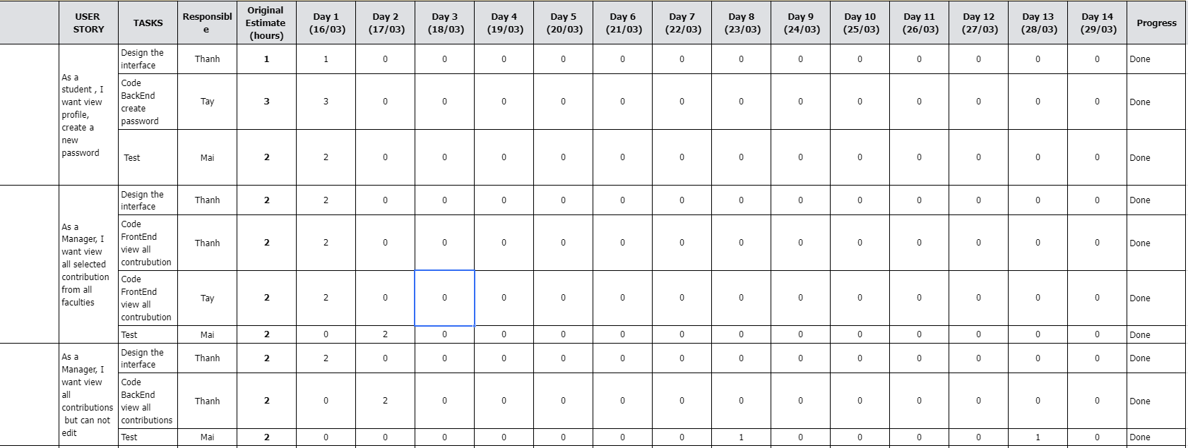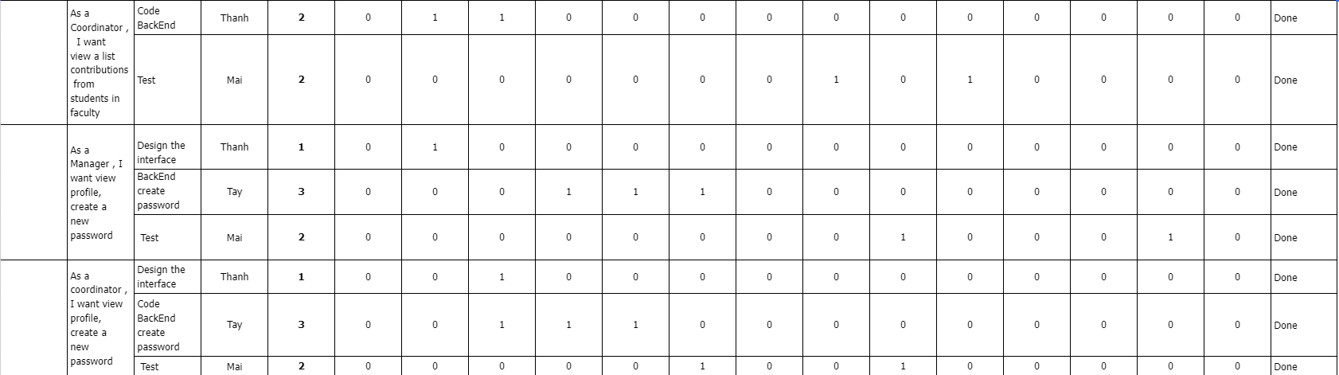

Looking at the Sprint board, you can see the team's progress in completing the work. The estimated time to complete Sprint 3 is 14 days. It took the team 13 days to complete the schedule. In the end, the group successfully completed 1 day ahead of schedule

1. **Sprint 4**

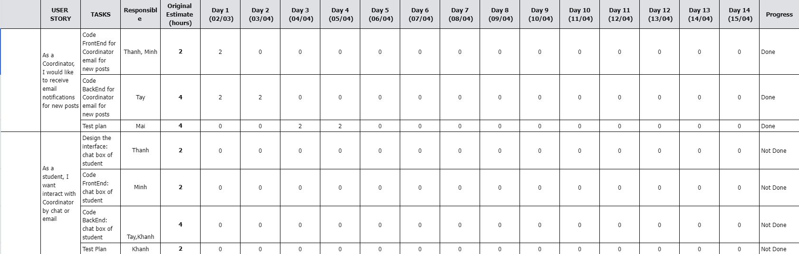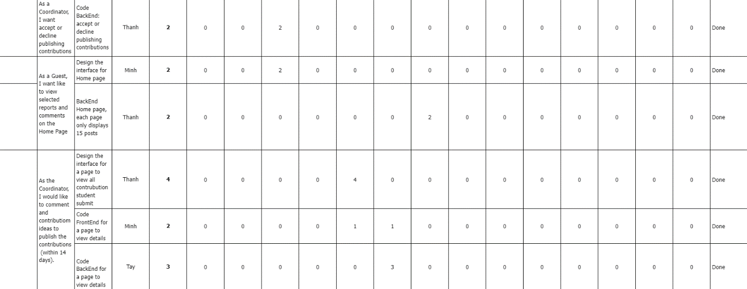

* 1. **Meeting minutes**

**Meeting 1**

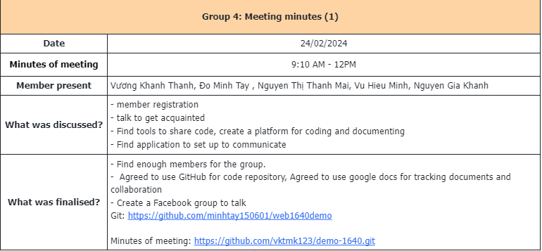

**Meeting 2**

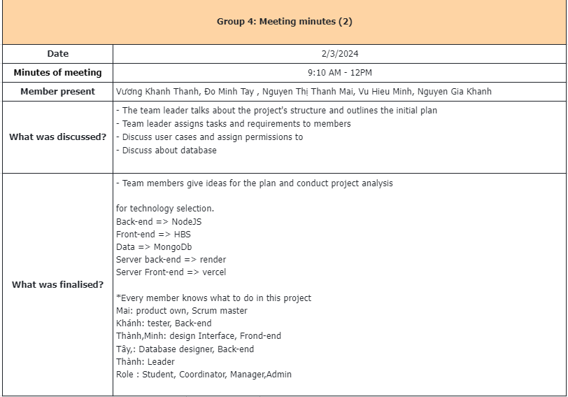

**Meeting 3**

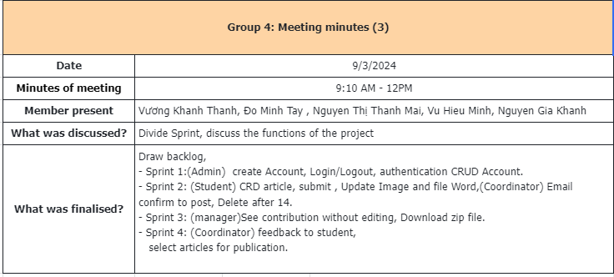

**Meeting 4**

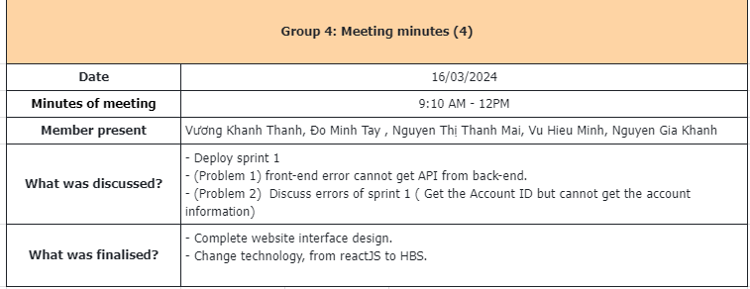

**Meeting 5**

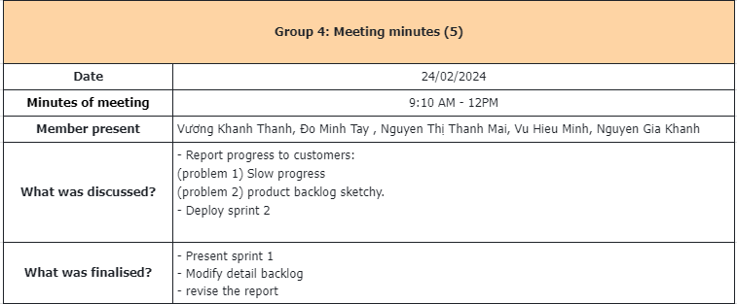

**Meeting 6**

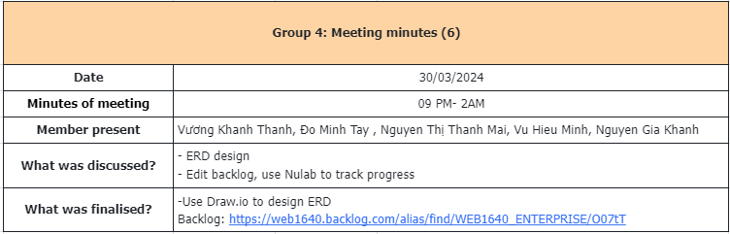

**Meeting 7**

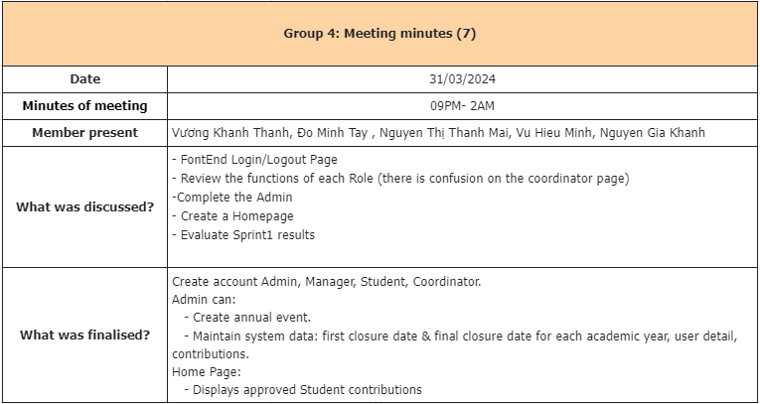

**Meeting 8**

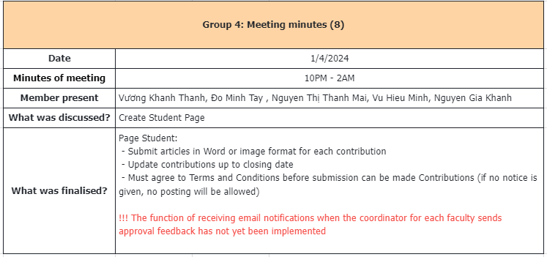

**Meeting 9**

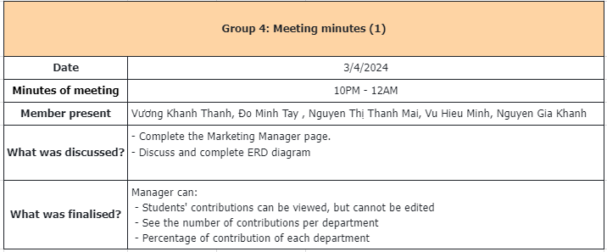

**Meeting 10**

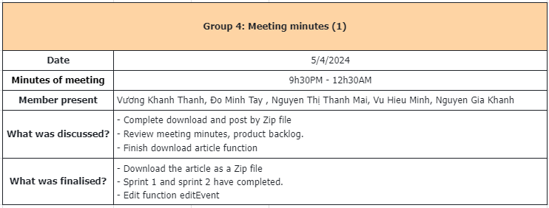

# **Conclusion**

The authors are making a role-based website for a large university. The team has completed most of the required functions of the website. During the implementation of the system, the author team regularly uses Google Meet in the evening to discuss project development. The group also has a schedule that separates the roles of group members and everyone also supports each other in their work. Through this, the group learned teamwork, project development planning, and programming skills.

# **Bibliography**

* Anh Tester (2022) *What Is Scrum? Overview Of The Scrum Model*. Available at: <https://anhtester.com/blog/scrum-la-gi-tong-quan-ve-mo-hinh-scrum-b428.html> (Accessed: 09 April 2024).